Name

Mathematics Extension 1 Year 11
Further Transformations

Book 1 |  | Version: 260928  Feedback:  https://MrDingMaths.com
Contents
Syllabus Content 2
Learning Intention 3

Syllabus Content
ME1-11-01 solves problems involving inequalities, functions and their inverses, graphical relationships between functions, and parametric equations
Graphical relationships
- Examine the relationship between the graph of $y=f\left(x\right)$ and the graph of $y=\frac{1}{f\left(x\right)}$ using graphing applications, and graph $y=\frac{1}{f\left(x\right)}$ given $y=f\left(x\right)$ in algebraic or graphical form, identifying any vertical and horizontal asymptotes of $y=f\left(x\right)$ and $y=\frac{1}{f\left(x\right)}$
- Graph $y=\sec{x}$, $y=\operatorname{cosec}{x}$ and $y=\cot{x}$ in both radians and degrees, identifying key properties including asymptotes, period, domain, range and symmetry, and compare each graph with the graph of its reciprocal
- Examine the relationship between the graph of $y=f\left(x\right)$ and the graphs of $y=\left|f\left(x\right)\right|$ and $y=f\left(\left|x\right|\right)$ using graphing applications, and graph $y=\left|f\left(x\right)\right|$ and $y=f\left(\left|x\right|\right)$ given $y=f\left(x\right)$ in algebraic or graphical form
- Examine the relationship between the graphs of $y=f\left(x\right)$ and $y=g\left(x\right)$ and the graphs of $y=f\left(x\right)+g\left(x\right)$ and $y=f\left(x\right)-g\left(x\right)$ using graphing applications, and graph $y=f\left(x\right)+g\left(x\right)$ and $y=f\left(x\right)-g\left(x\right)$ given $y=f\left(x\right)$ and $y=g\left(x\right)$ in algebraic or graphical form
- Determine the domains and ranges of the sum and difference of functions where possible, and, if appropriate, verify them using a graphing application
- Apply knowledge of graphical relationships to solve problems involving graphs of functions, justifying conclusions in the context of the problem where appropriate

Sketching The Reciprocal of a Function

- Reciprocal of a Function
- The reciprocal of a function $f\left(x\right)$ is $\frac{1}{f\left(x\right)}$, or ${\left(f\left(x\right)\right)}^{-1}$.
- To sketch the graph, the key features to identify are vertical asymptotes, intercepts, behaviour as $x→±∞$ and behaviour as $x→$ asymptotes±.
- The function $y=$ $\frac{1}{-\left(x-3\right)\left(x+1\right)}$ is shown below:

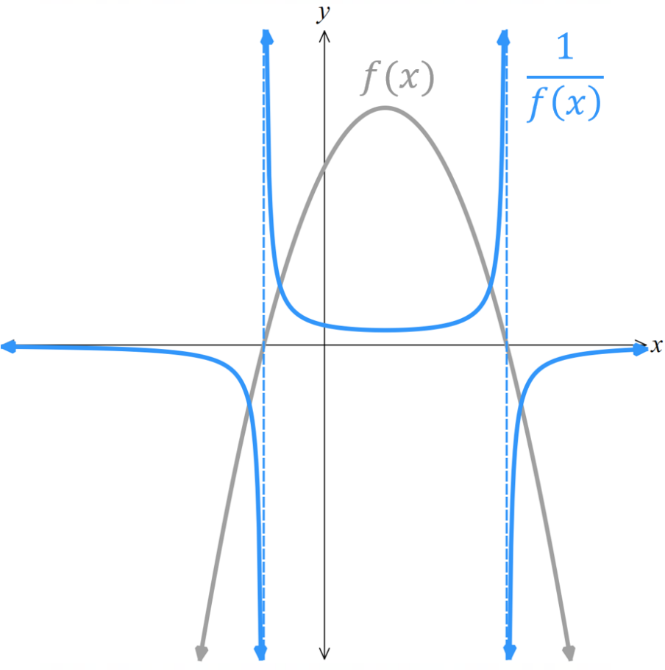 | 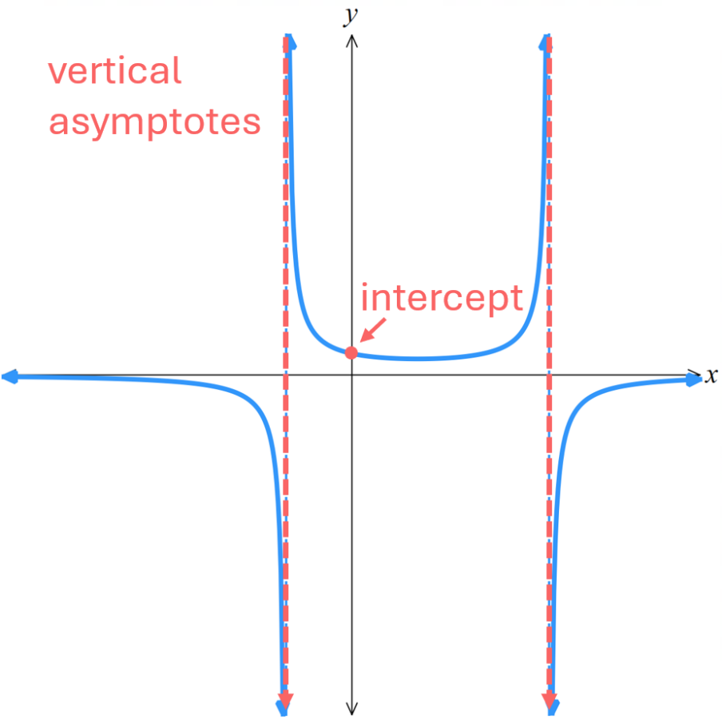
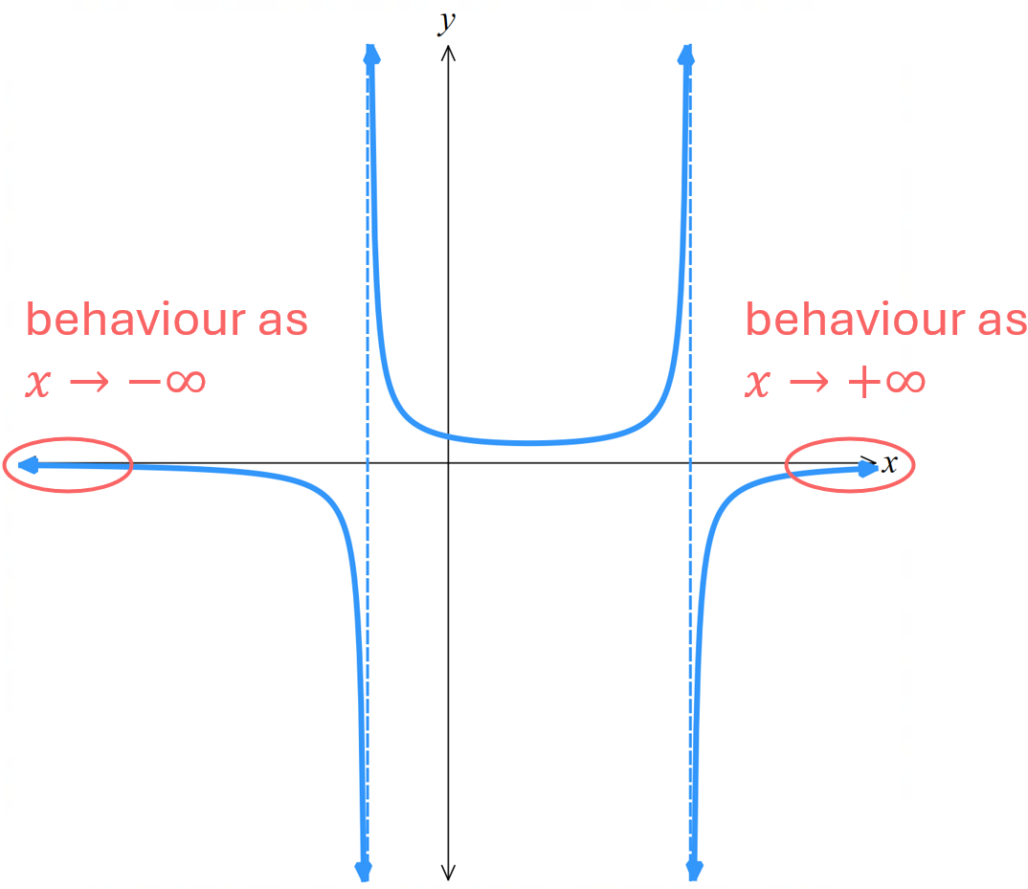 | 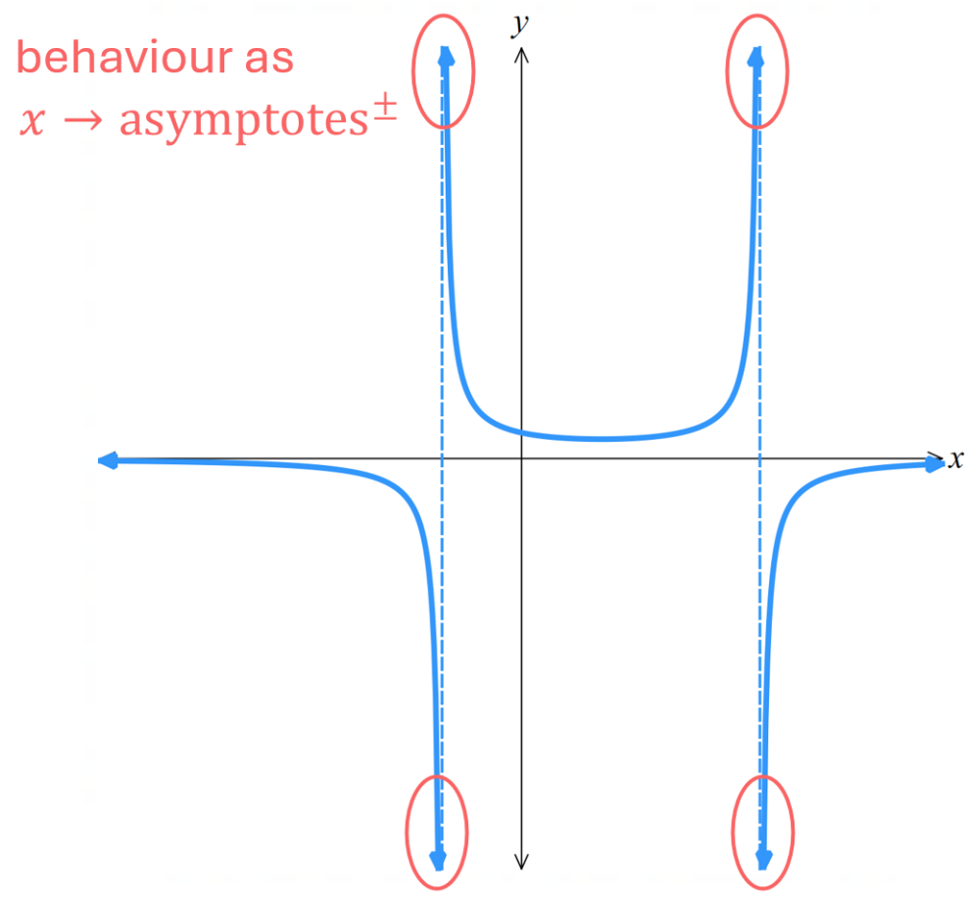

- Key Ideas for Sketching the Reciprocal of a Function
If $f\left(x\right)=0,$then $\frac{1}{f\left(x\right)}$ is a vertical asymptote.
If $f\left(x\right)→0$, then $\frac{1}{f\left(x\right)}$ $→∞$
If $f\left(x\right)→∞$, then $\frac{1}{f\left(x\right)}$ $→0$
If a point $\left(a,b\right)$ is given, then the new point is $\left(a,\frac{1}{b}\right)$

- Sketching the Reciprocal of a Function
The graph of $y=x-2$ is given.  Sketch $y=$ $\frac{1}{x-2}$  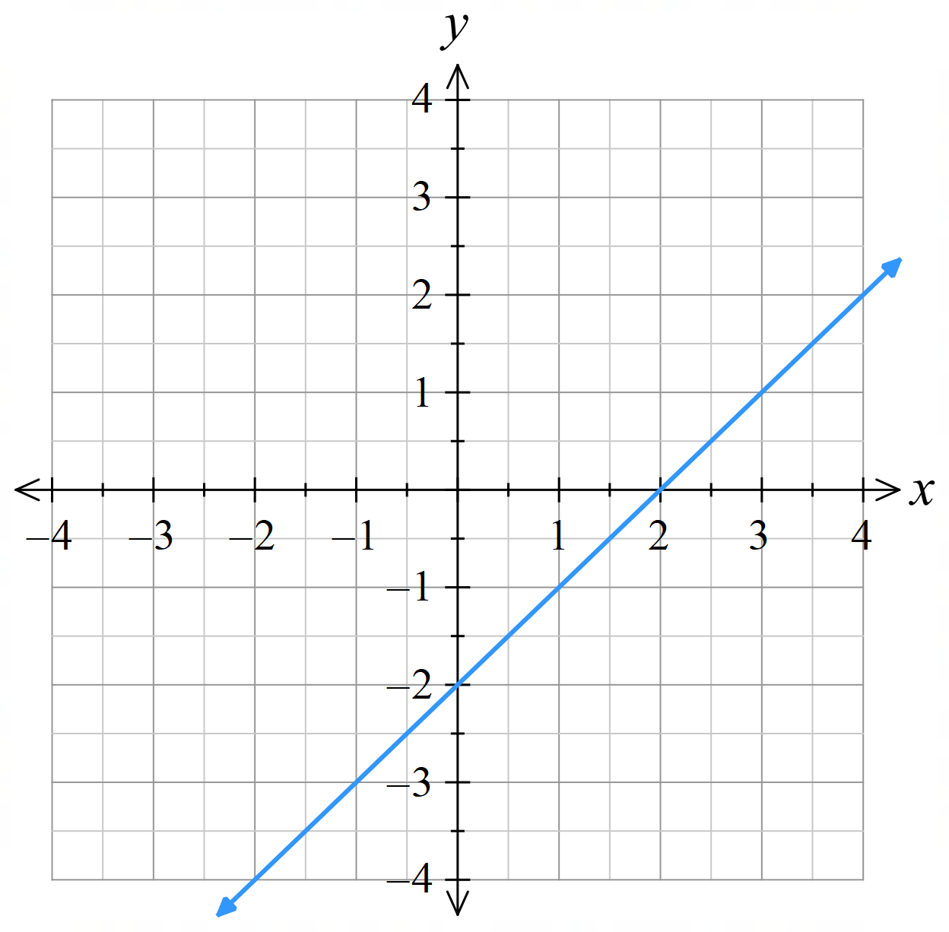 | The graph of $y=\left(x+1\right)\left(x-3\right)$ is given.  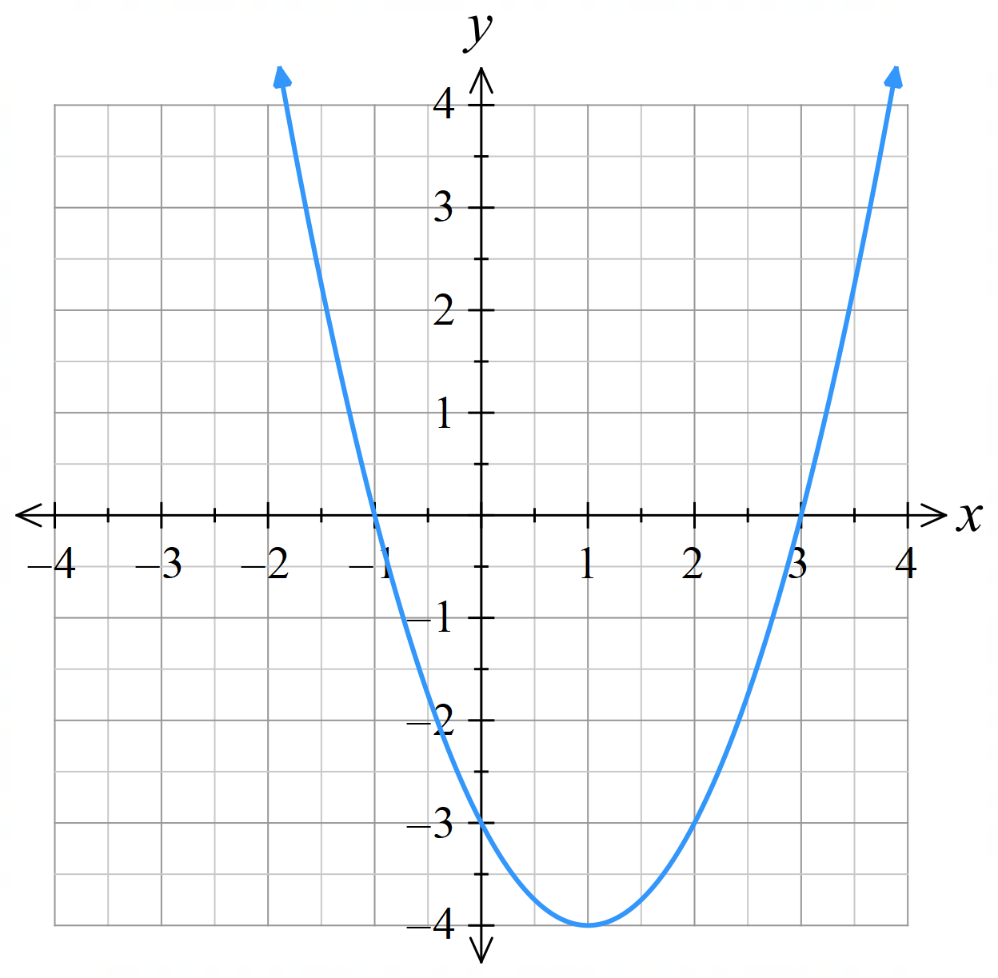  Sketch $y=$ $\frac{1}{\left(x+1\right)\left(x-3\right)}$

- Rules for Sketching the Reciprocal of a Function
Use these rules to sketch $y=$ $\frac{1}{f\left(x\right)}$ given only the graph of $y=f\left(x\right)$:
- New coordinates and sign.
If the graph of $y=f\left(x\right)$ has a point $\left(a,b\right)$, where $b≠0$, then $y=$ $\frac{1}{f\left(x\right)}$ has a point at $\left(a,\frac{1}{b}\right)$.
If $f\left(x\right)=1$, then $\frac{1}{f\left(x\right)}$ $=1$ as well.

- Vertical asymptotes and behaviour.
If $f\left(x\right)=0$, then $\frac{1}{f\left(x\right)}$ is a vertical asymptote.
If $f\left(x\right)$ is very small, then $\frac{1}{f\left(x\right)}$ is very large.
If $f\left(x\right)→0^{-}$, then $\frac{1}{f\left(x\right)}$ $→-∞$
If $f\left(x\right)→0^{+}$, then $\frac{1}{f\left(x\right)}$ $→+∞$

- Horizontal asymptotes and behaviour.
If $f\left(x\right)$ is very large, then $\frac{1}{f\left(x\right)}$ is very small.
If $f\left(x\right)→+∞$, then $\frac{1}{f\left(x\right)}$ $→0^{+}$ (horizontal asymptote)
If $f\left(x\right)→-∞$, then $\frac{1}{f\left(x\right)}$ $→0^{-}$ (horizontal asymptote)

If $f\left(x\right)$ has an existing horizontal asymptote $f\left(x\right)→c$, then $\frac{1}{f\left(x\right)}$ $→$ $\frac{1}{c}$

- Turning points:
If $f\left(x\right)$ has a turning point at $\left(a,b\right)$, then $\frac{1}{f\left(x\right)}$ has a turning point at $\left(a,\frac{1}{b}\right)$.

- Gradient:
If $f\left(x\right)$ is increasing, then $\frac{1}{f\left(x\right)}$ is decreasing.
If $f\left(x\right)$ is decreasing, then $\frac{1}{f\left(x\right)}$ is increasing.

- Example Sketch a function $\frac{1}{f\left(x\right)}$, given the graph of $f\left(x\right)$.
$y=f\left(x\right)$ is given. Sketch $y=$ $\frac{1}{f\left(x\right)}$.
1. Vertical asymptotes & behaviour
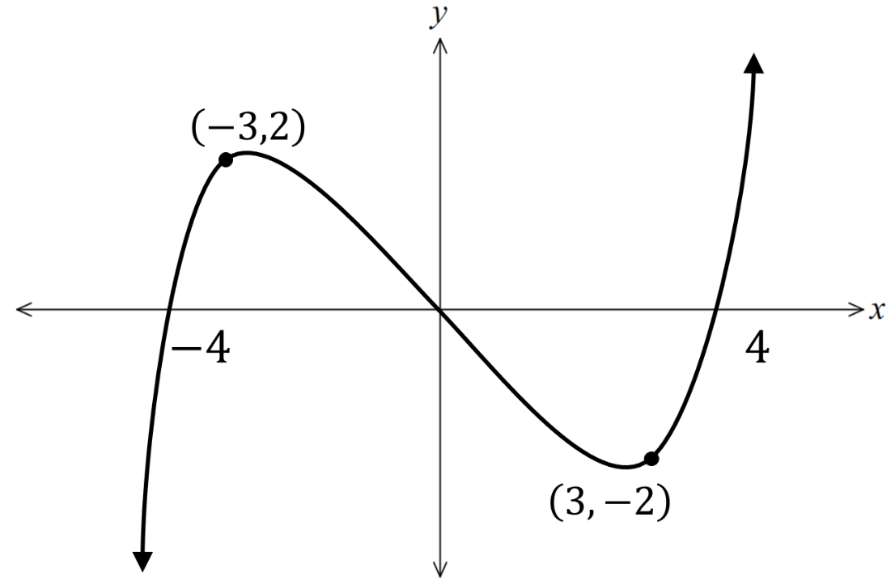
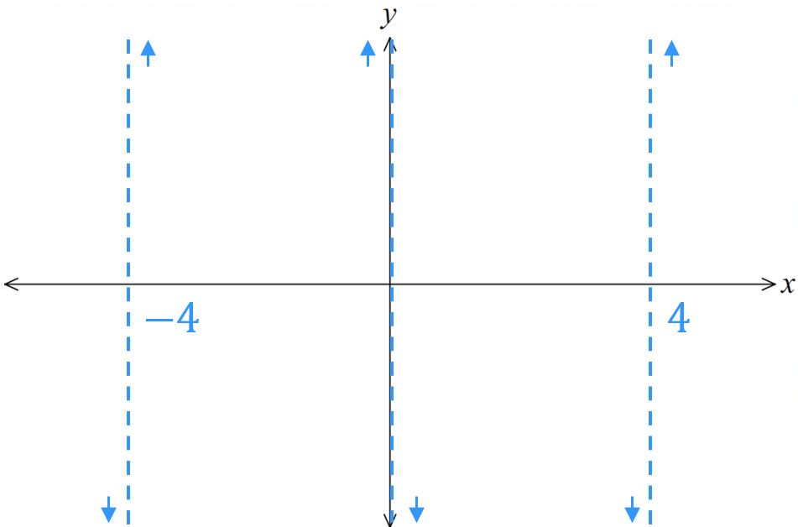

2. Horizontal asymptotes & behaviour 3. Turning points
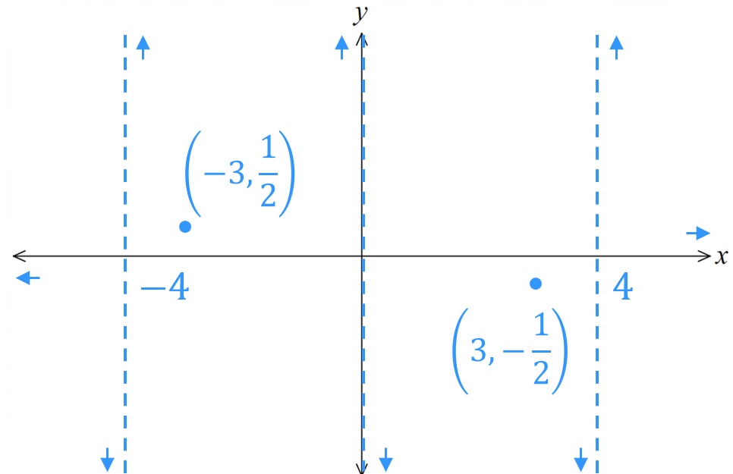
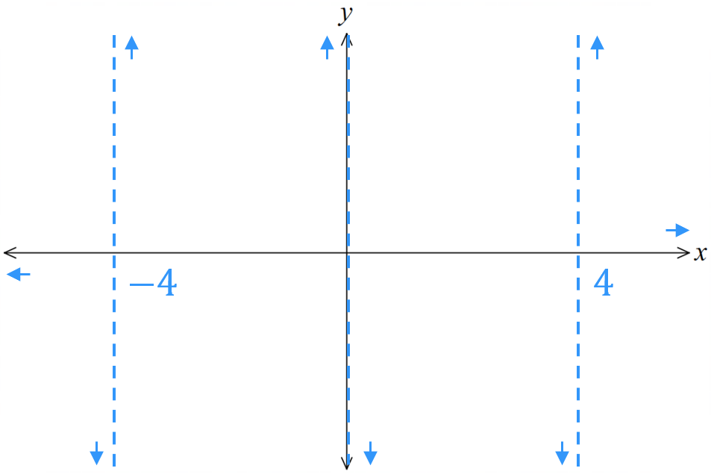

4. Gradient
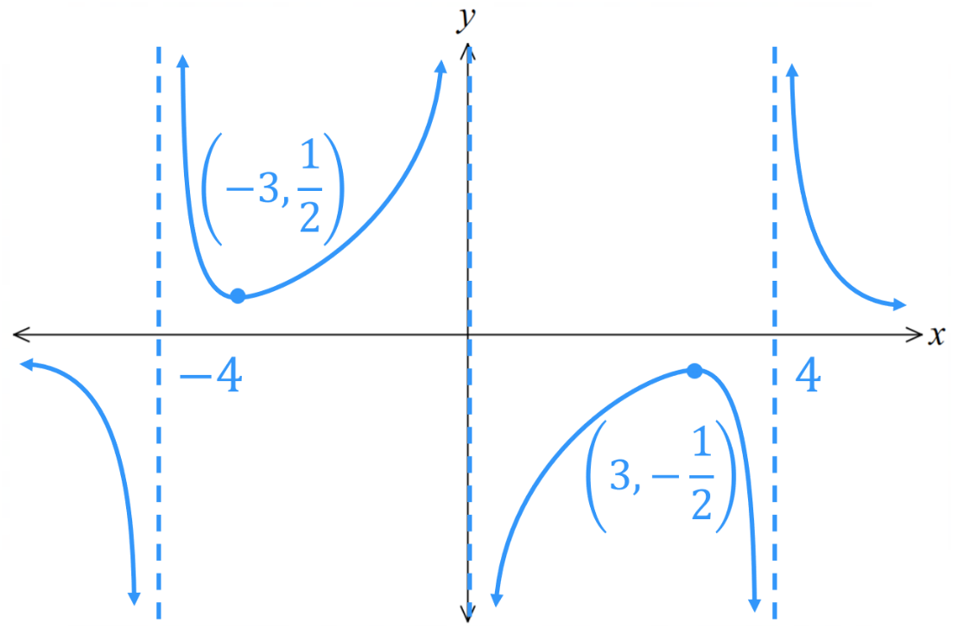

- Guided Practice
$y=f\left(x\right)$ is given. Sketch $y=$ $\frac{1}{f\left(x\right)}$ on the same axis.
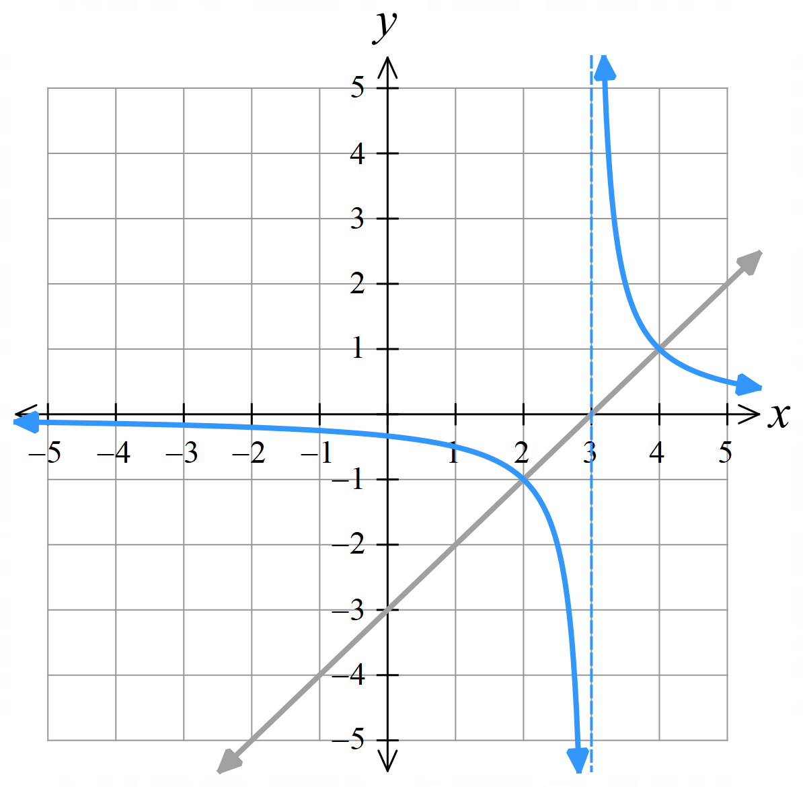  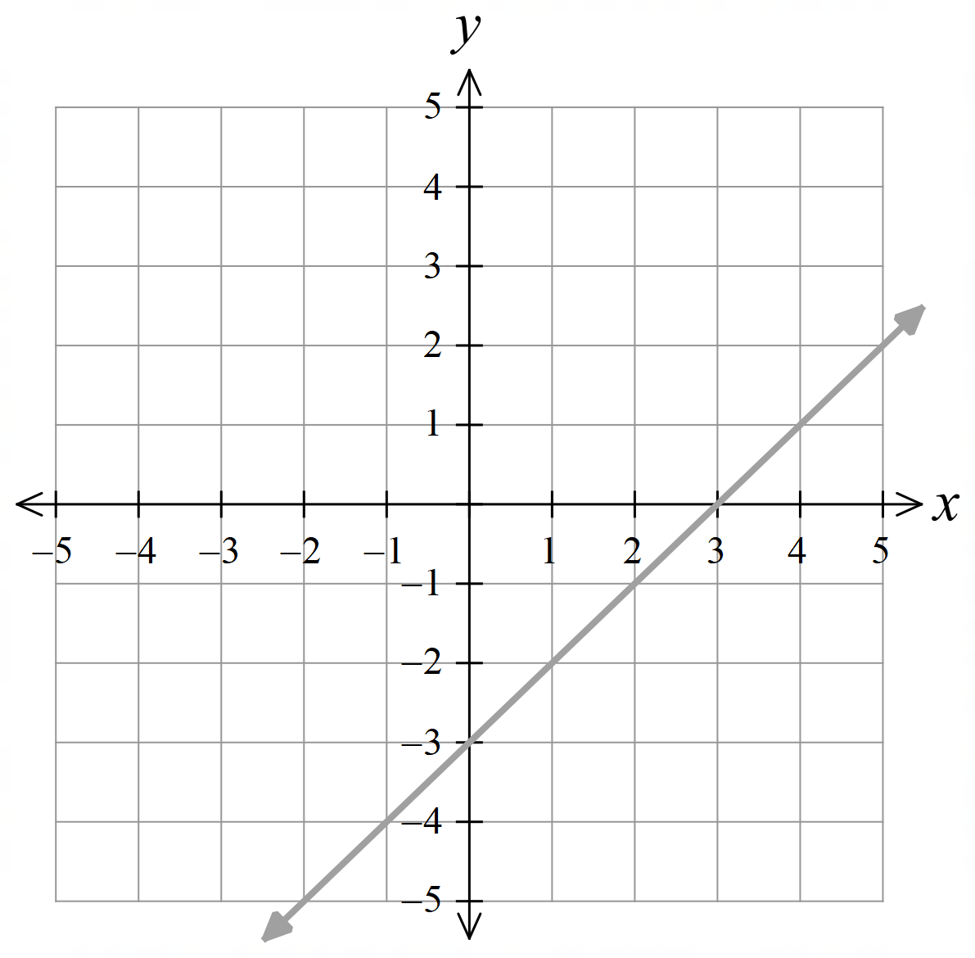 | 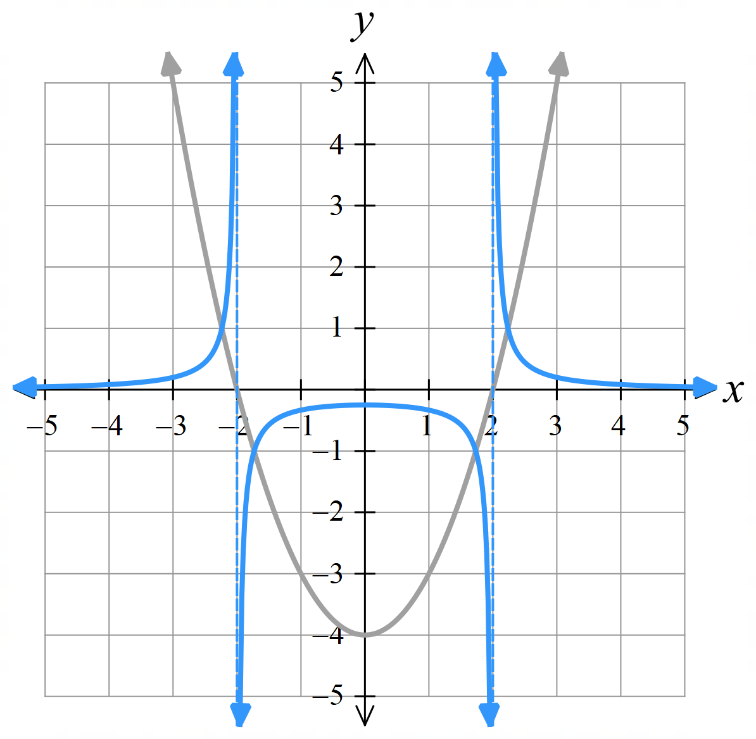  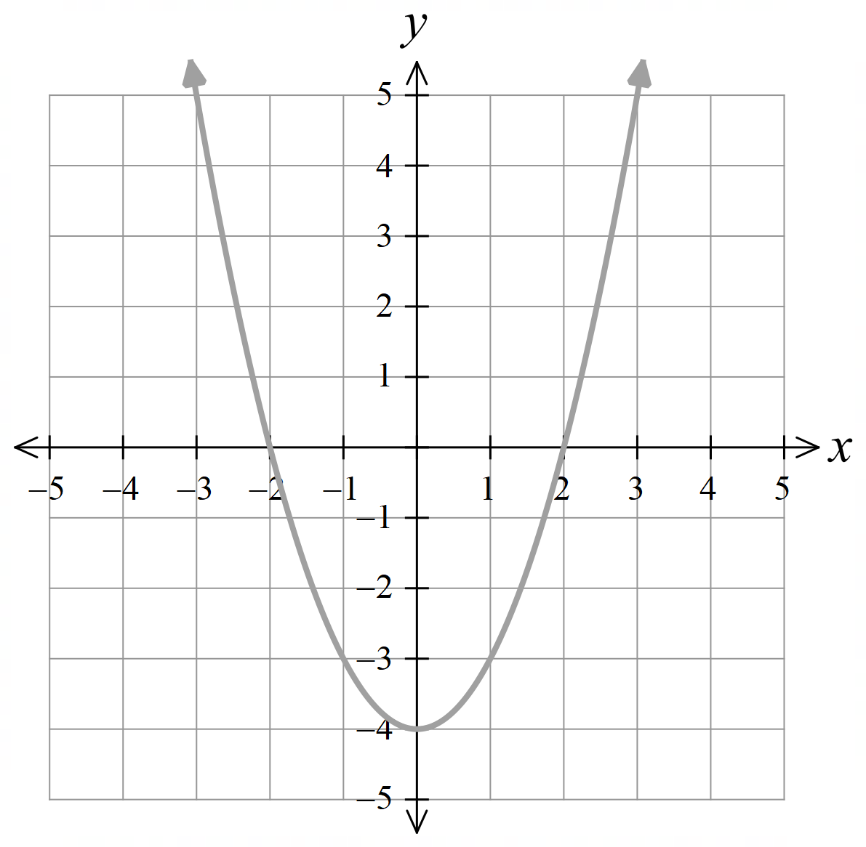
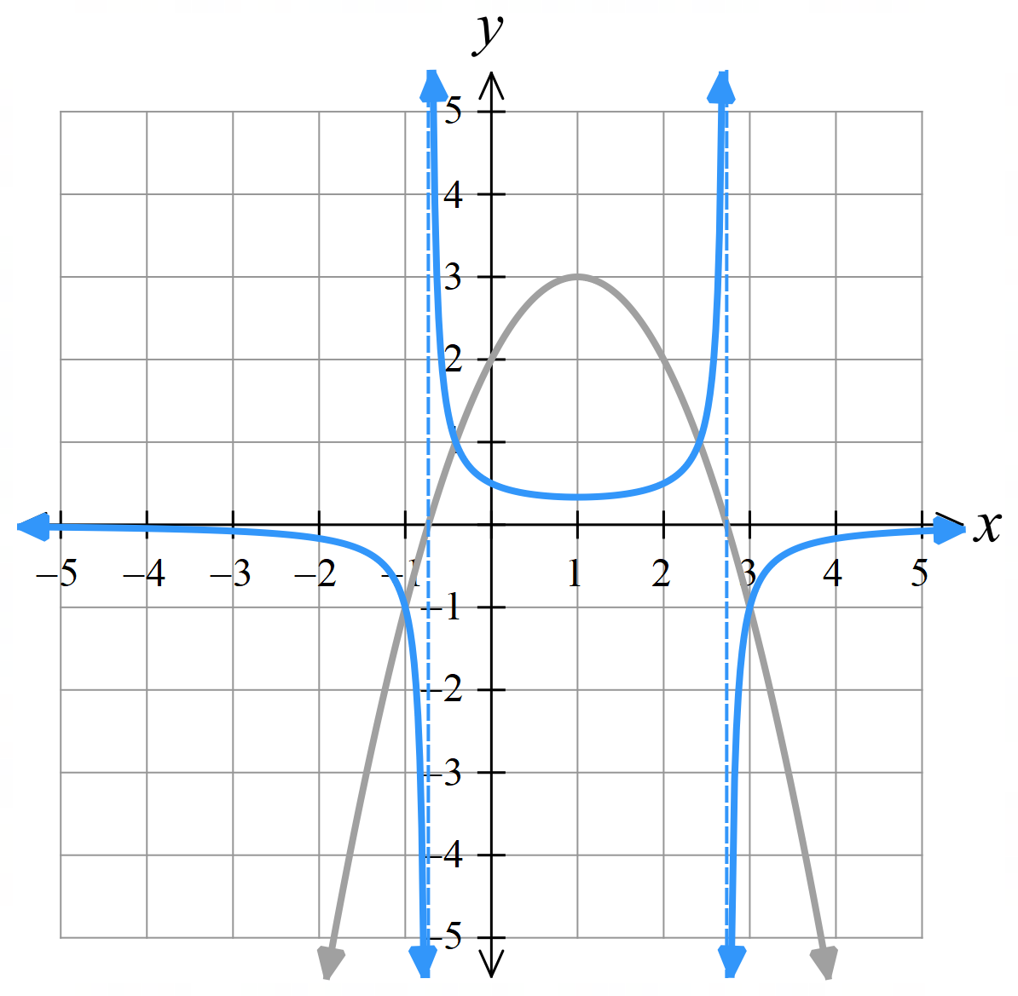  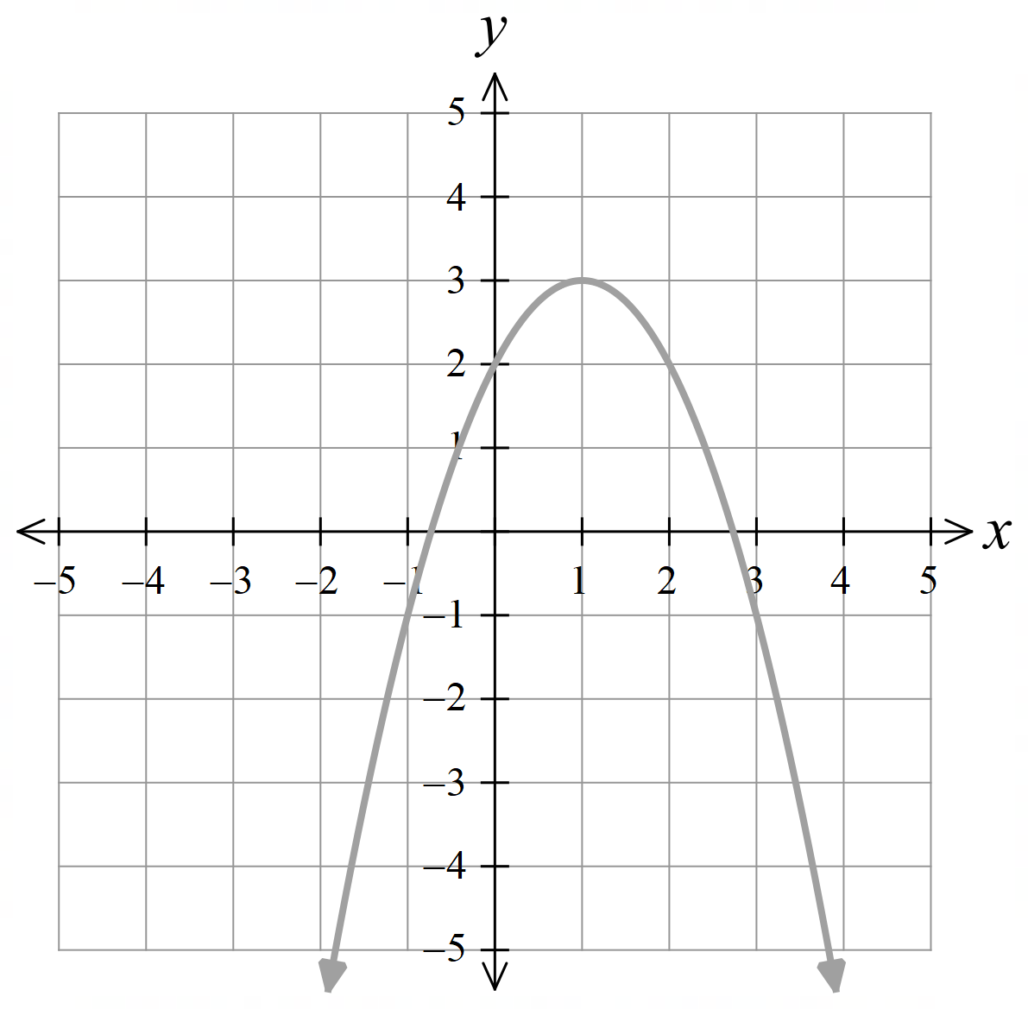 | 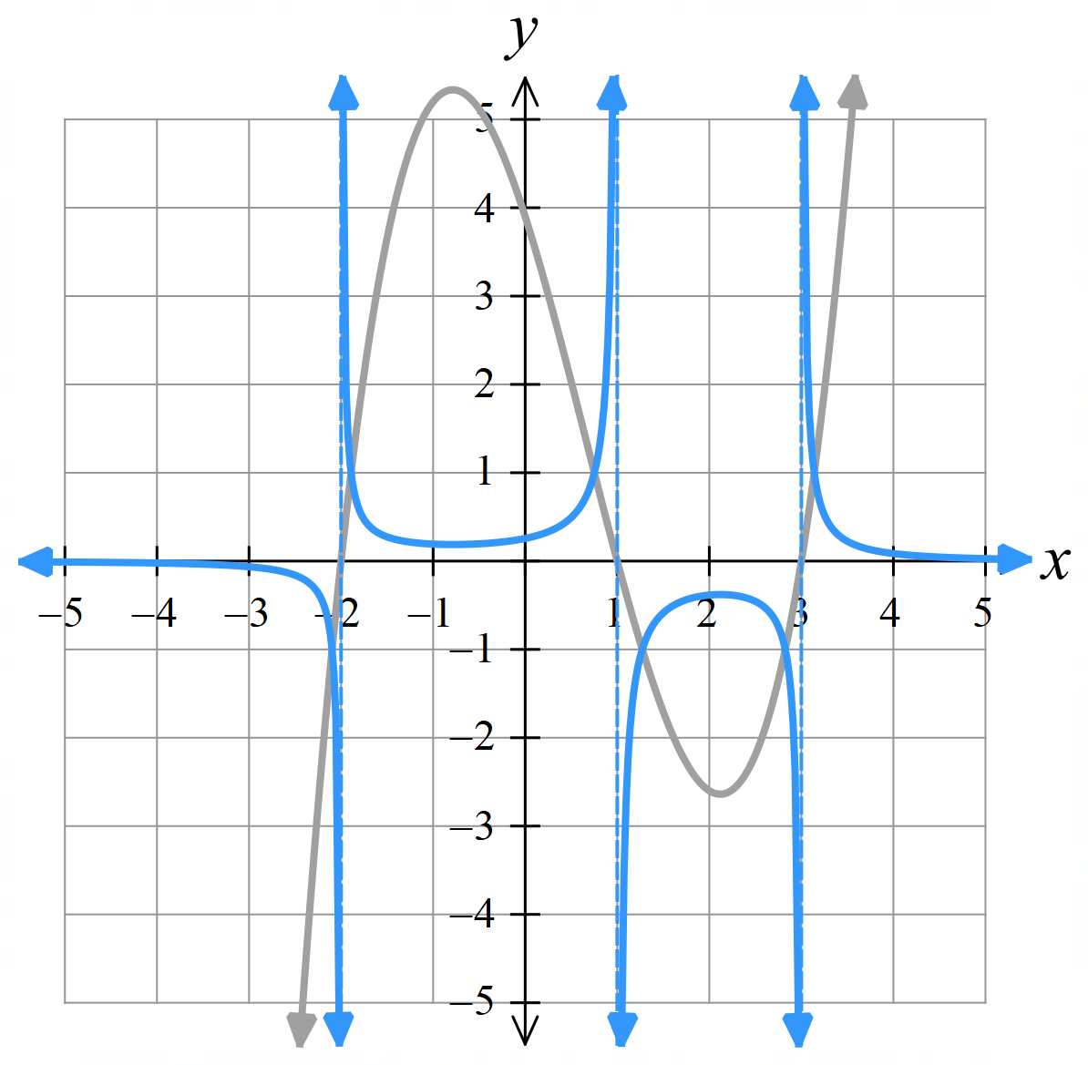  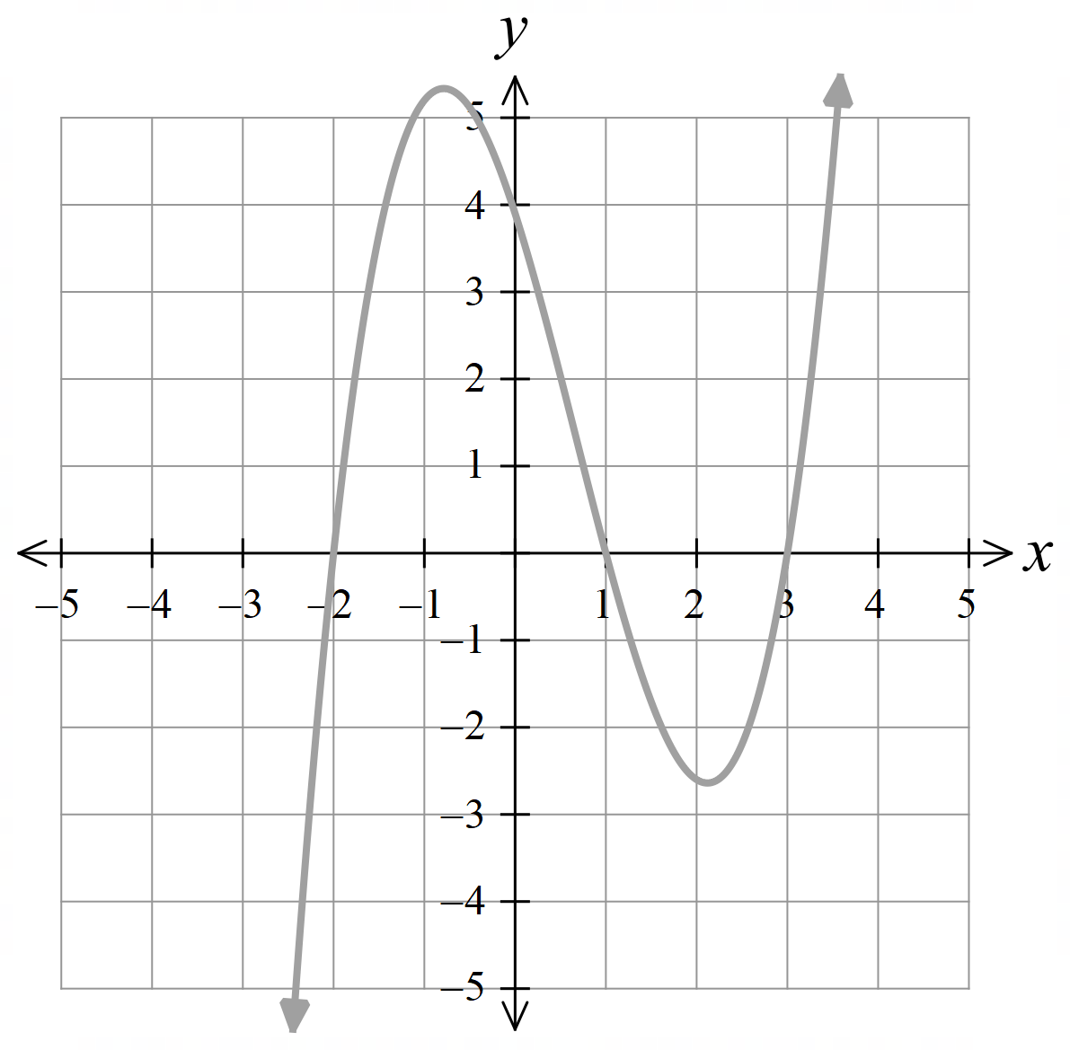

Foundation
- For each $f\left(x\right)$ given, sketch $\frac{1}{f\left(x\right)}$ on the same axis.
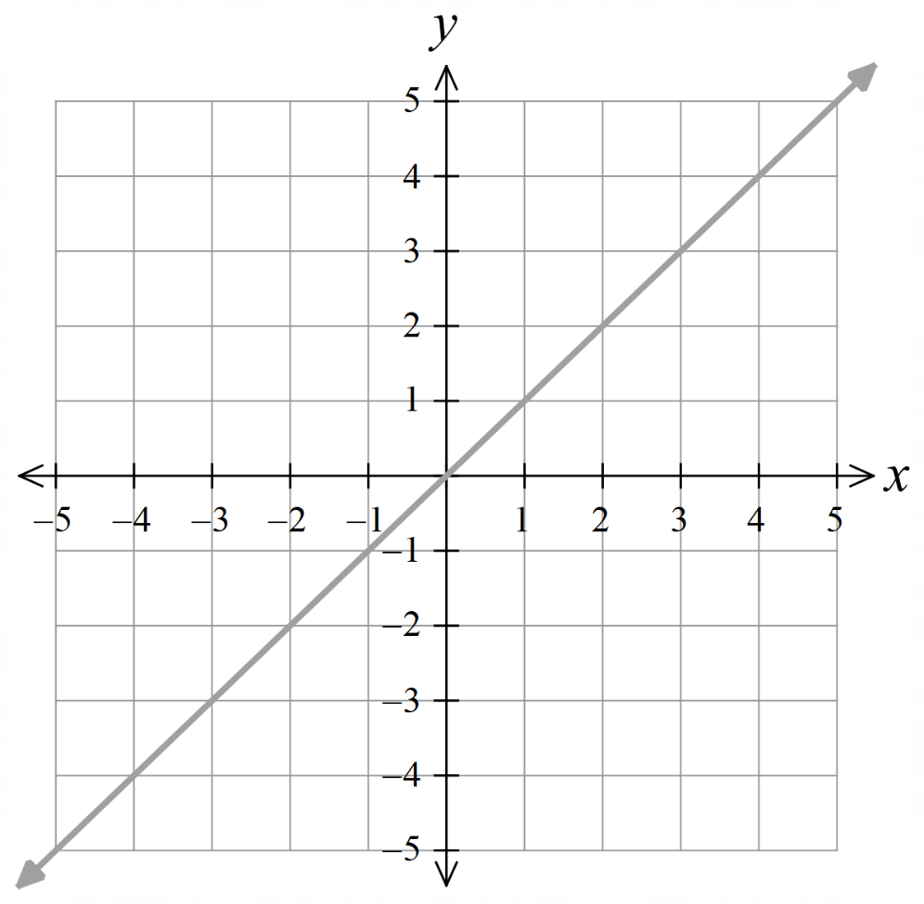 | 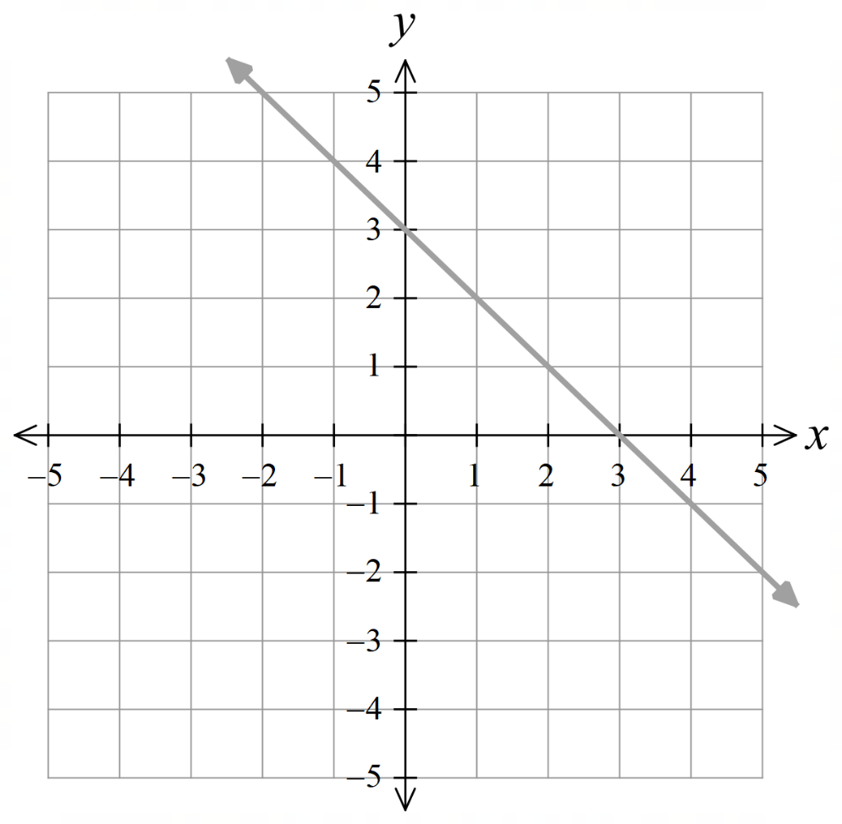  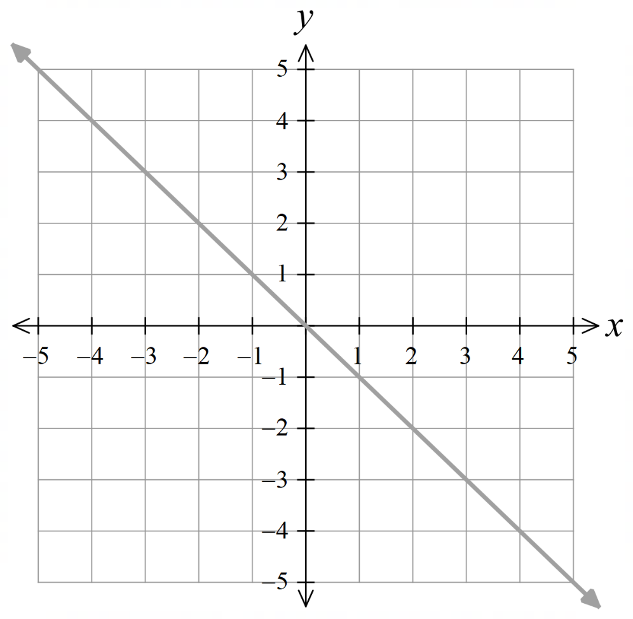  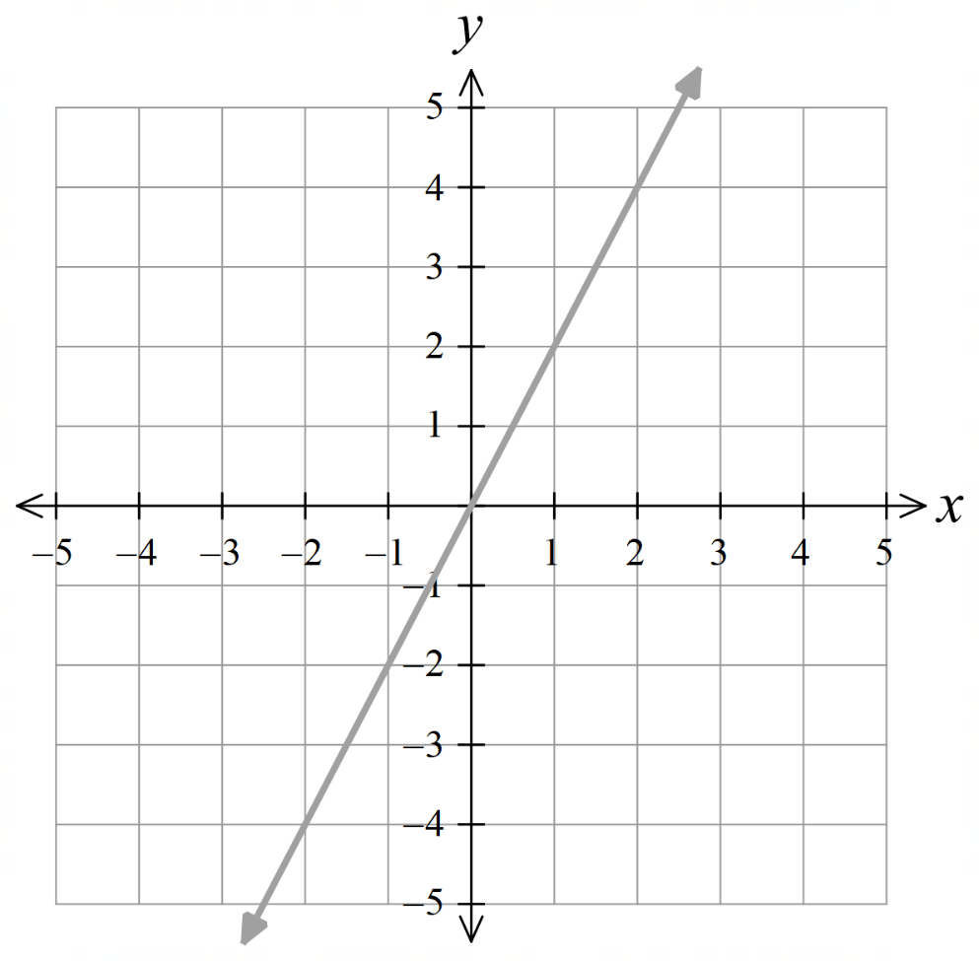  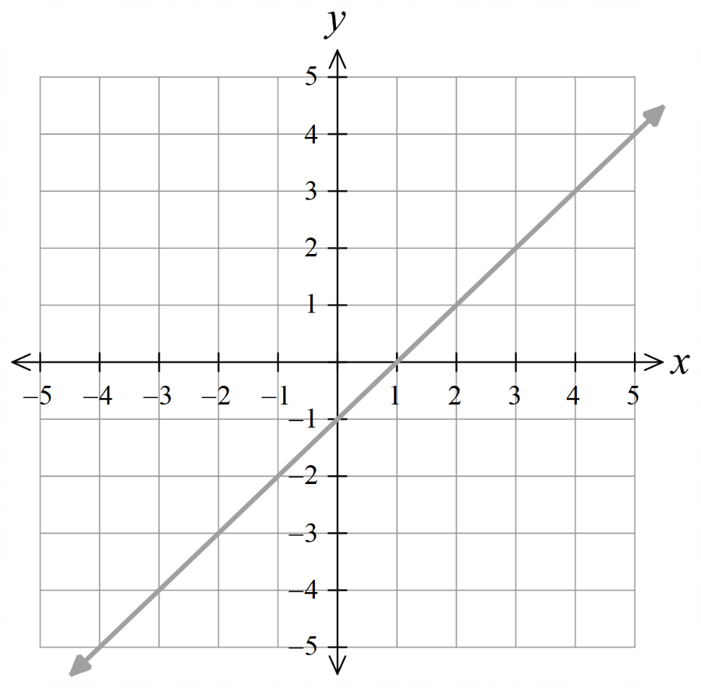  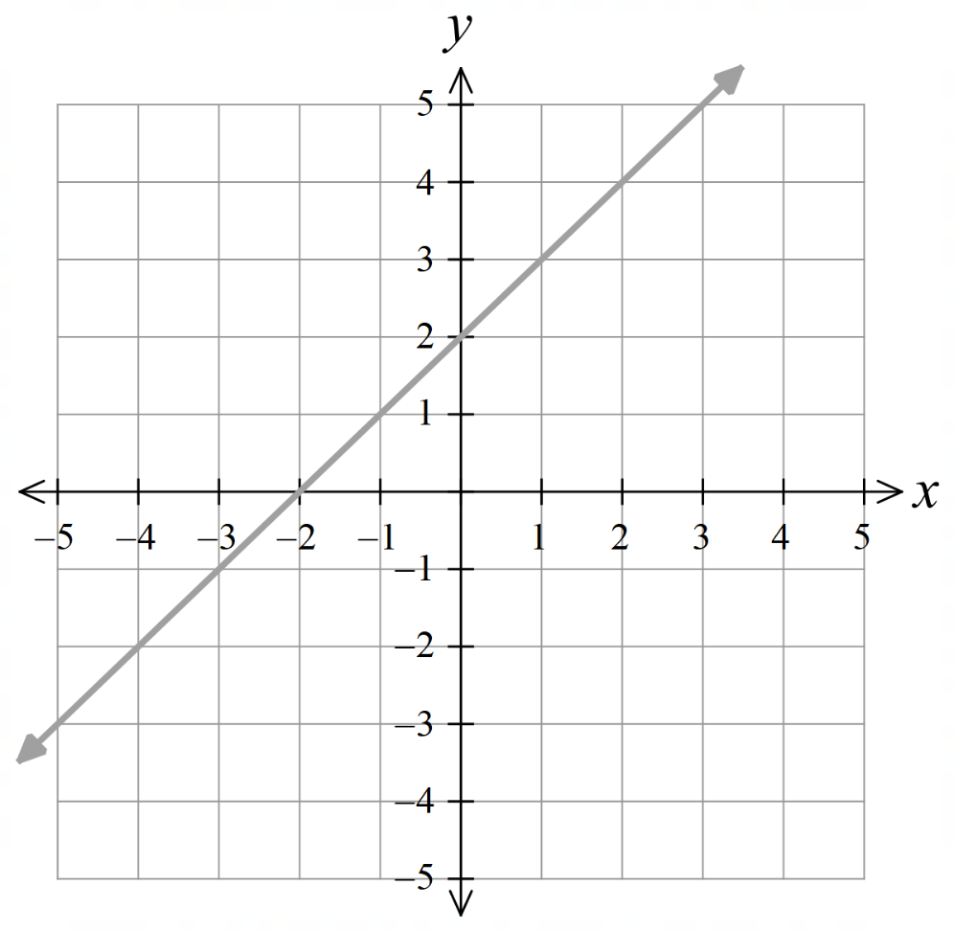  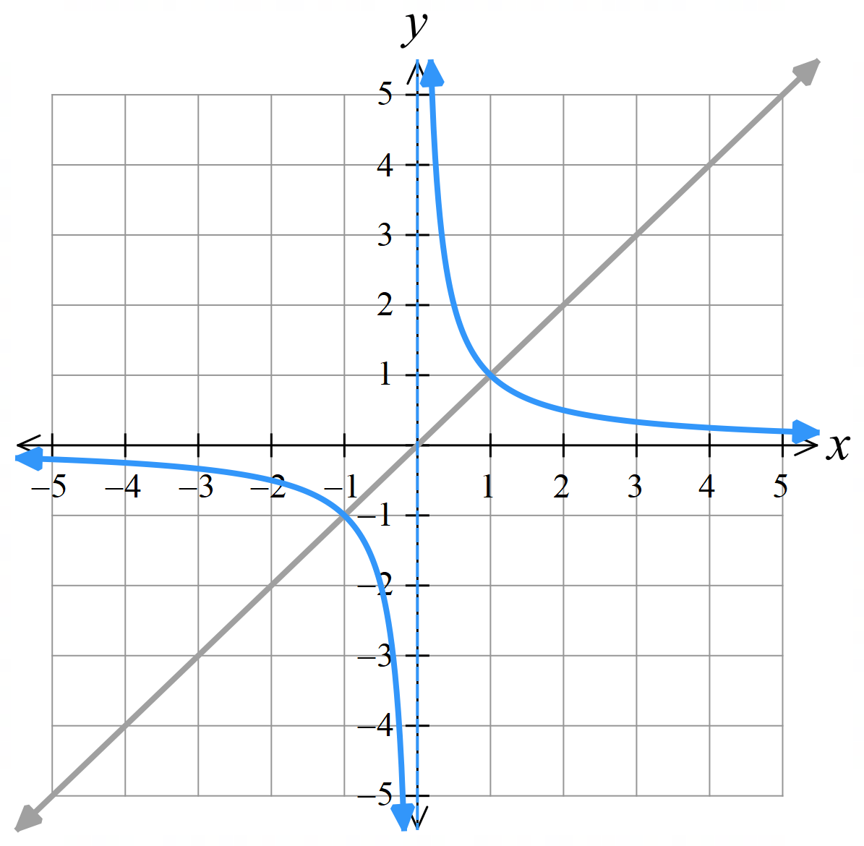  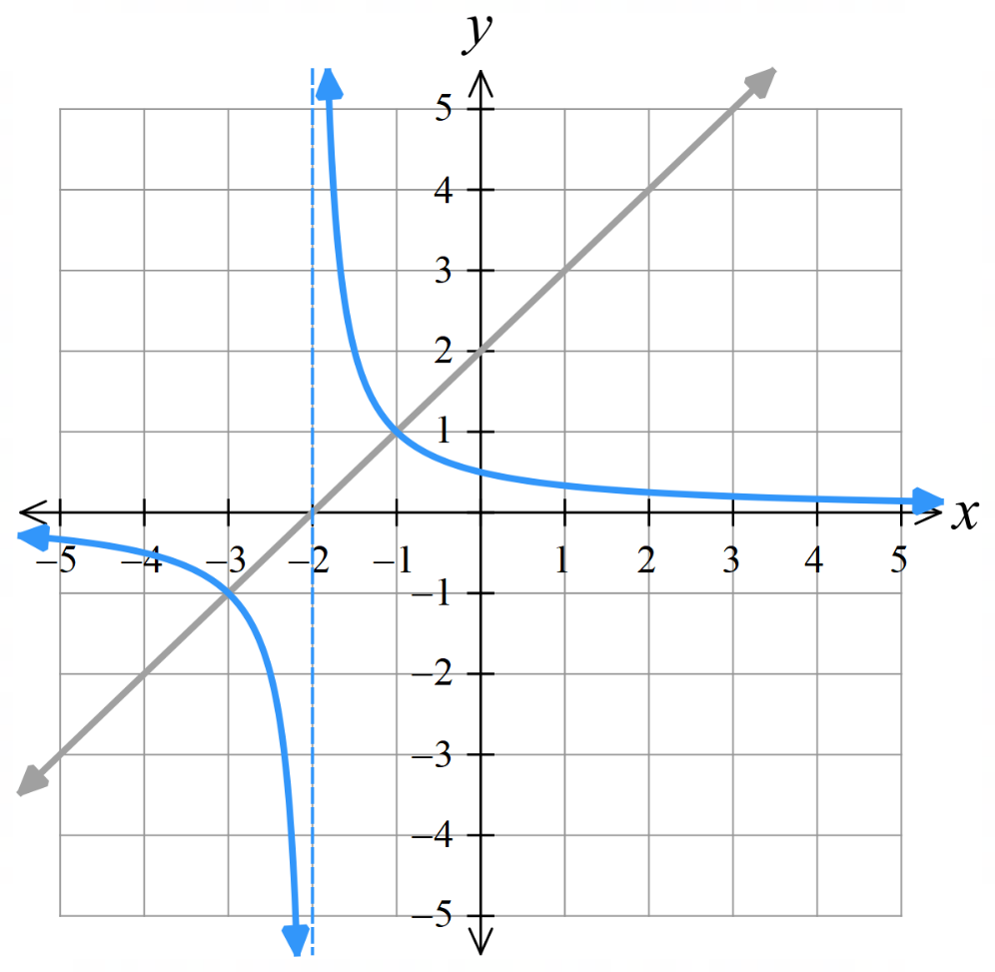  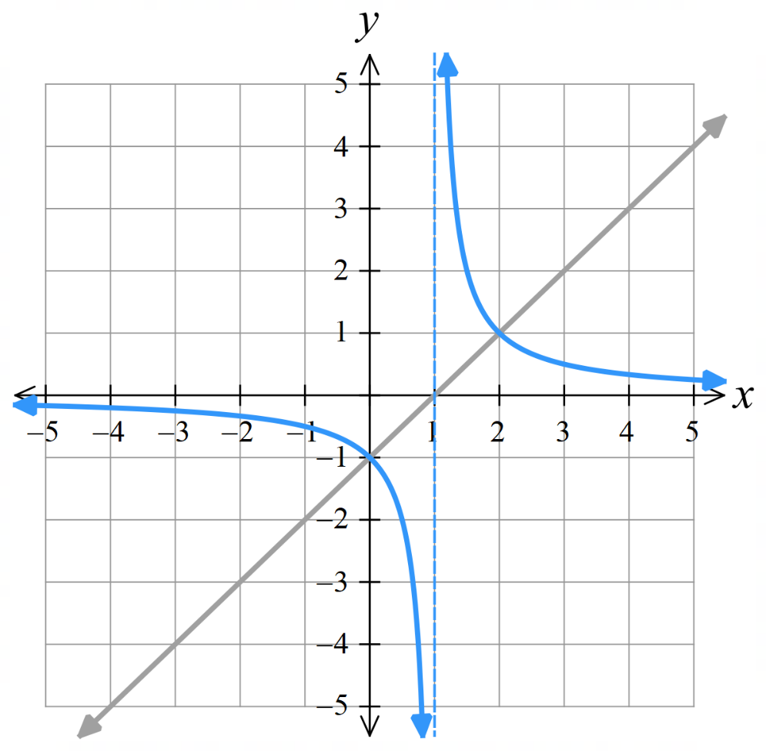  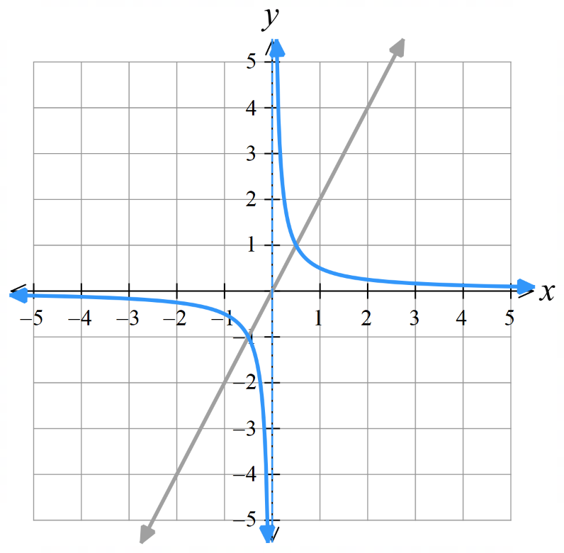  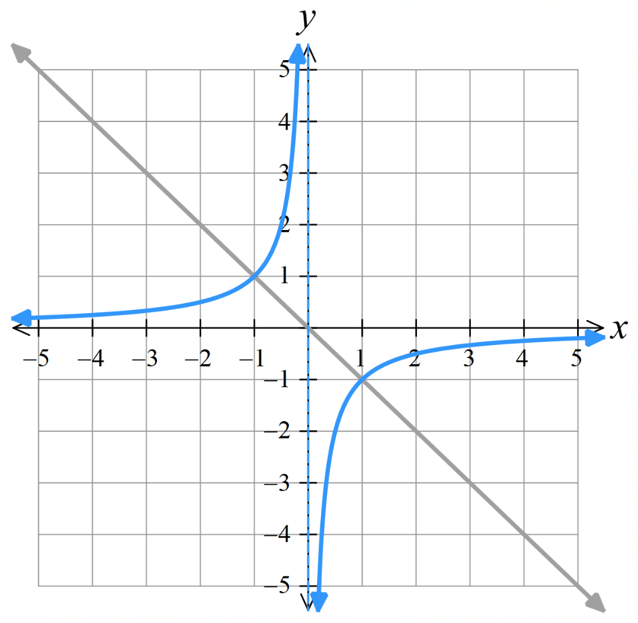  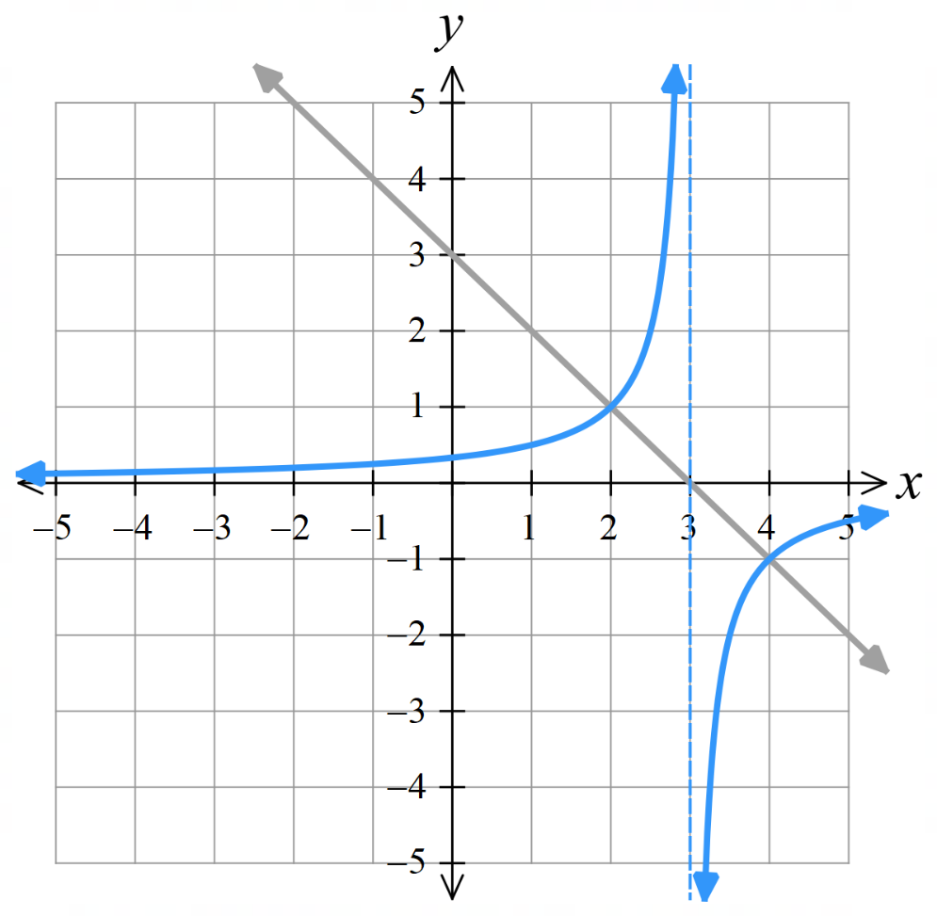
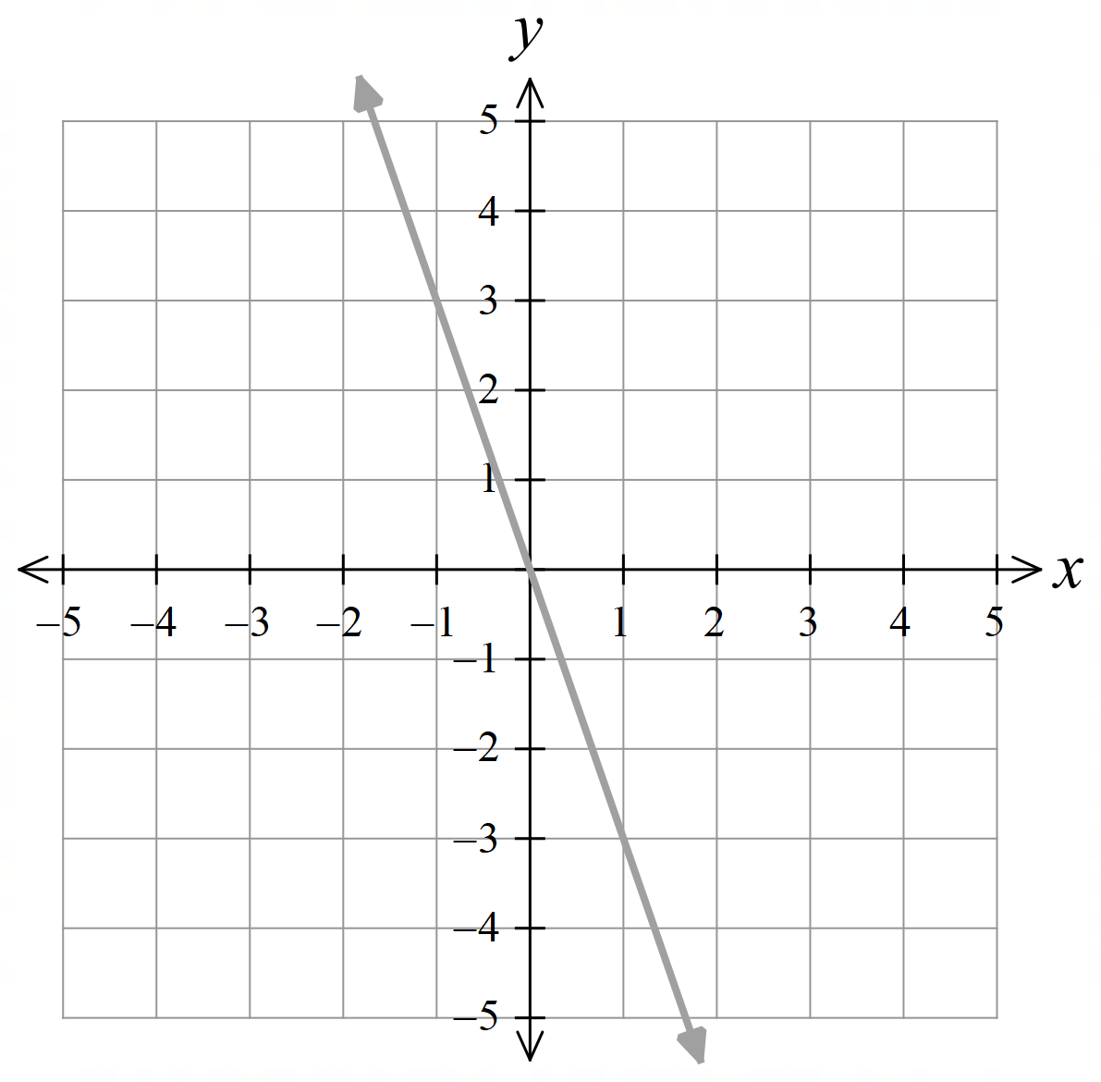  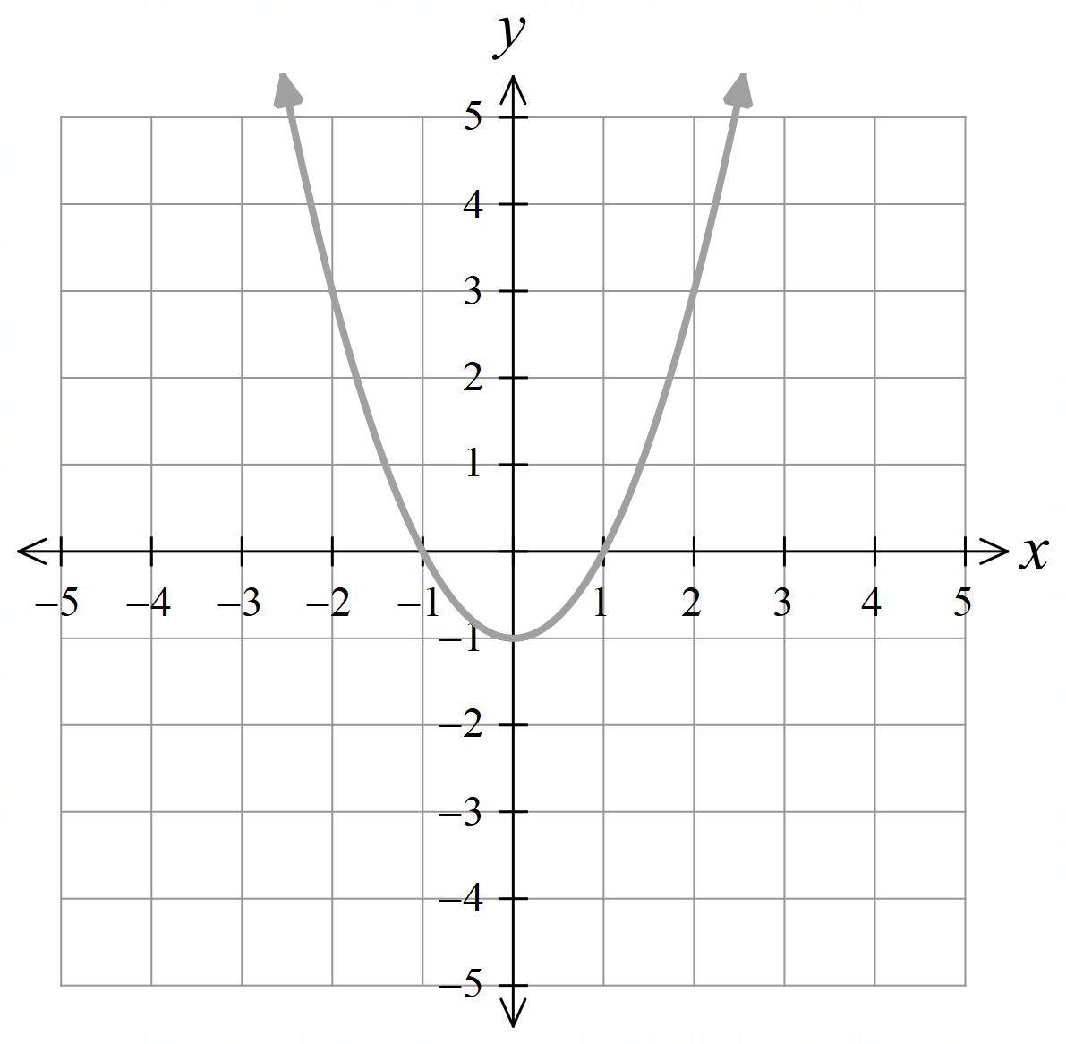  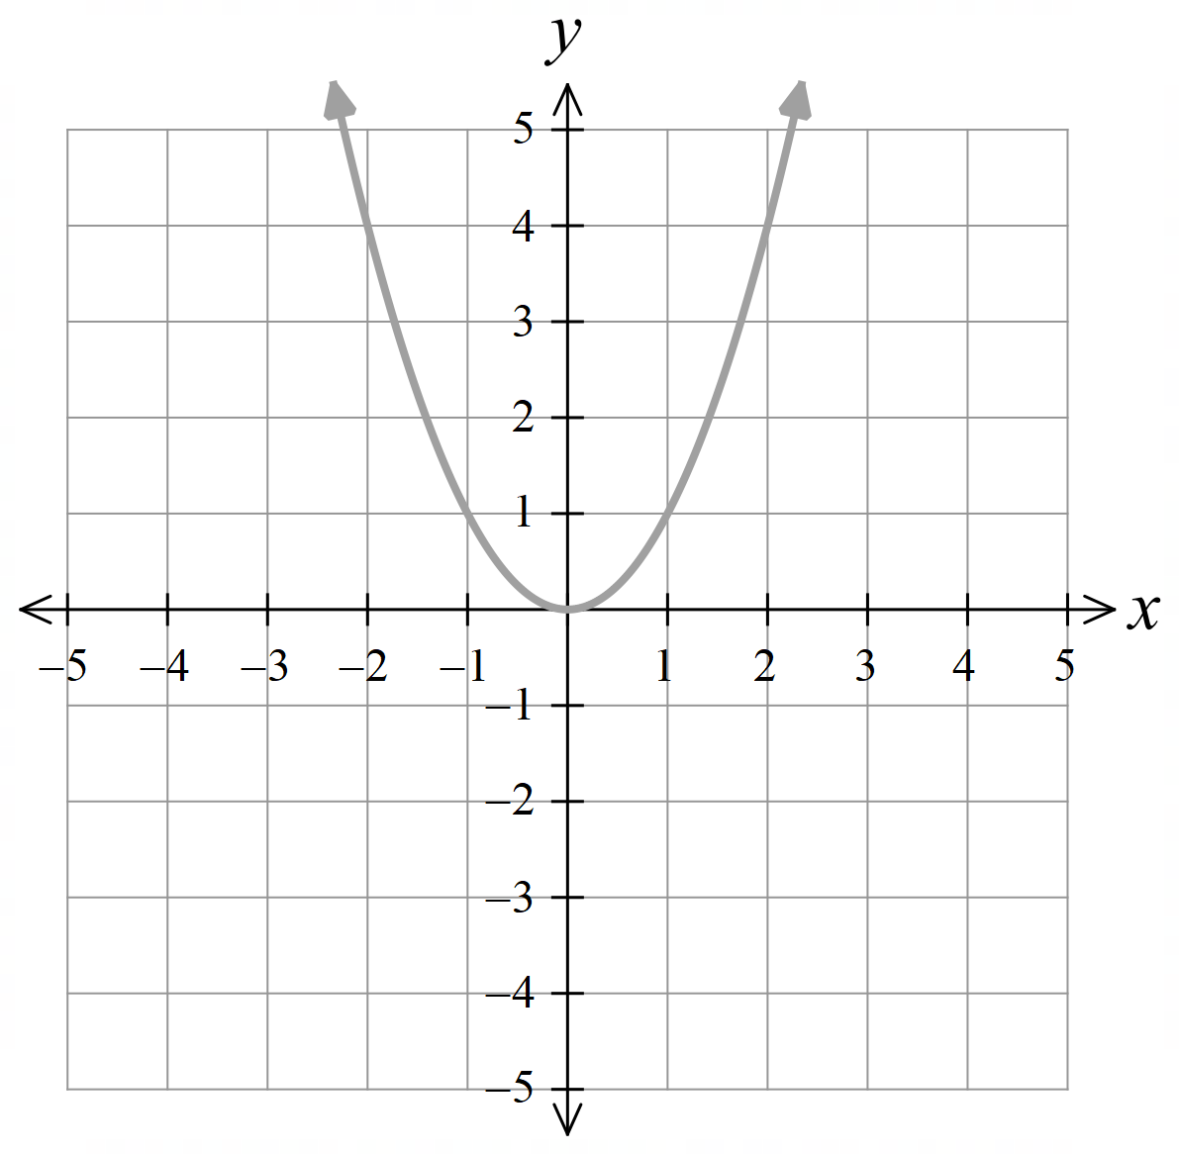 | 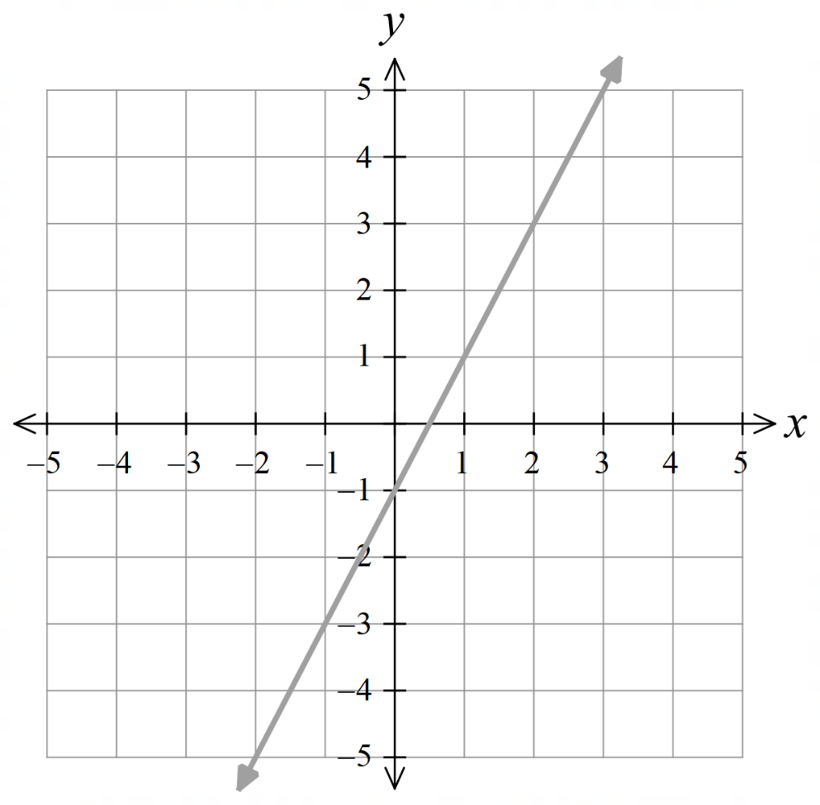  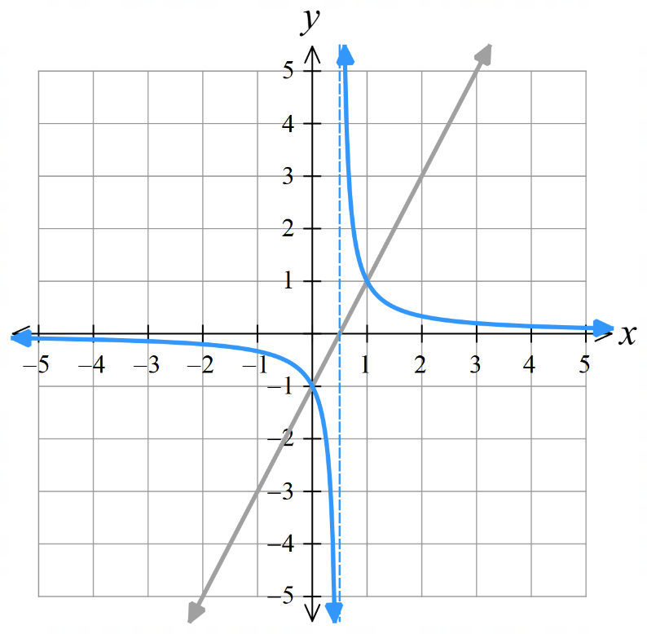  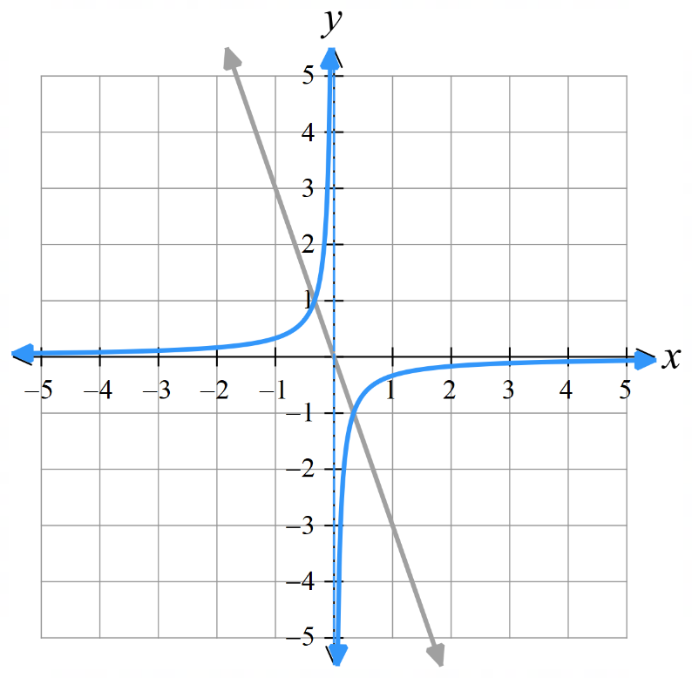  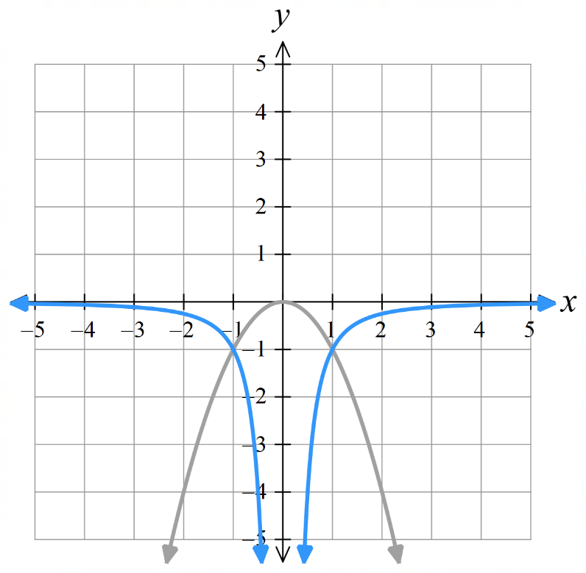  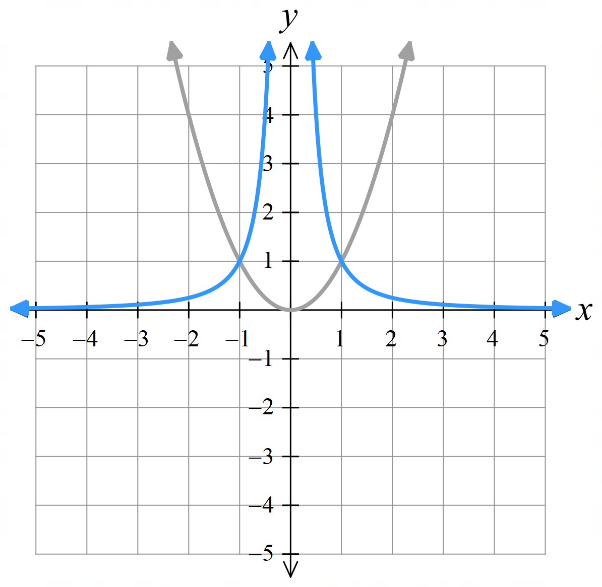  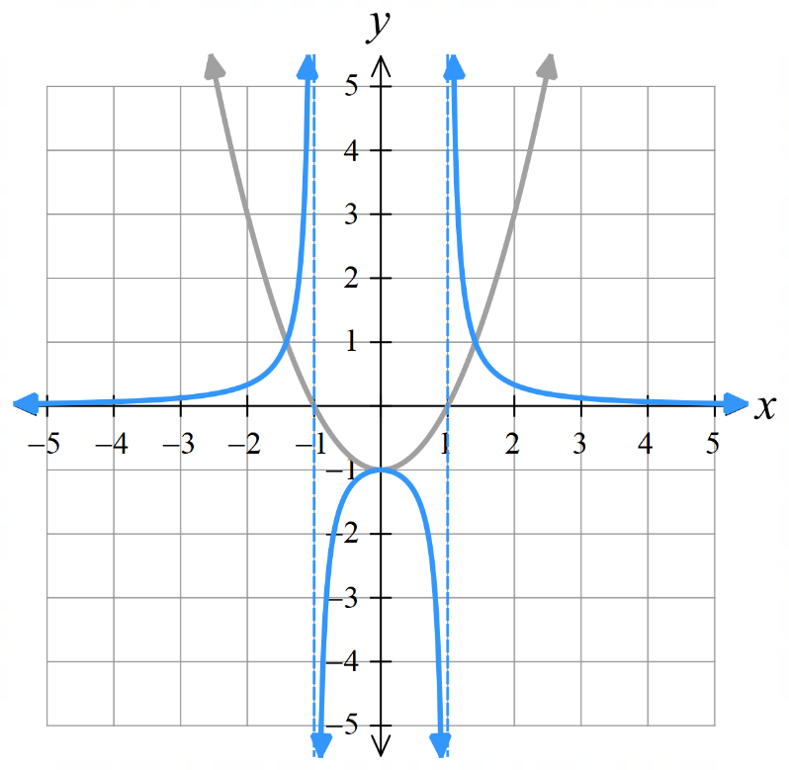  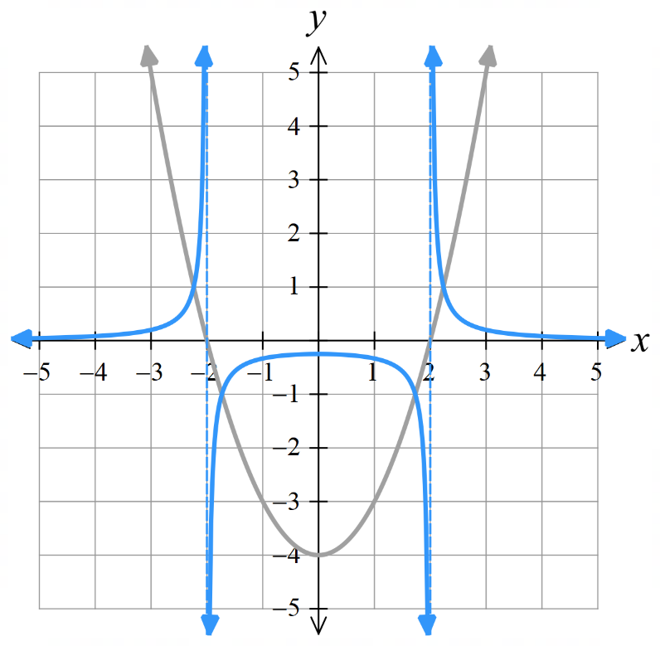
 | 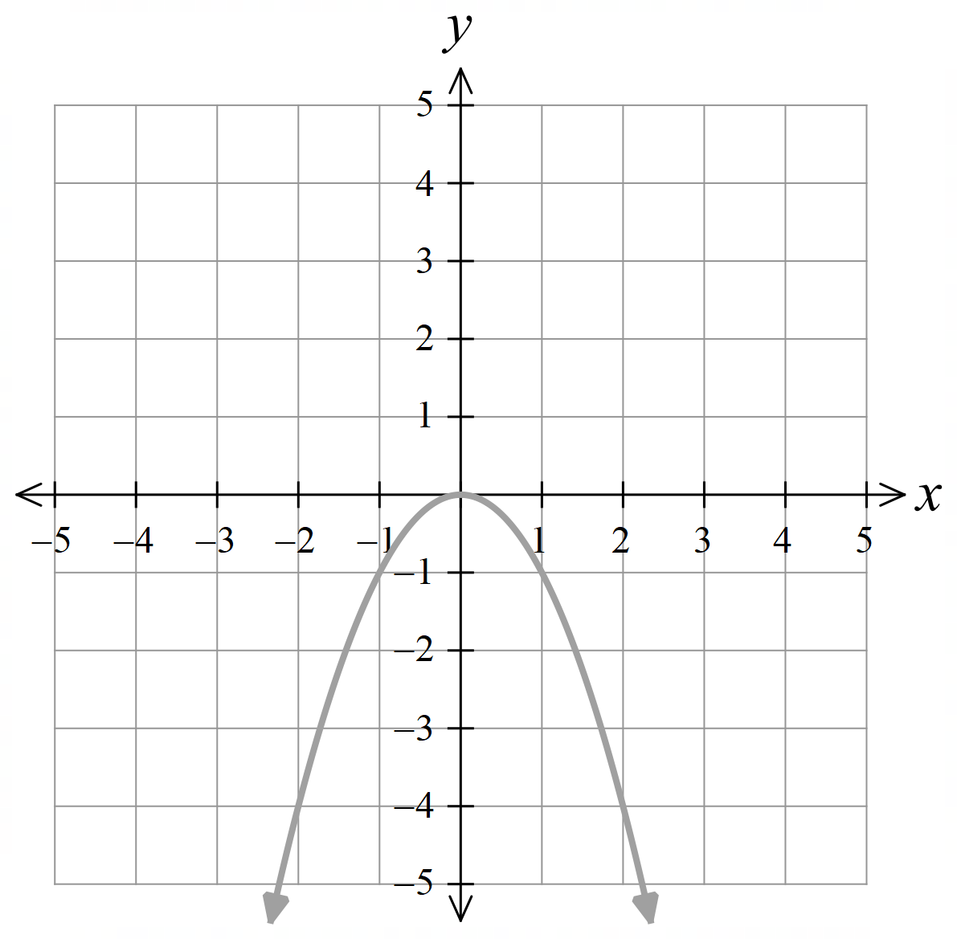
 | 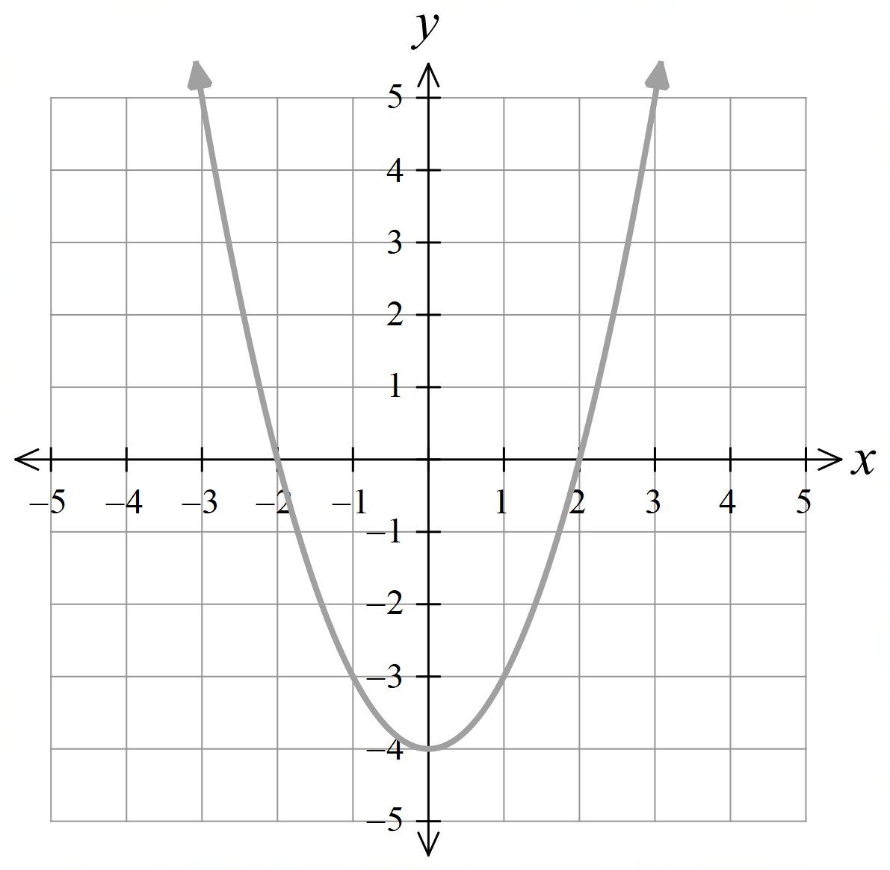
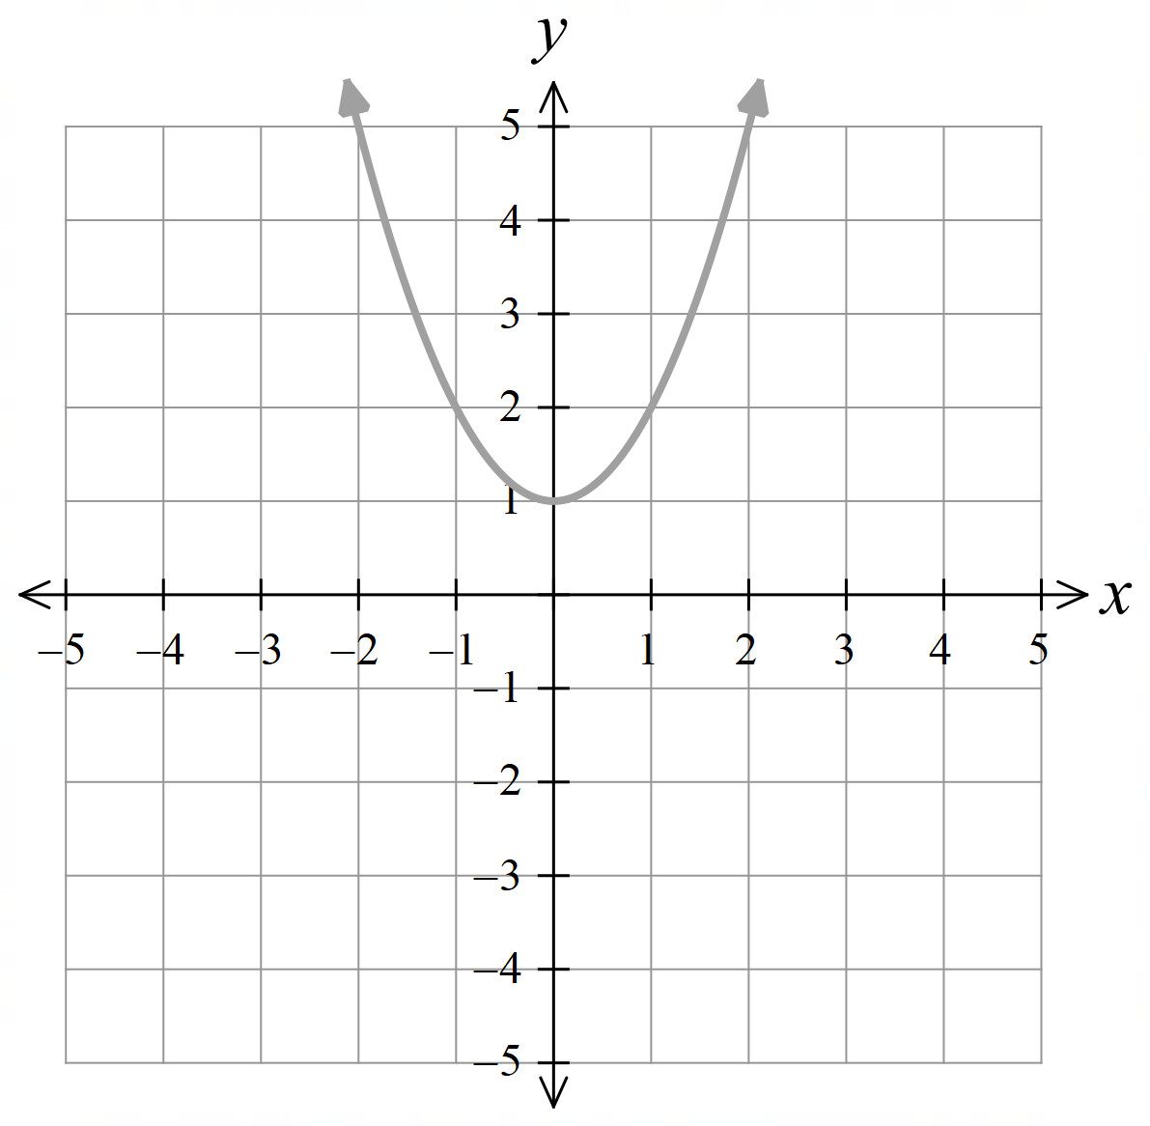  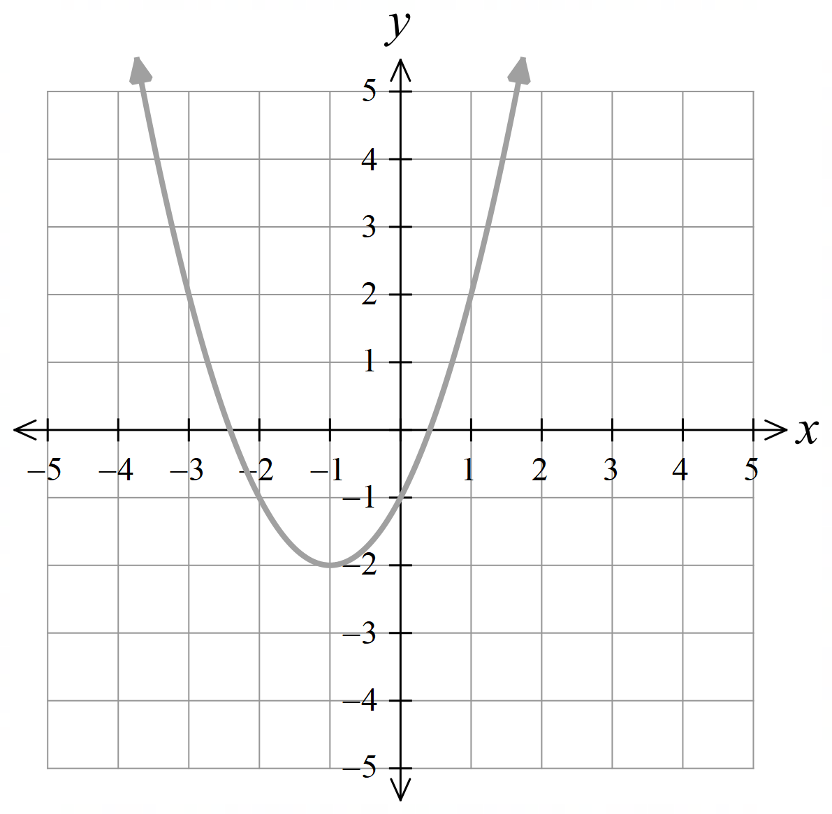  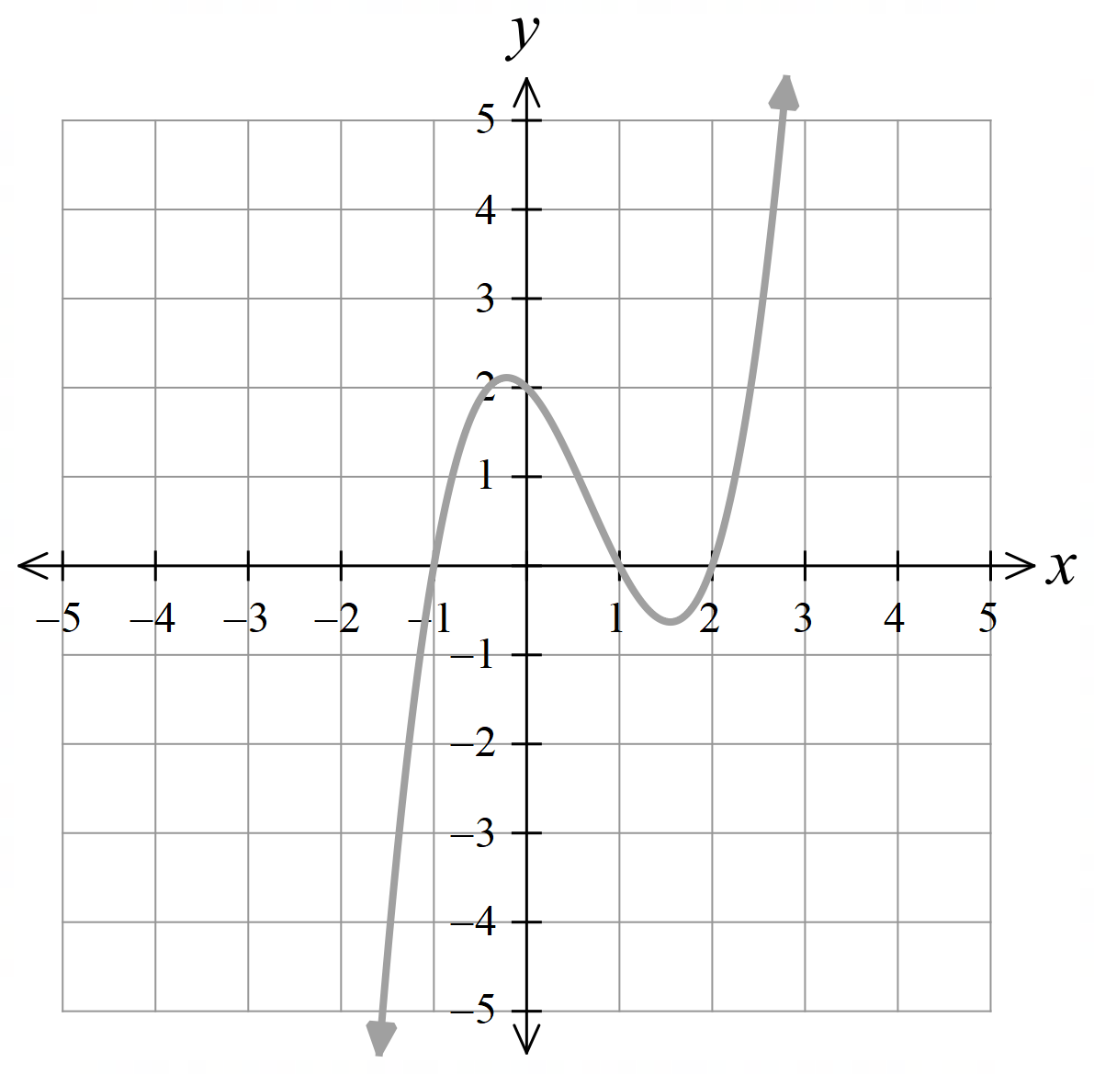 | 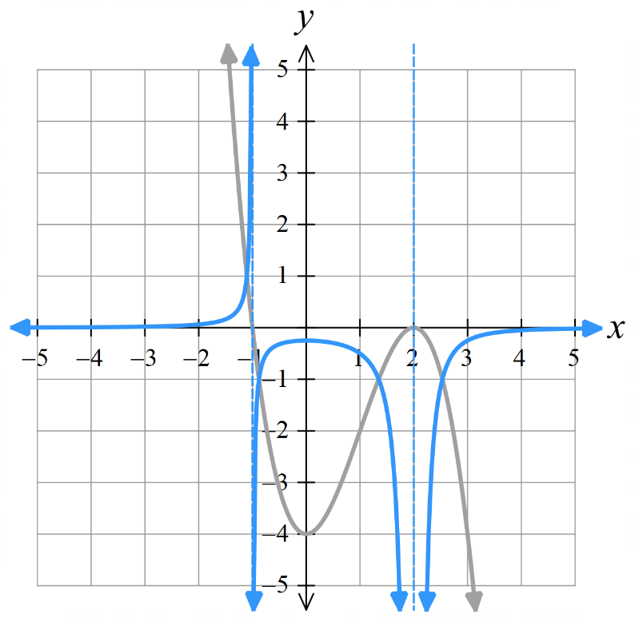  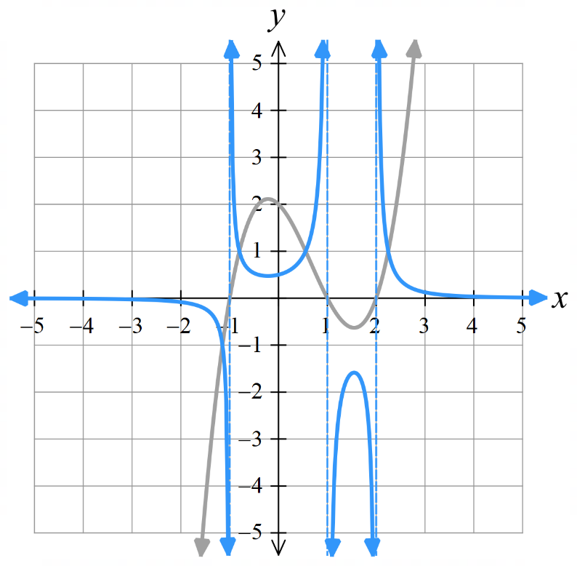  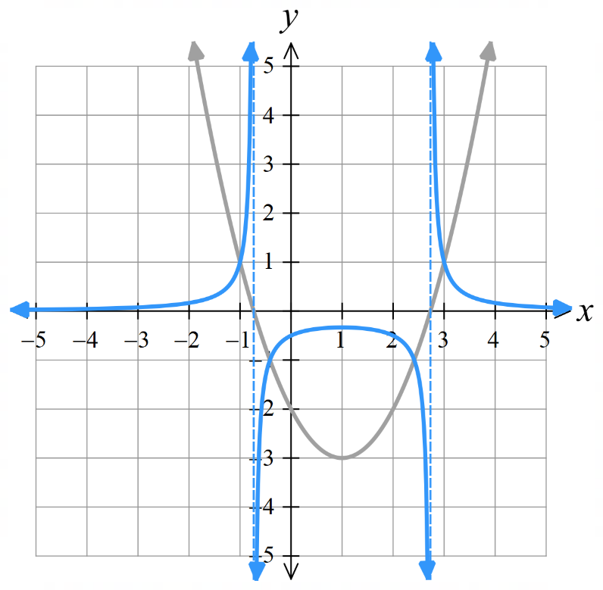  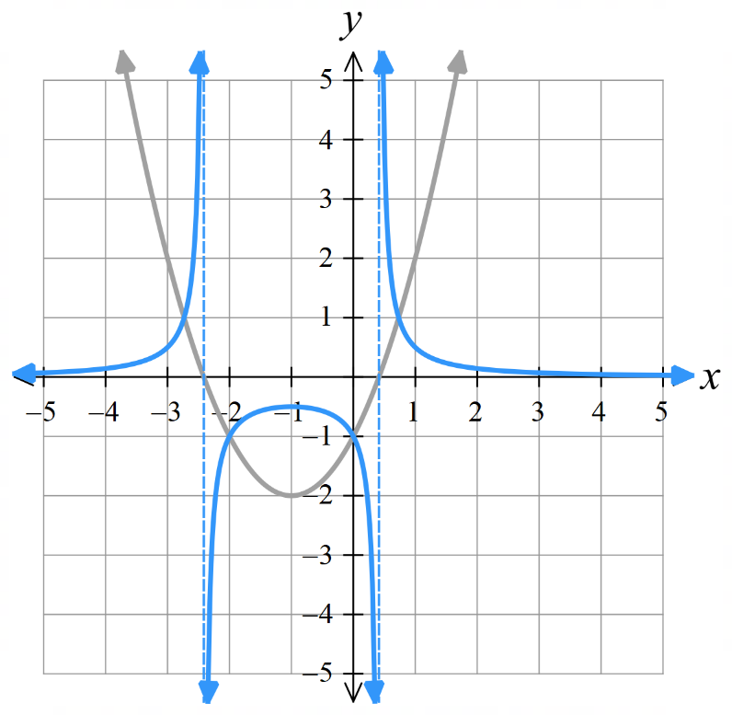  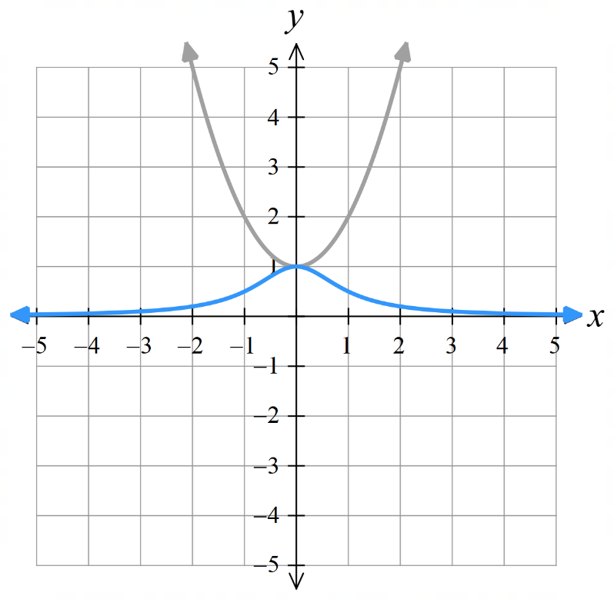  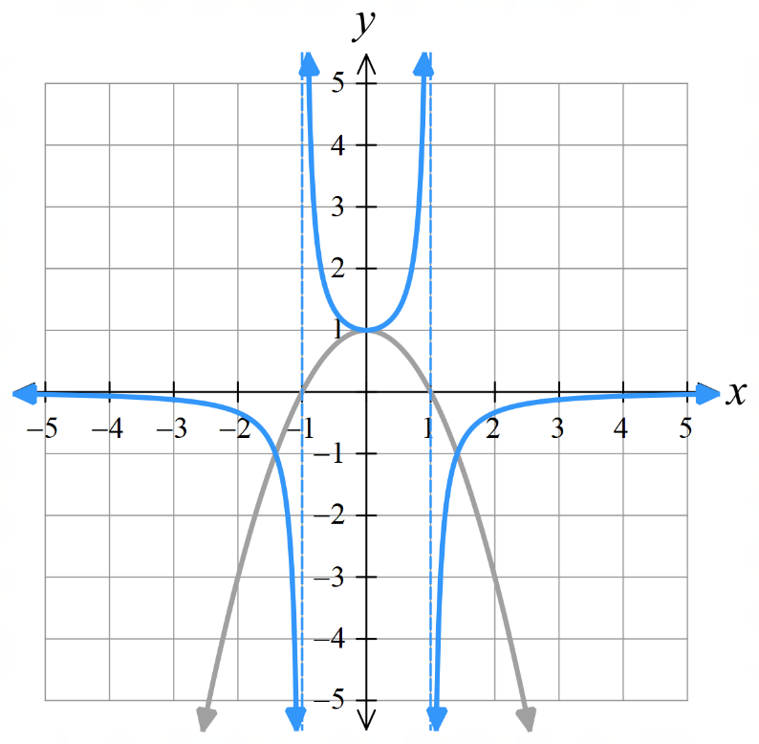
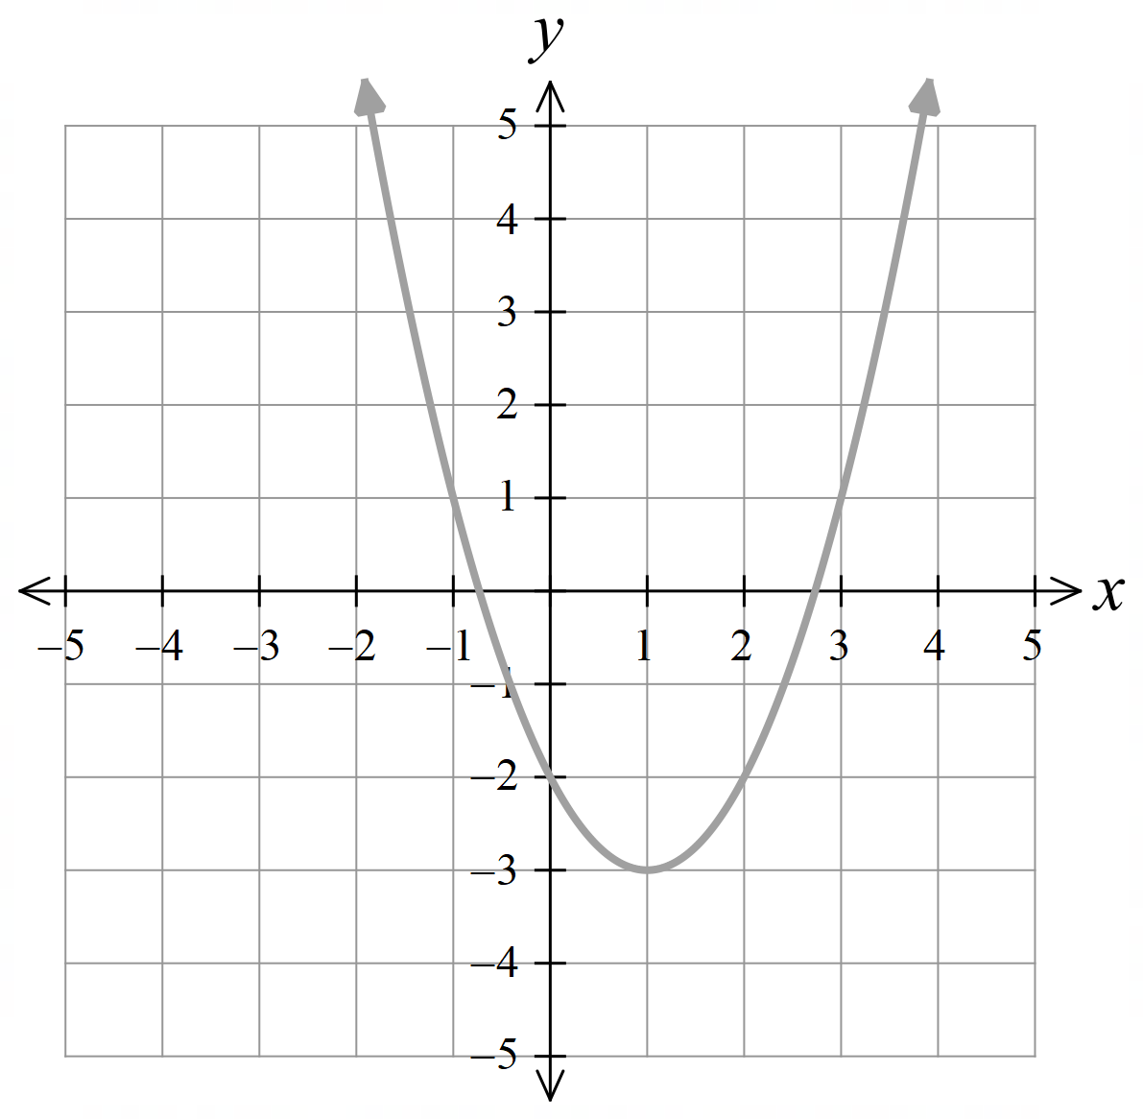
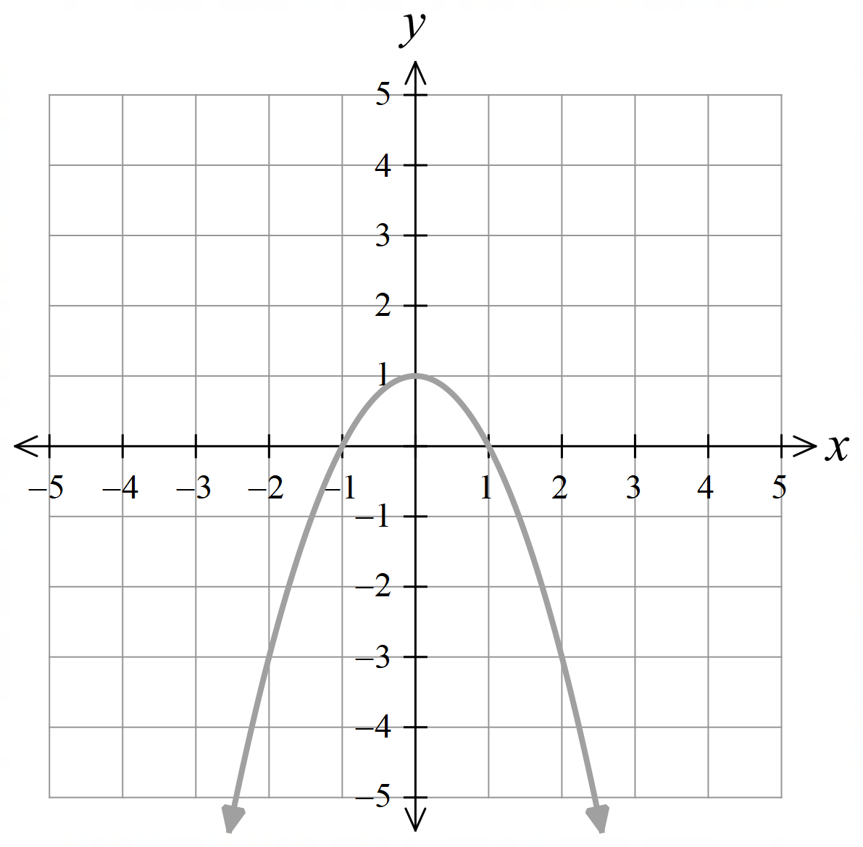

 | 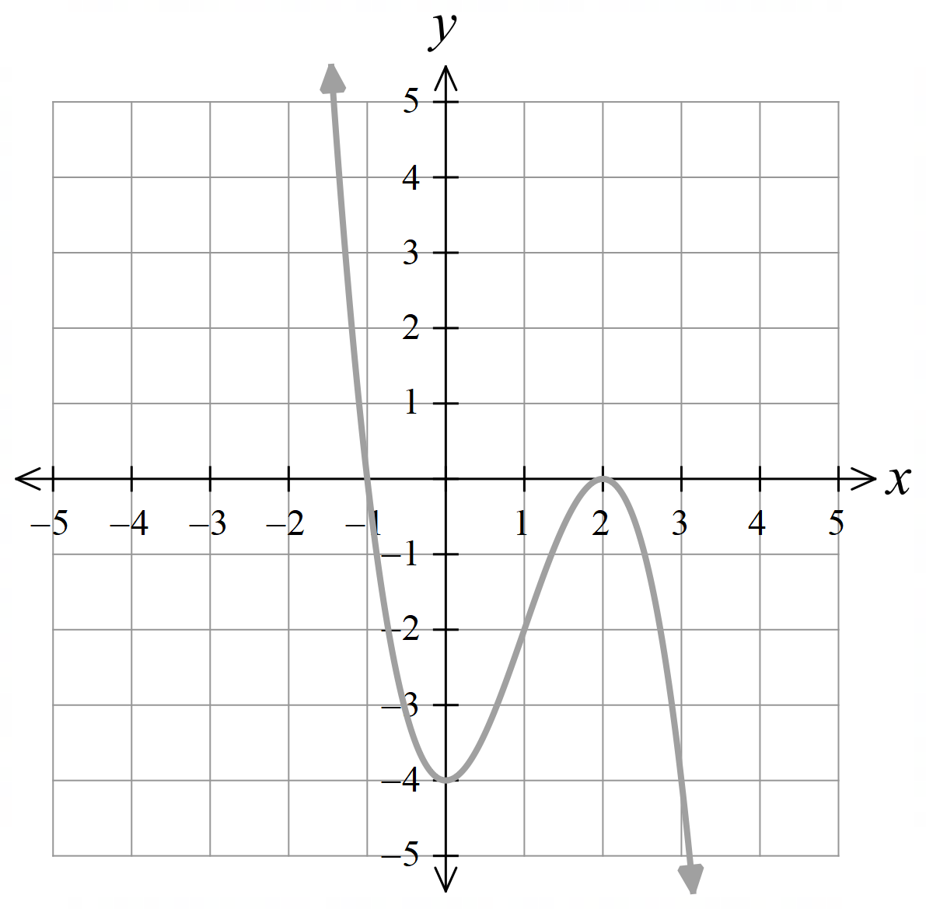
- The graph of $y=2x-1$ is shown as a dotted line. Which graph represents $y=$ $\frac{1}{2x-1 }$?
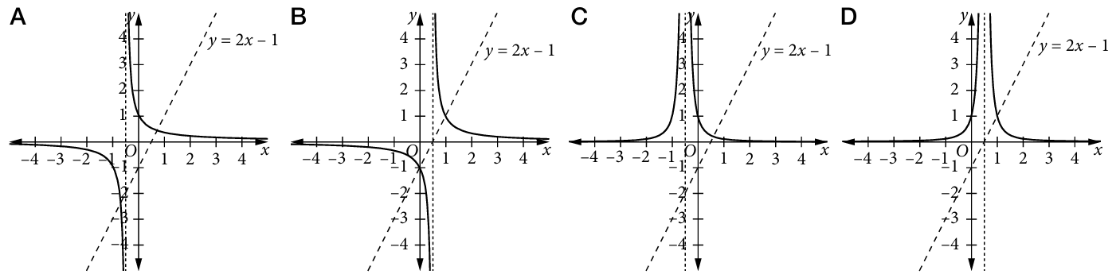

B
- The graph of $y={\left(2x-1\right)}^{2}$ is shown as a dotted line. Which graph represents $y=$ $\frac{1}{{\left(2x-1\right)}^{2} }$?
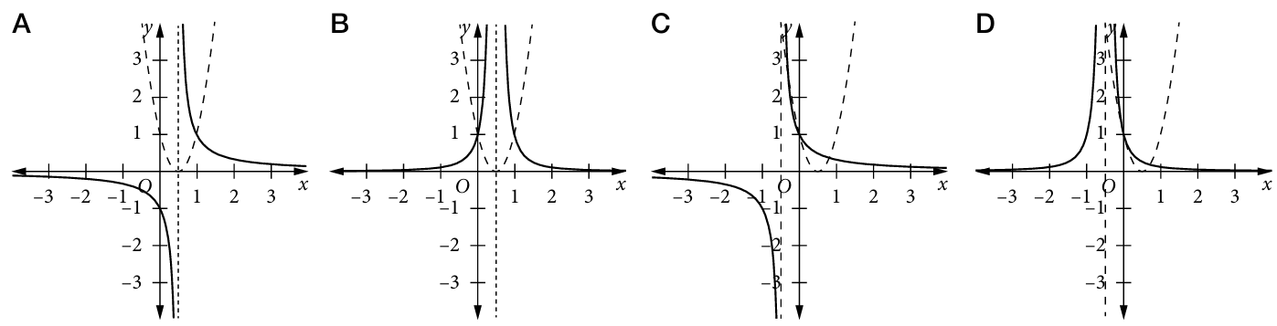

B
- The graph of $y={\left(2x-1\right)}^{3}$ is shown as a dotted line. Which graph represents $y=$ $\frac{1}{{\left(2x-1\right)}^{3}}$?
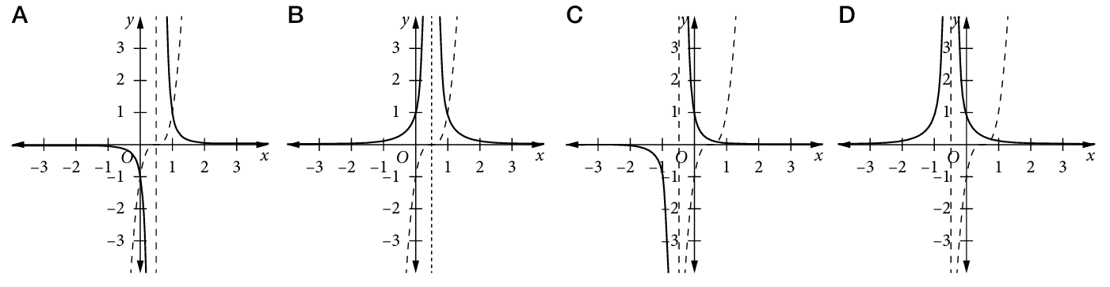

A
- 2010 HSC Extension 2 Band 2
- Sketch the graph of $y=x^{2}+4x$ | 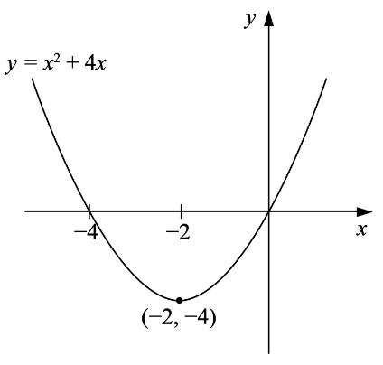  - Sketch the graph of $y=$ $\frac{1}{x^{2}+4x}$  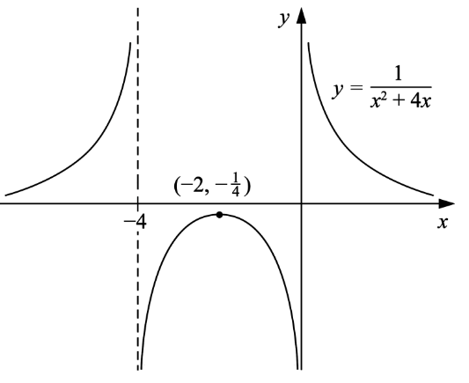  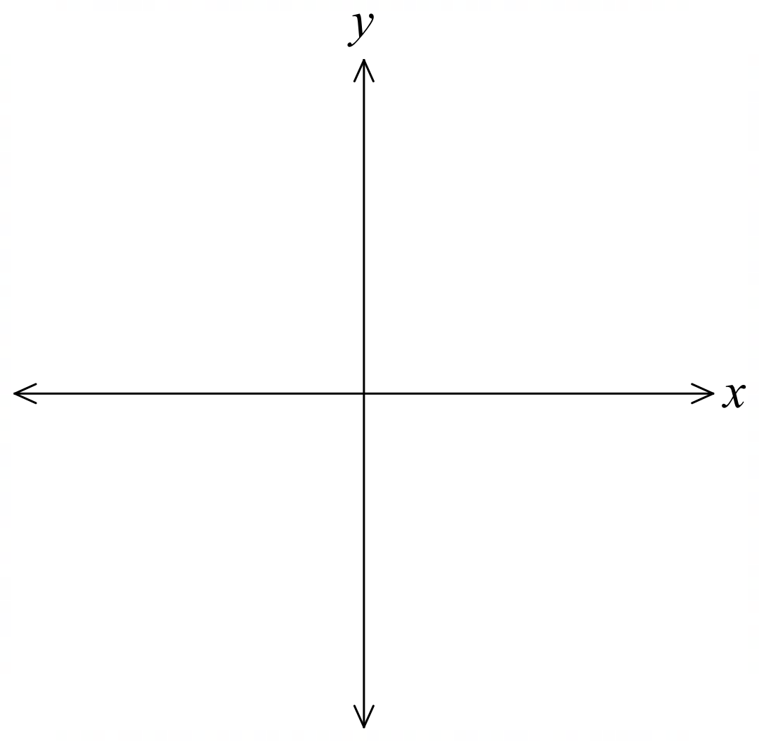

Development
- Sketch the reciprocals of these functions, showing all significant features.
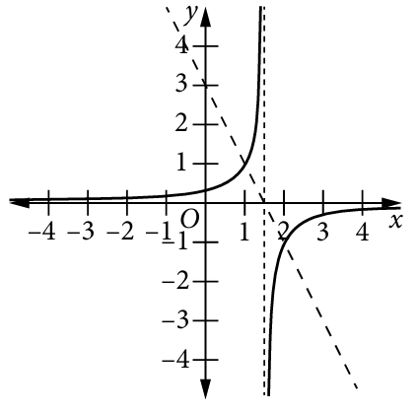  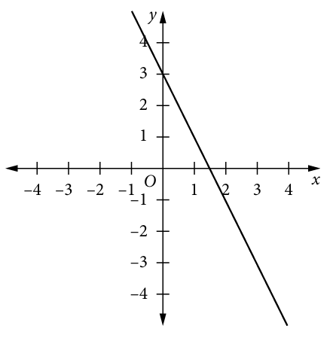 | 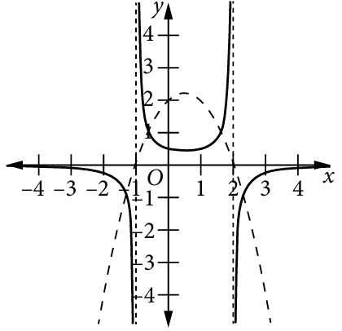  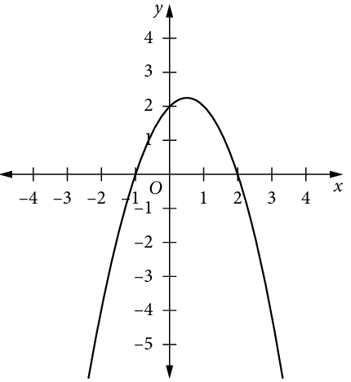
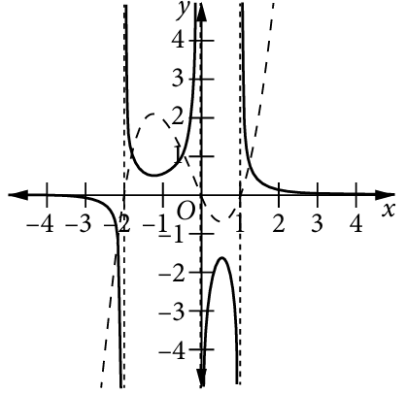  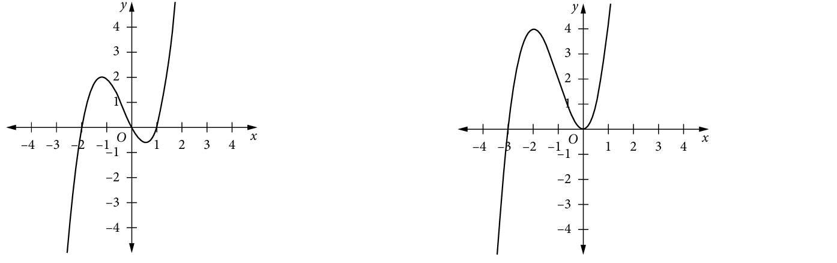  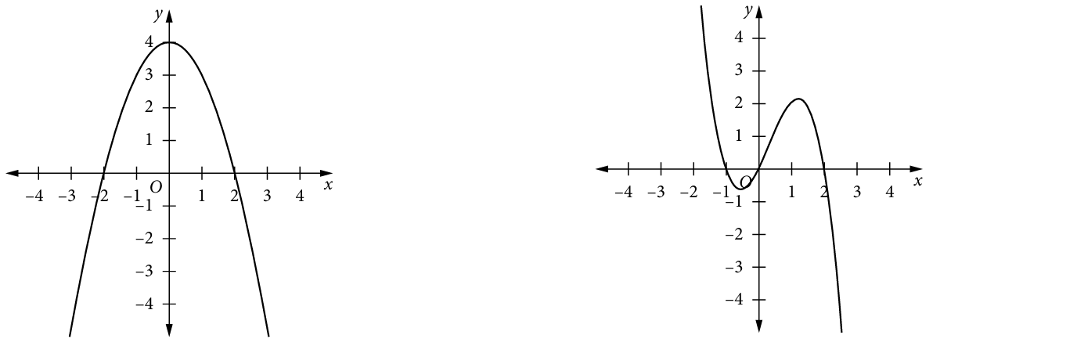 | 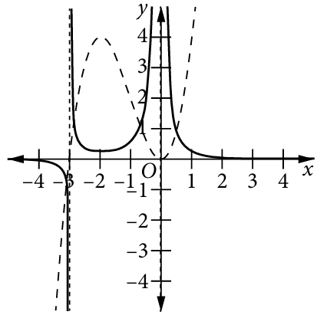
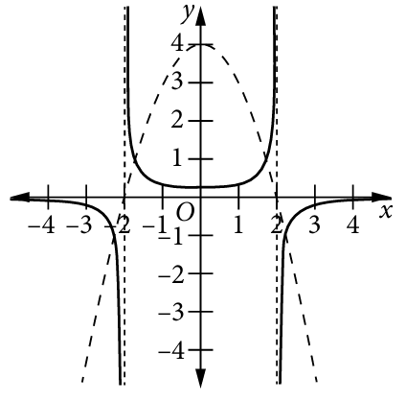 | 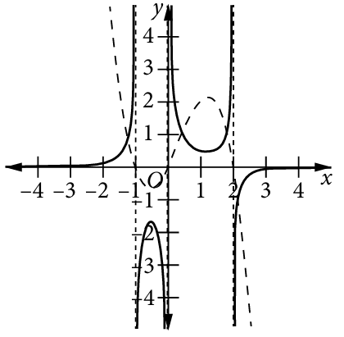

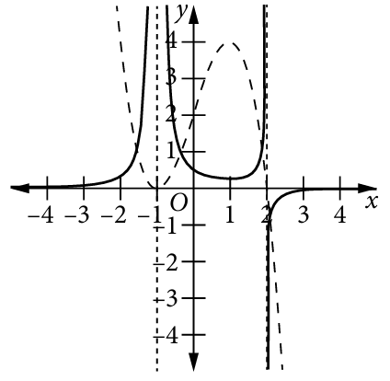 | 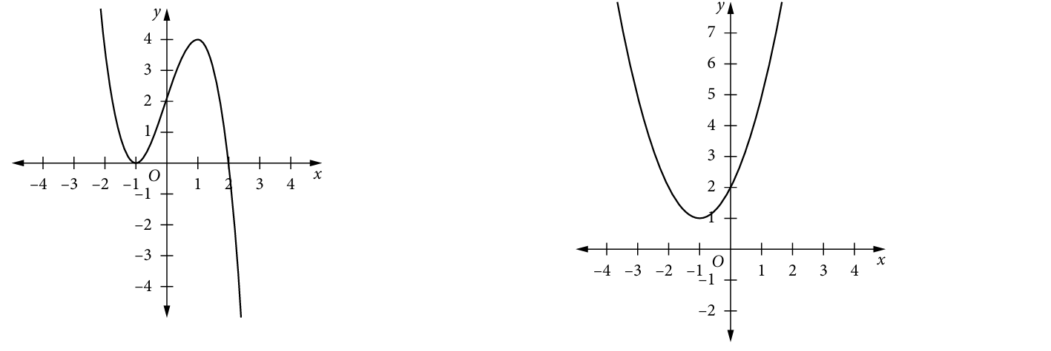  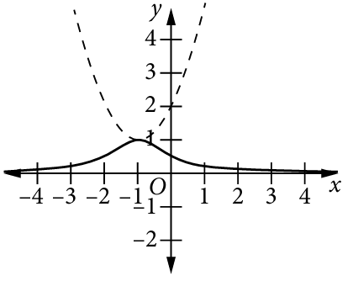

- Sketch the reciprocal of these functions, showing all important features.
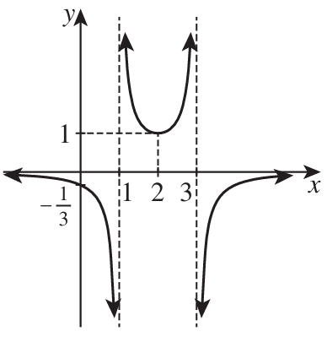  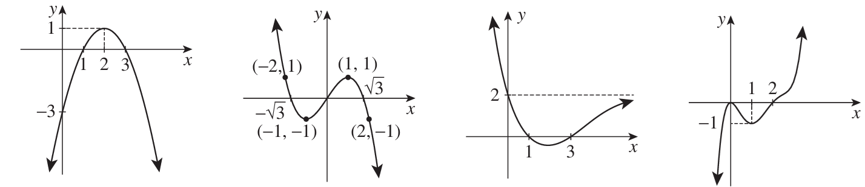 | 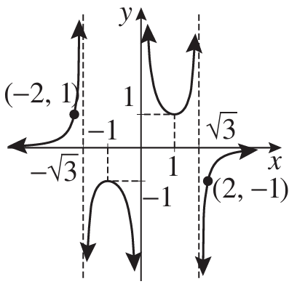
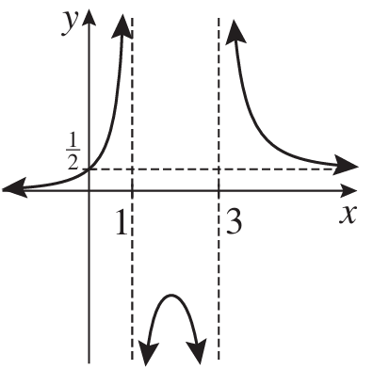 | 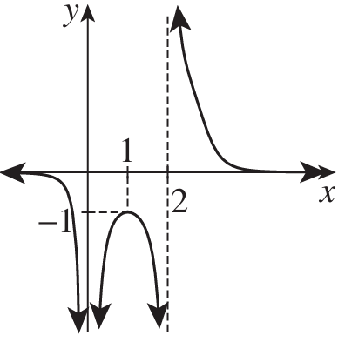

Mastery
- By sketching an appropriate “base” function and reciprocating, sketch these equations.
$$y=\frac{1}{x-2}$$  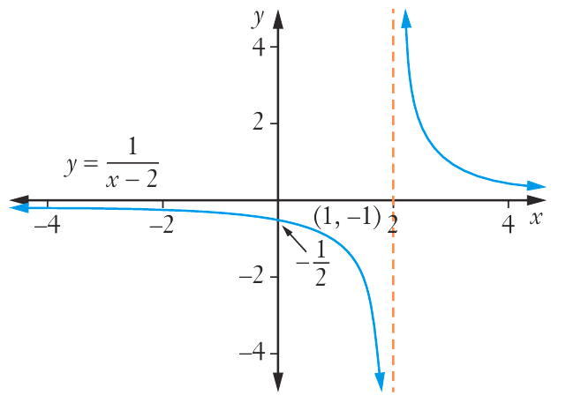  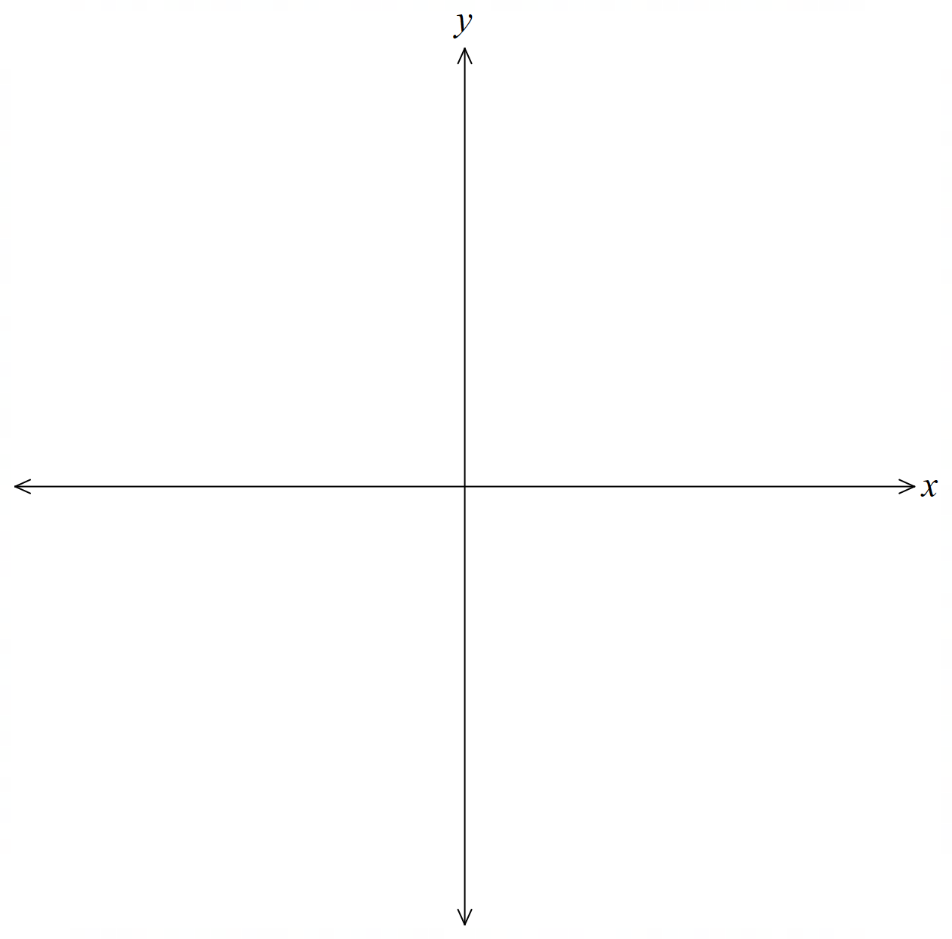 | $$y=\frac{1}{{\left(x+1\right)}^{2}}$$  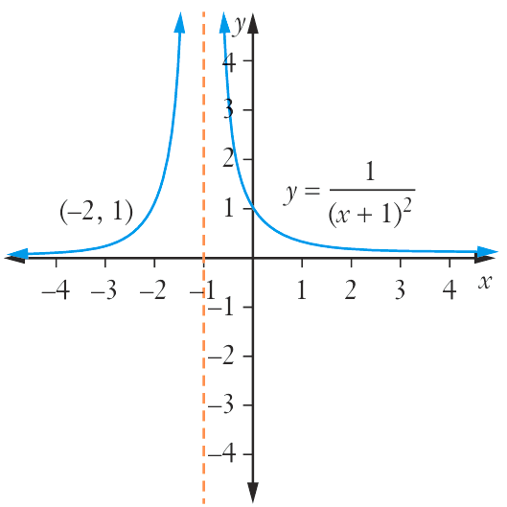
$$y=\frac{2}{x^{2}-4}$$  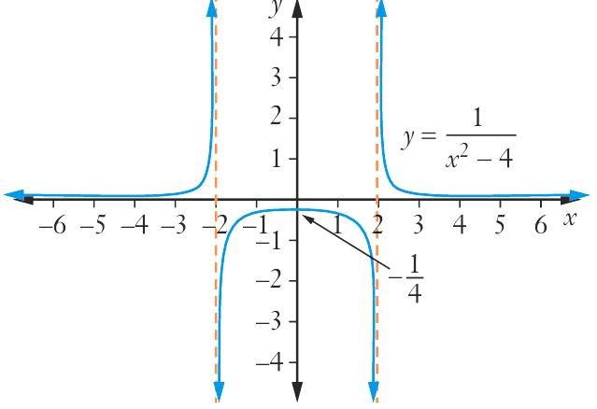 | $$y=-\frac{1}{x^{3}}$$  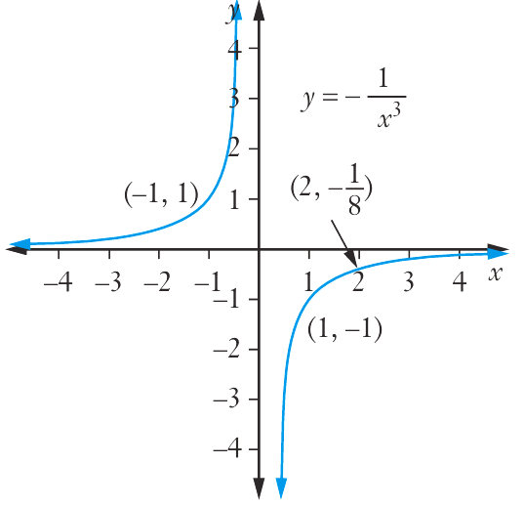
$$y=\frac{1}{x^{2}-2x-8}$$  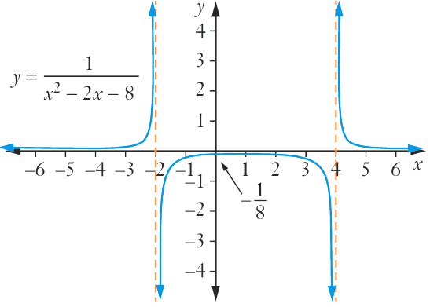 | $$y=\frac{1}{\left(x+1\right)\left(x+3\right)\left(x-2\right)}$$  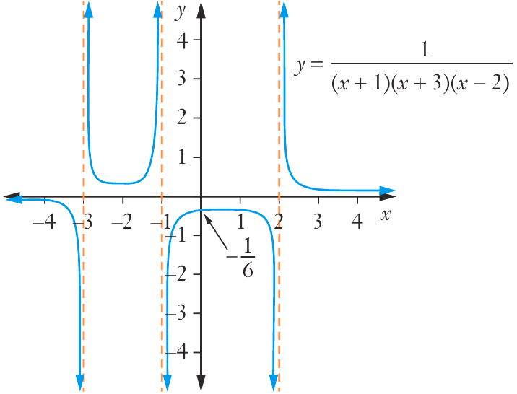
$$y=\frac{1}{1-x^{2}}$$  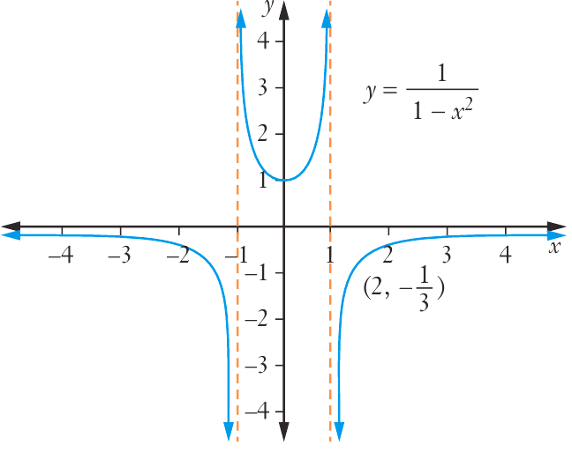 | $$y=\frac{1}{\left(x-3\right){\left(x+1\right)}^{2}}$$  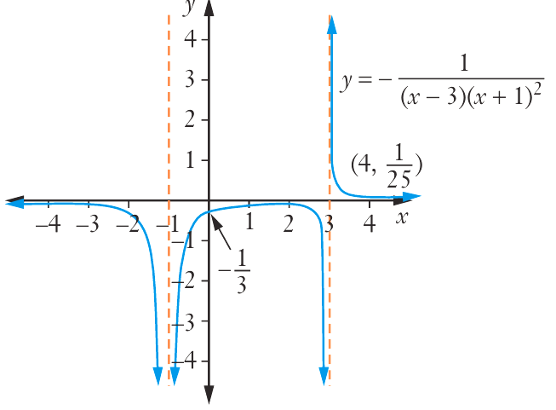
- $f\left(x\right)=$ $\frac{1}{x+1}$, Grace was asked to find the equation and domain of $g\left(x\right)=\frac{1}{f\left(x\right)}$. She says:

$\frac{1}{f\left(x\right)}$ would have an equation of $x+1$, this has domain $x∈R$

Explain why her equation is correct but domain is incorrect.

The original function is undefined for $x=-1$, so the new function is $g\left(x\right)=x+1,$similarly undefined for $x≠-1$.
- The graph of $y=f\left(x\right)$ is given. Sketch $y=$ $\frac{1}{f\left(x\right)}$
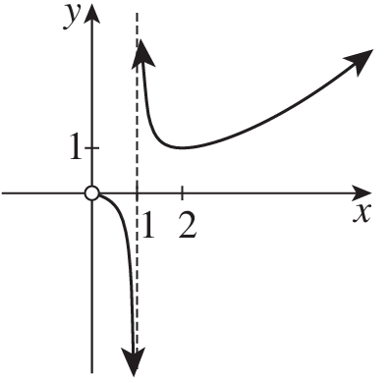  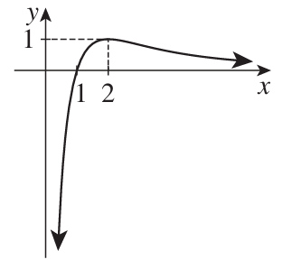 | 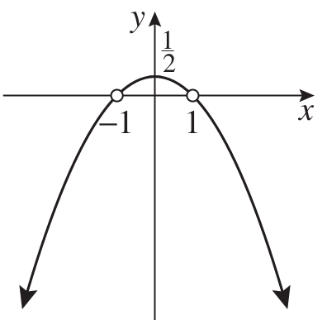  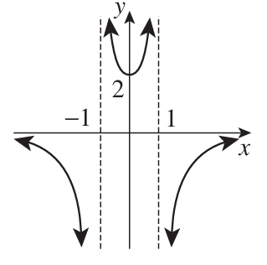

- HSC Sample Question Band 4
The function $y=f\left(x\right)$ is given. Sketch $y=$ $\frac{1}{f\left(x\right)}$ and state the range in interval notation.
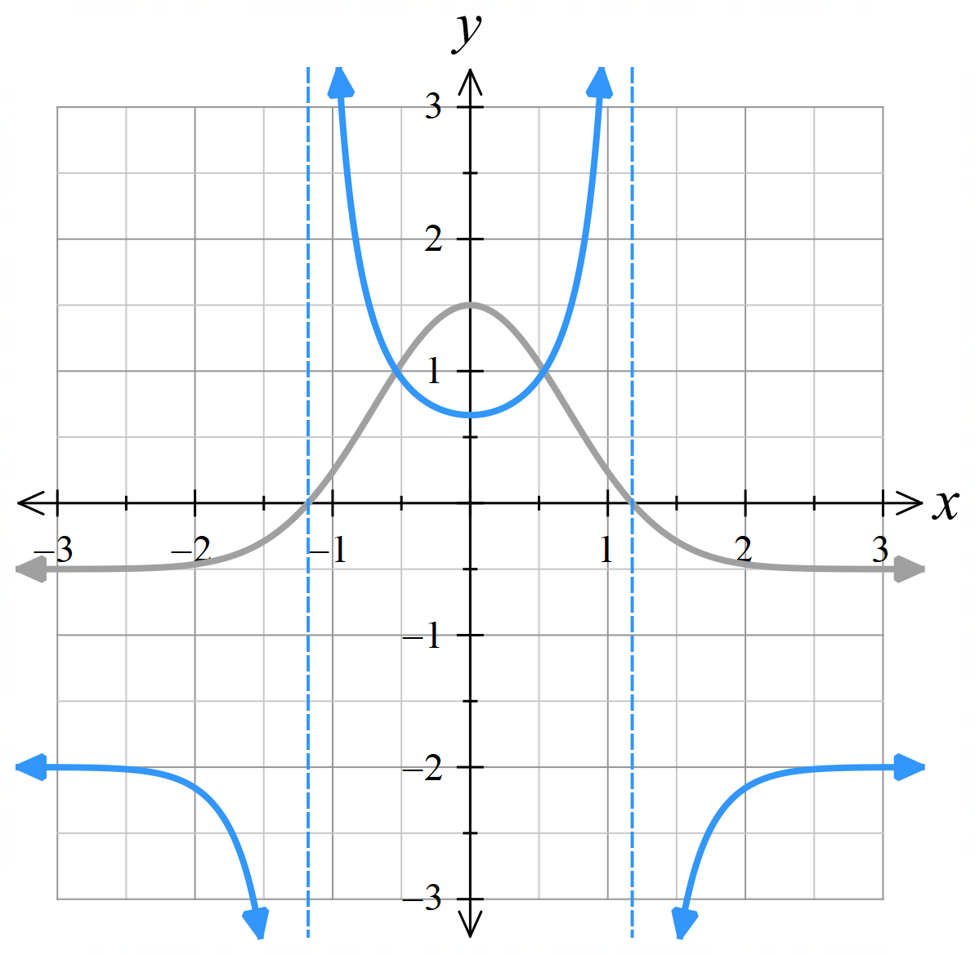
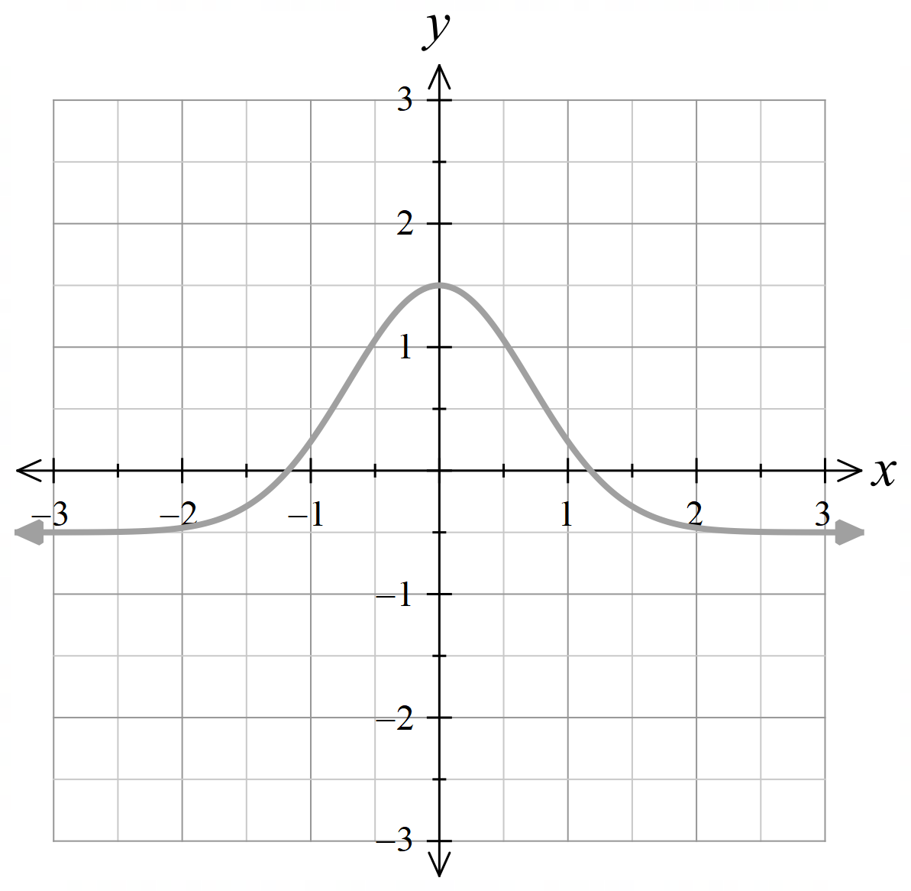

$$R:\left(-∞,-2\right)∪\left[\frac{2}{3}, ∞\right)$$

Graph of the Absolute Value of a Function

- Absolute Value Transformations
$$y=\left|f\left(x\right)\right|$$ | $$y=f\left(\left|x\right|\right)$$
- All points on and above the $x$-axis remain unchanged.  - Reflect all points below the $x$-axis upward. | - All points on and to the right of the $y$-axis remain unchanged.  - Remove all points left of the $y$-axis and reflect all points right of the $y$-axis across.

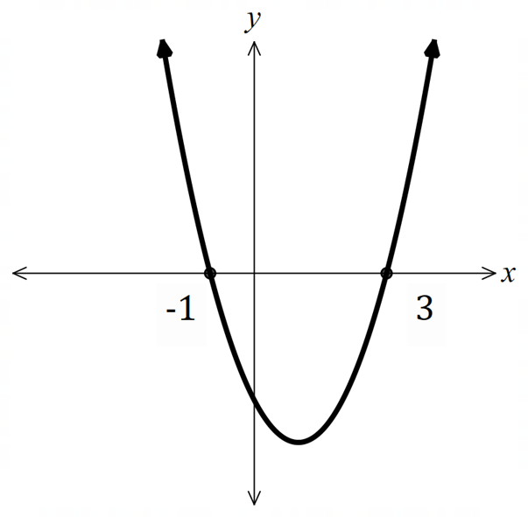
- Example Sketch a function $y=\left|f\left(x\right)\right|$, and $y=f\left(\left|x\right|\right)$ given the graph of $f\left(x\right)$.
$y=f\left(x\right)$ is given. Sketch $y=\left|f\left(x\right)\right|$.  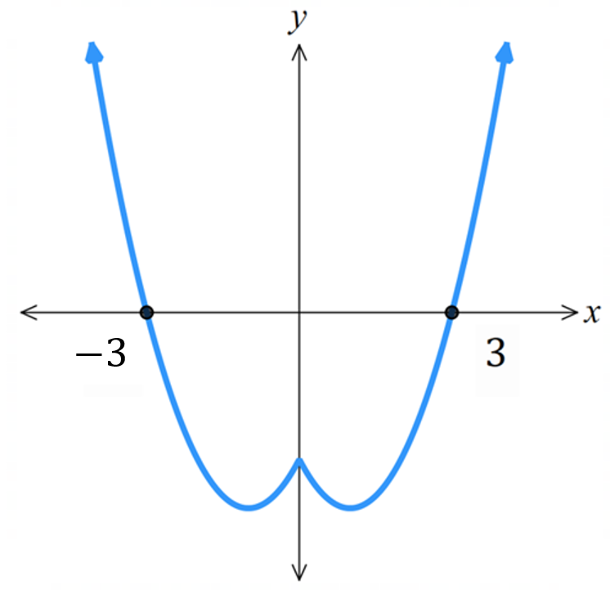  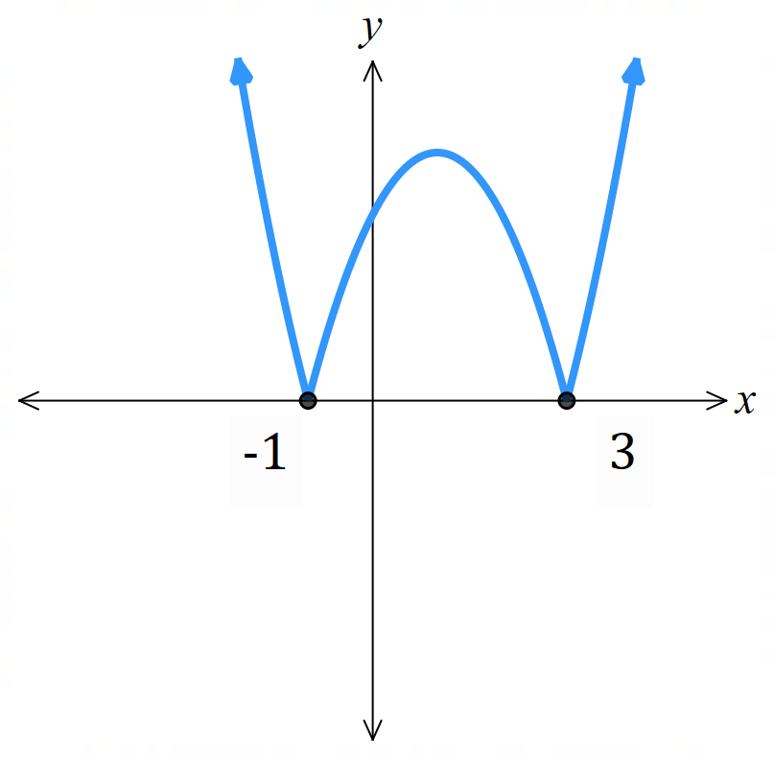 | $y=f\left(x\right)$ is given. Sketch $y=f\left(\left|x\right|\right)$.

- Guided Practice
$y=f\left(x\right)$ is given. Sketch $y=\left|f\left(x\right)\right|$ on the same axis.
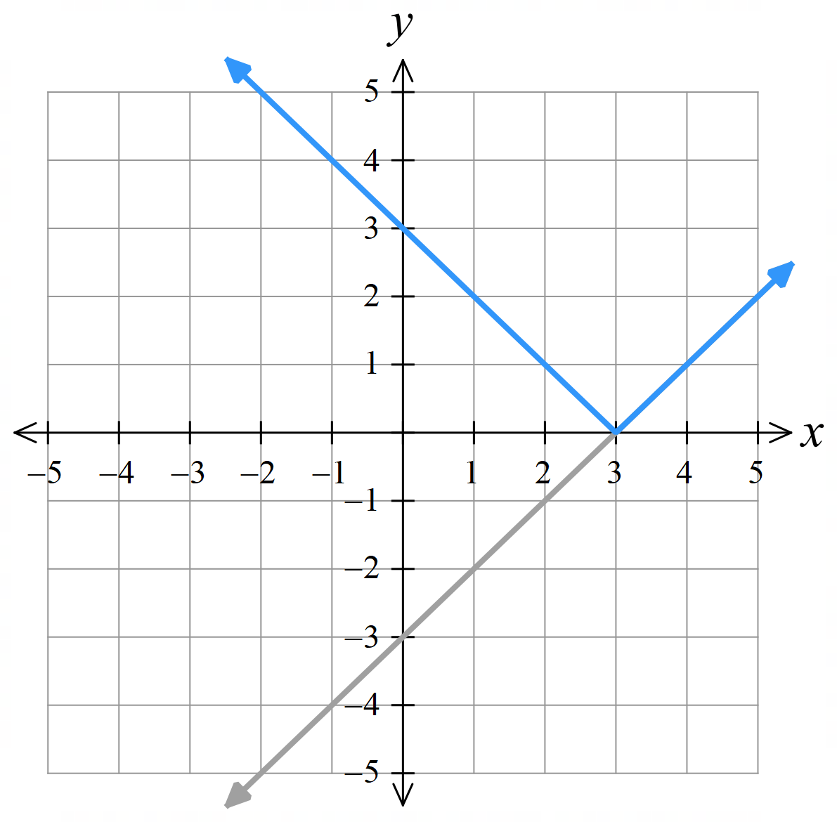 | 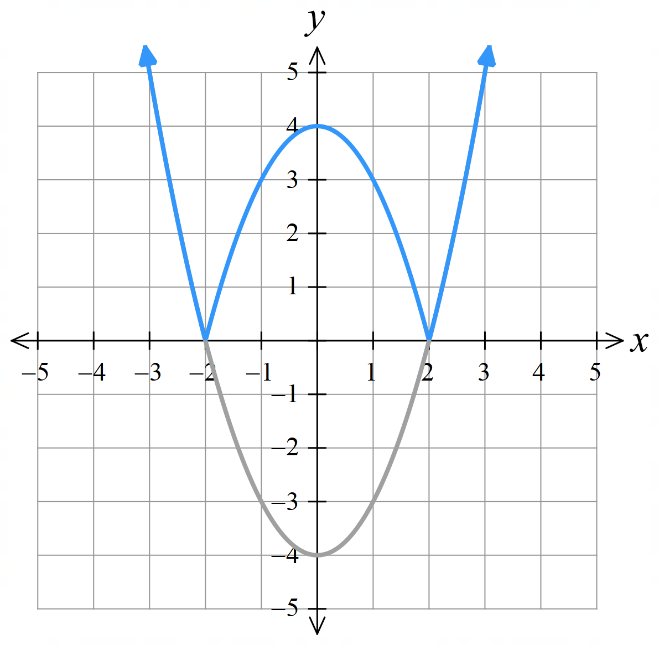
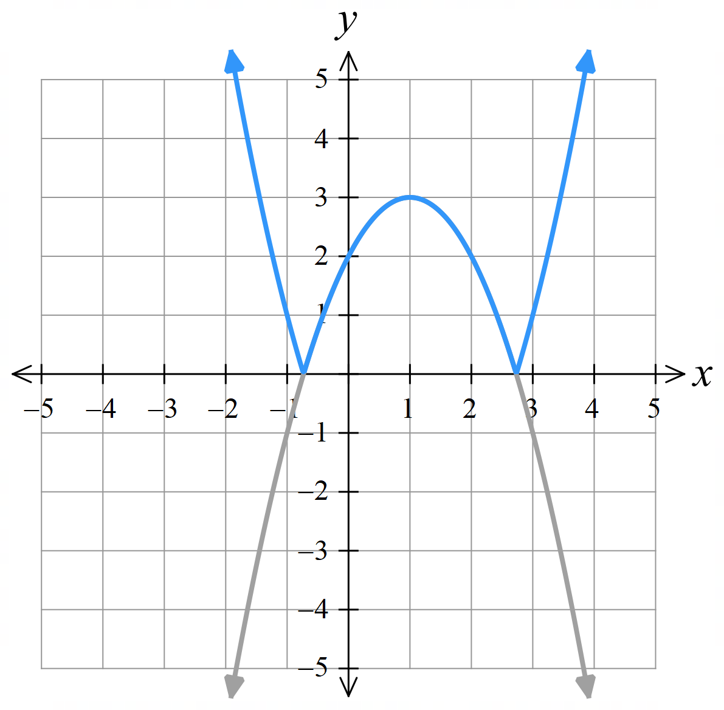 | 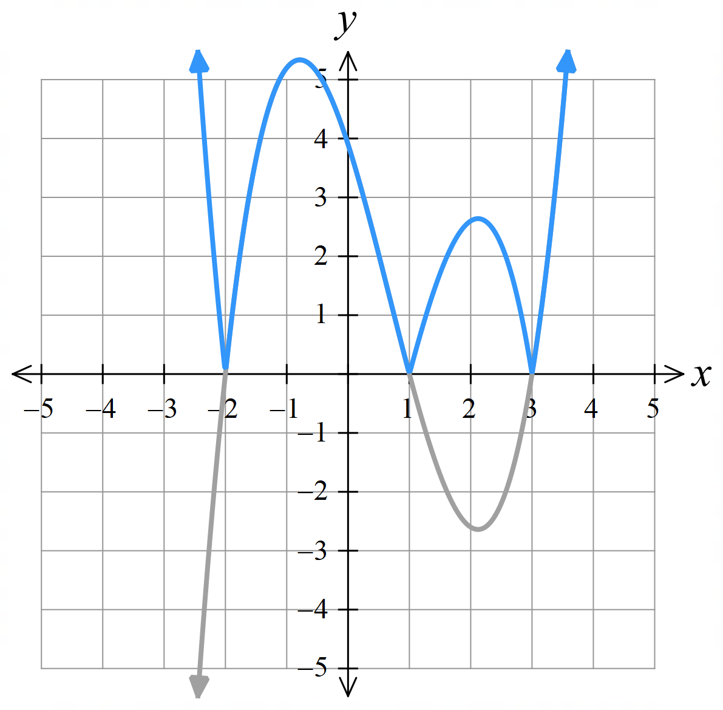

Foundation
- The graph of $f\left(x\right)=x-2$ is shown as a dotted line. Which graph represents $y=\left|x-2\right|$?
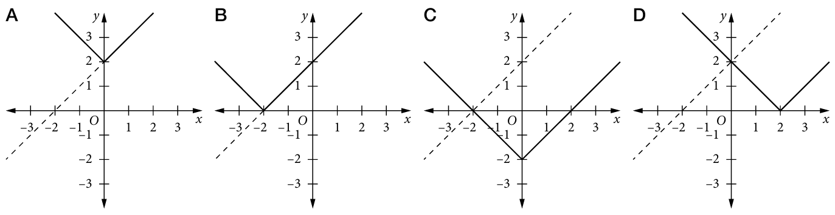

B
- The graph of $f\left(x\right)={\left(x-1\right)}^{2}$ is shown as a dotted line. Which graph represents $y={\left(\left|x\right|-1\right)}^{2}$?
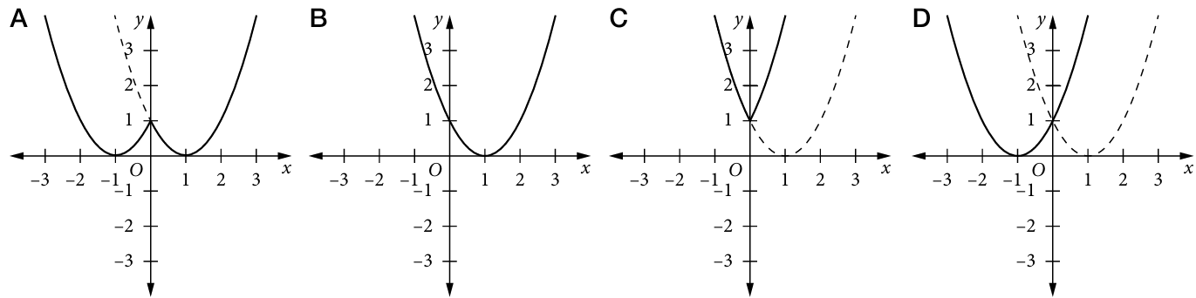

A
- The graph of $f\left(x\right)={x\left(x+2\right)}^{2}$ is shown as a dotted line. Which represents $y=\left|x\right|{\left(\left|x\right|+2\right)}^{2}$?
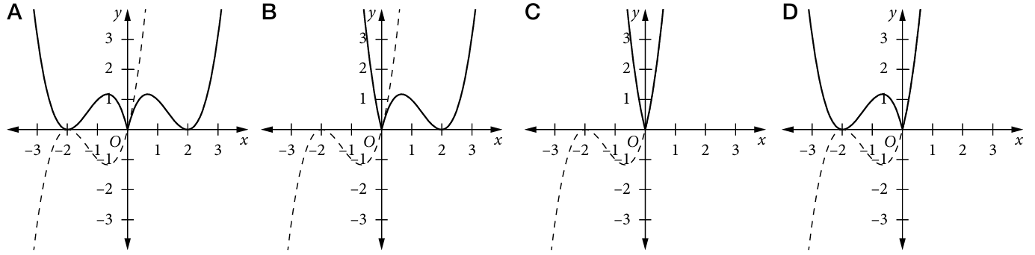

C

Development
- The graph of $f\left(x\right)$ is given,
- Sketch $y=\left|f\left(x\right)\right|$  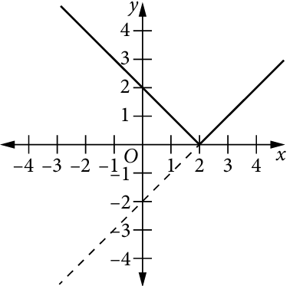  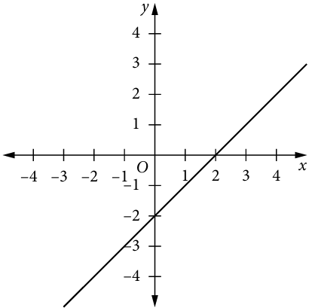 | - Sketch $y=f\left(\left|x\right|\right)$  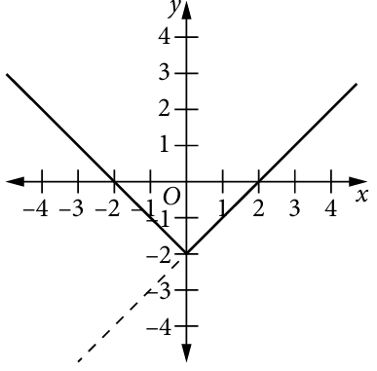
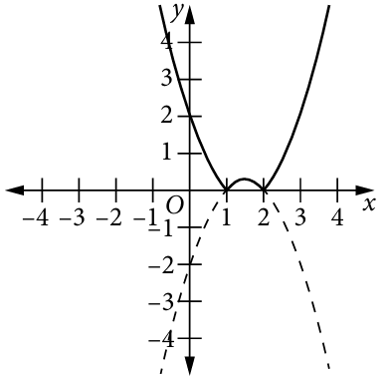  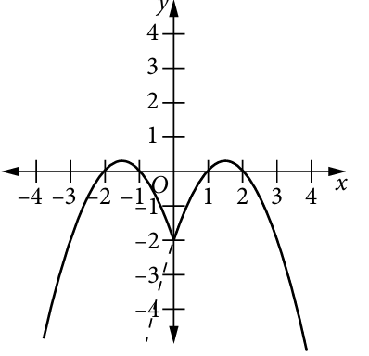  - Sketch $y=\left|f\left(x\right)\right|$  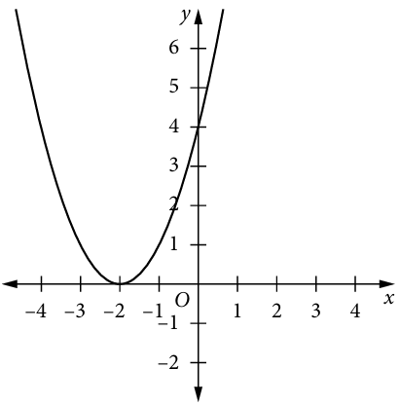 | - Sketch $y=f\left(\left|x\right|\right)$  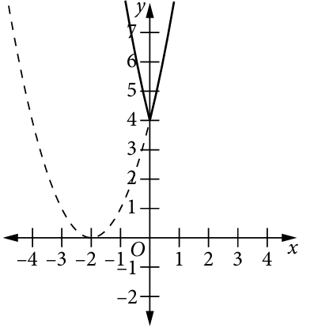
- Sketch $y=\left|f\left(x\right)\right|$  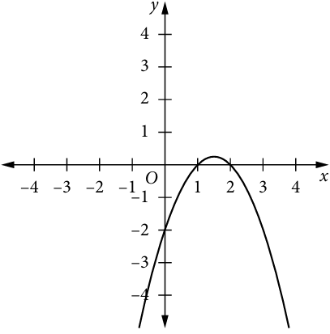 | - Sketch $y=f\left(\left|x\right|\right)$

- Sketch $y=\left|f\left(x\right)\right|$  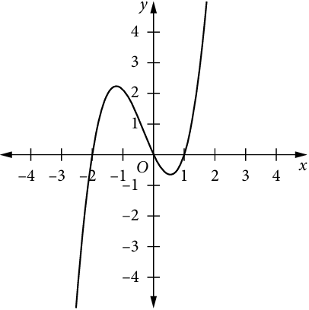  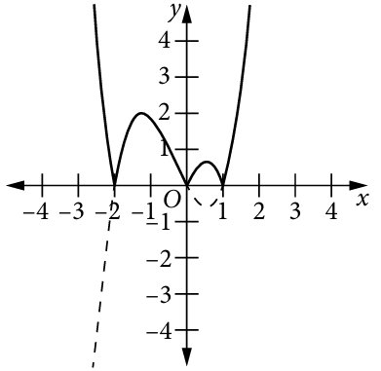 | - Sketch $y=f\left(\left|x\right|\right)$  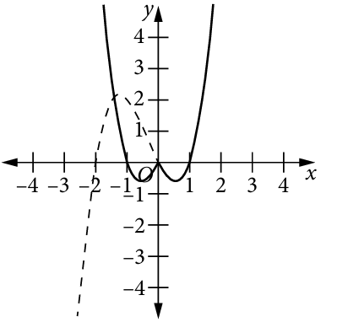
- Sketch $y=\left|f\left(x\right)\right|$  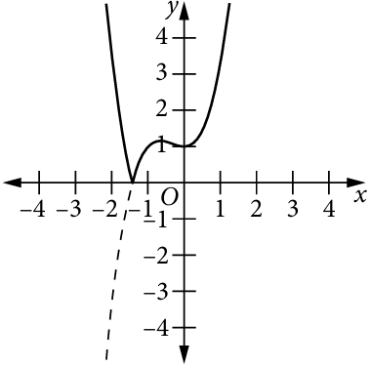  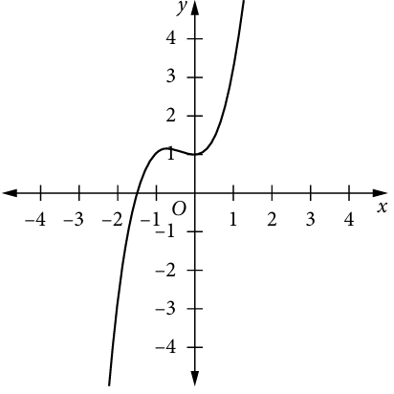 | - Sketch $y=f\left(\left|x\right|\right)$  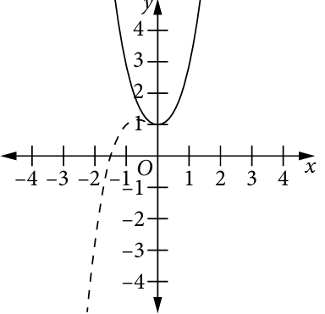
- Sketch $y=\left|f\left(x\right)\right|$  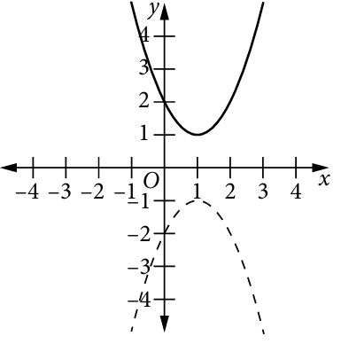  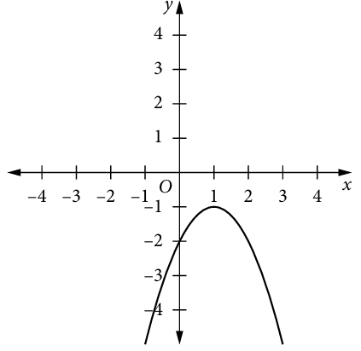 | - Sketch $y=f\left(\left|x\right|\right)$  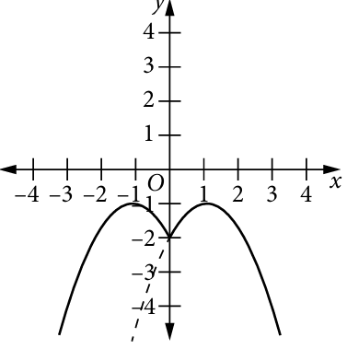

Mastery
- The graph of $f\left(x\right)$ is given,
- Sketch $y=\left|f\left(x\right)\right|$  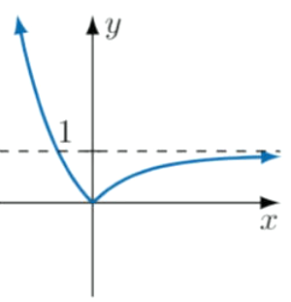  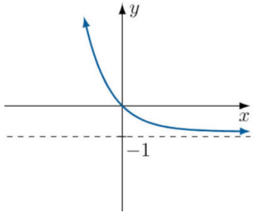 | - Sketch $y=f\left(\left|x\right|\right)$  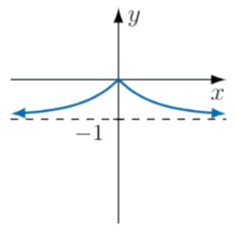

- The graph of $f\left(x\right)$ is given,
- Sketch $y=\left|f\left(x\right)\right|$  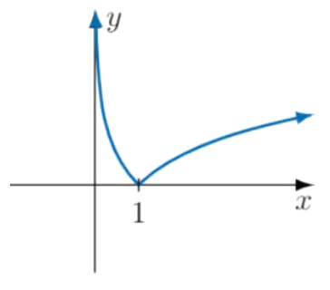  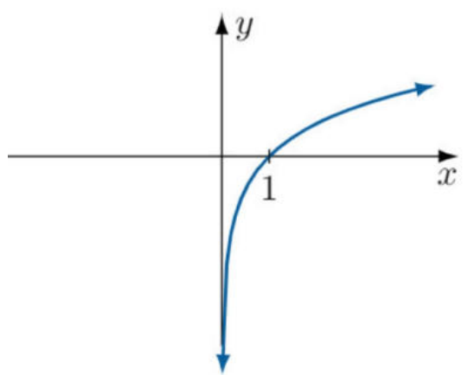 | - Sketch $y=f\left(\left|x\right|\right)$  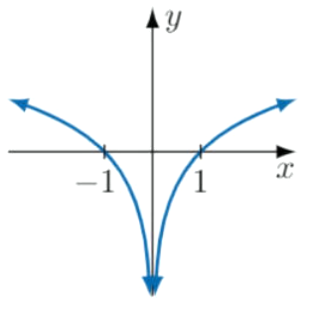

- By first sketching an appropriate $y=f\left(x\right),$ use it to sketch these functions.
- $y=\left|2x+1\right|$ | - $y=\left|x^{3}+1\right|$  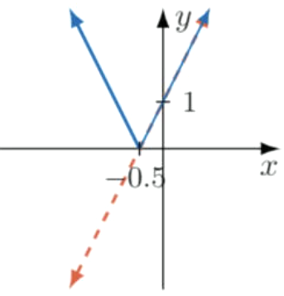  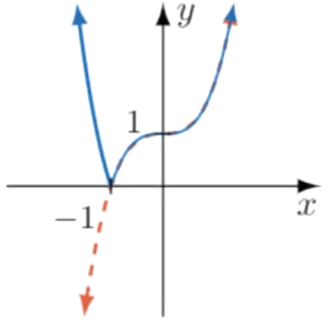
- $y=\left|x^{3}-x\right|$  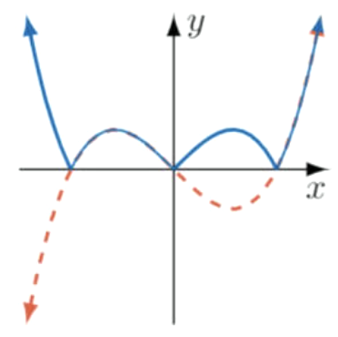 | - $y=\left|1+\frac{1}{x}\right|$  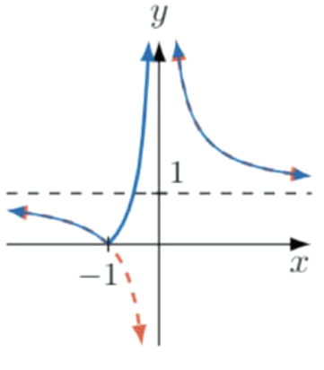
- $y=$ $\frac{1}{\left|x\right|}$  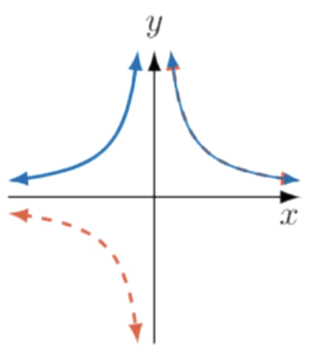  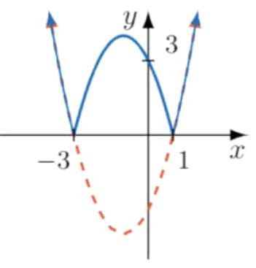 | - $y=\left|x^{2}+2x-3\right|$
- $y=1-2\left|x\right|$ | 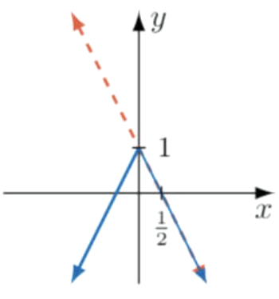  - $y=4\left|x\right|-{\left|x\right|}^{2}$  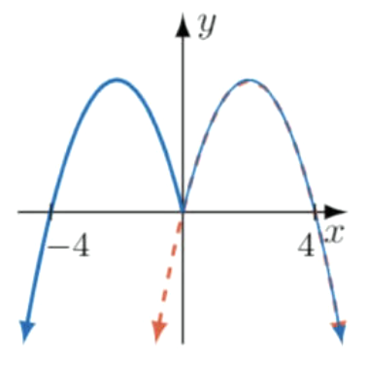
- $y=\left|x^{3}\right|-16\left|x\right|$ | 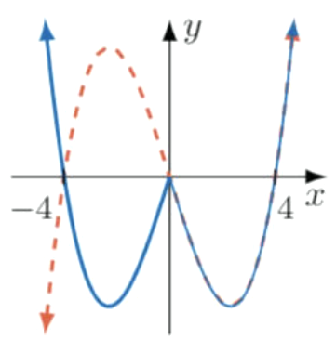  - $y={\left|x\right|}^{3}-1$  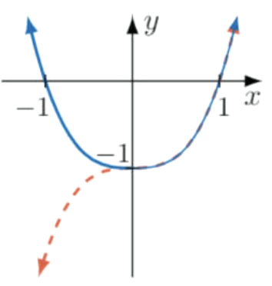
- A quadratic was transformed to form the following graph.
Find the equation of the original quadratic.
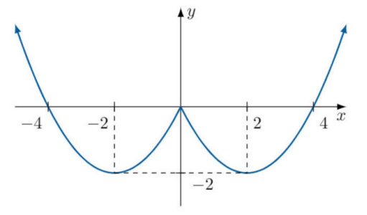

$$y=\frac{1}{2}\left(x^{2}-4x\right)$$

- Show that  $$\frac{x+1}{x-1}=1+\frac{2}{x-1}$$  $$\frac{x+1}{x-1}=\frac{\left(x-1\right)+2}{x-1}$$  $$=1+\frac{2}{x-1}$$ | 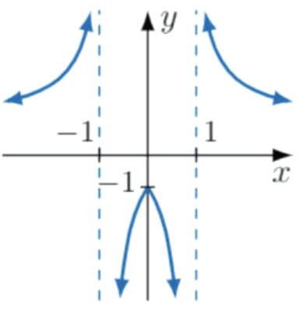  - Hence sketch  $$y=\frac{\left|x\right|+1}{\left|x\right|-1}$$

- Show that  $$\frac{x-1}{x+1}=1-\frac{2}{x+1}$$  $$\frac{x-1}{x+1}=\frac{\left(x+1\right)-2}{x+1}$$  $$=1-\frac{2}{x+1}$$ | 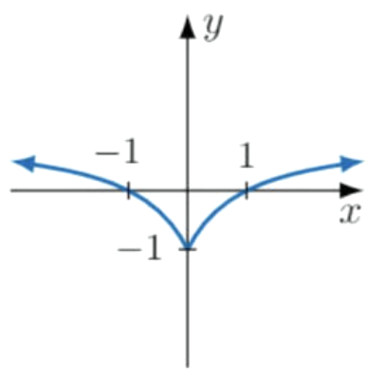  - Hence sketch  $$y=\frac{\left|x\right|-1}{\left|x\right|+1}$$

Mixed Practice

Foundation
- $y=f\left(x\right)$ is given. One the same axis, sketch:
  - $y=$ $\frac{1}{f\left(x\right)}$
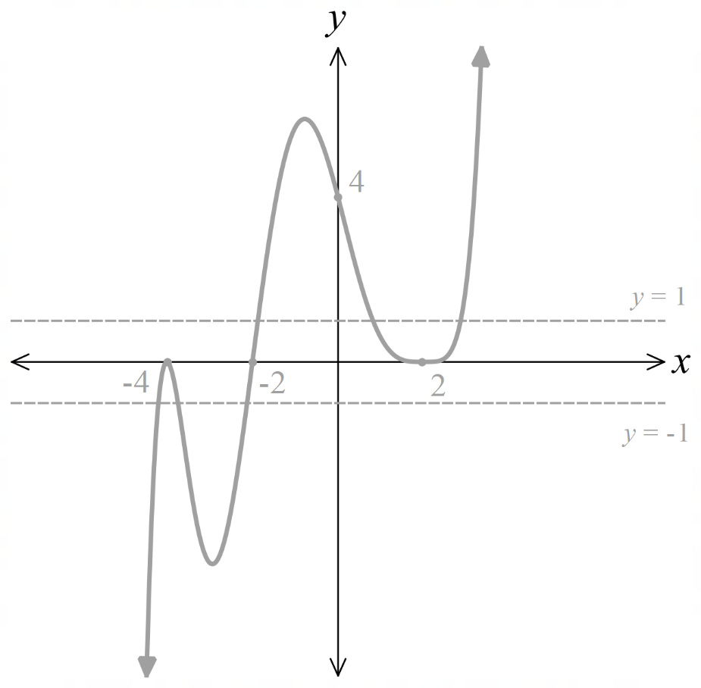

  - $y=\left|f\left(x\right)\right|$
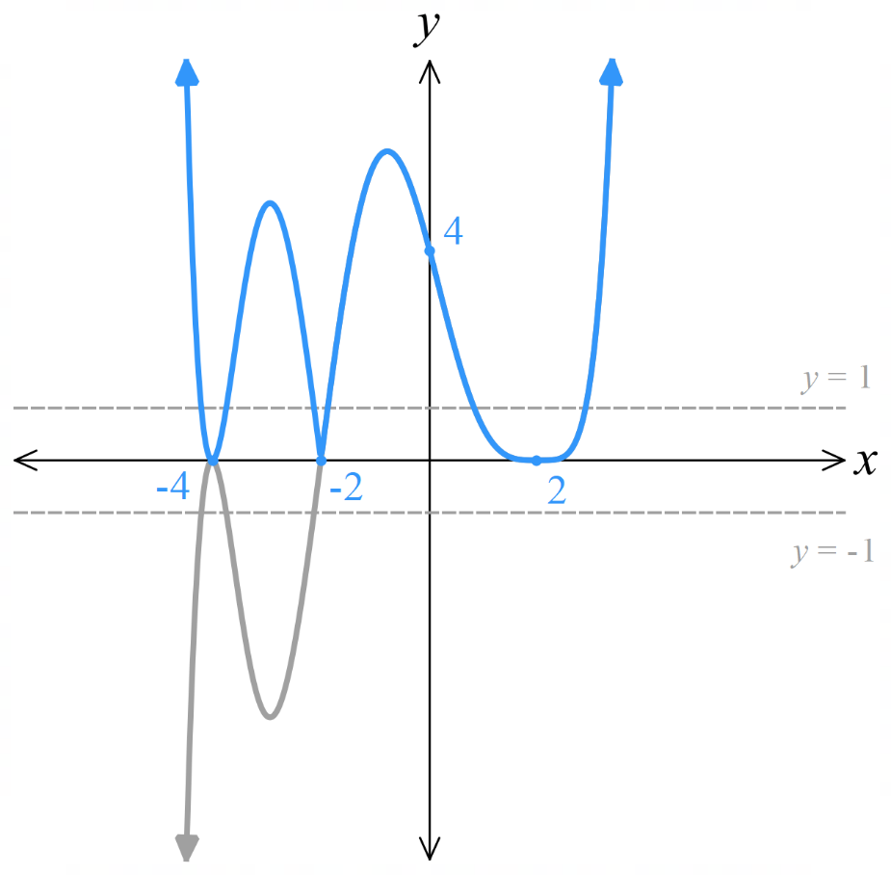
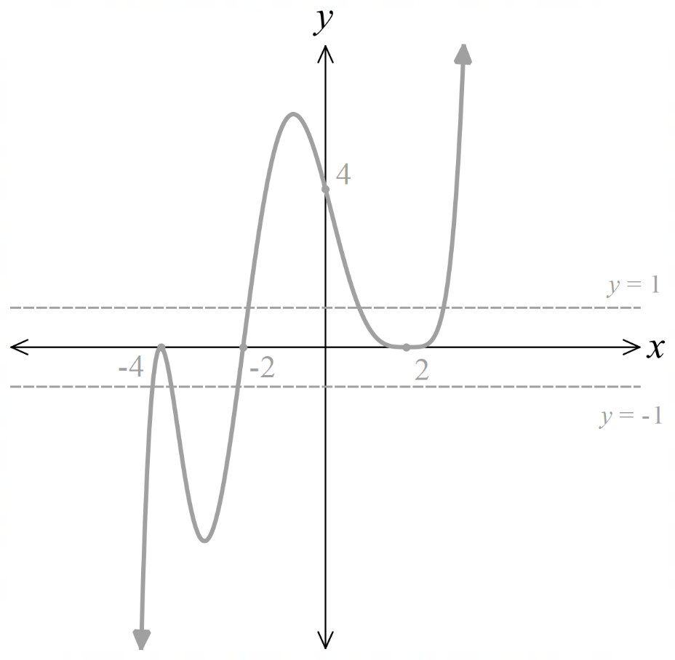

  - $y=f\left(\left|x\right|\right)$
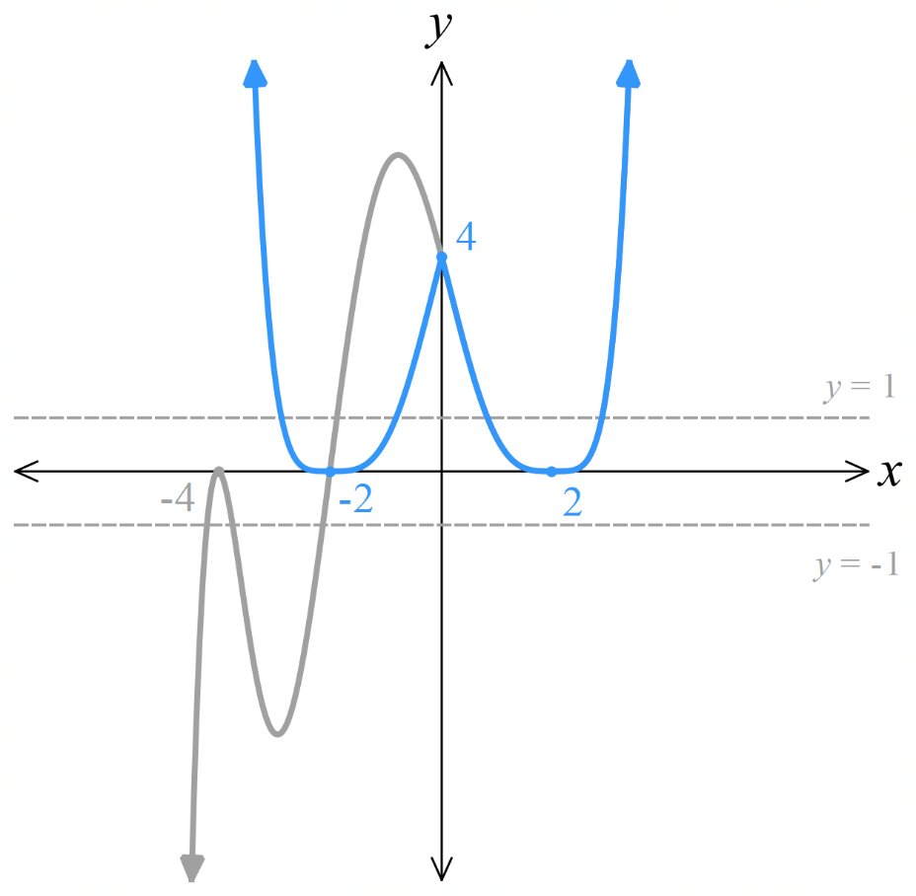

- $y=f\left(x\right)$ is given. One the same axis, sketch:
  - $y=$ $\frac{1}{f\left(x\right)}$
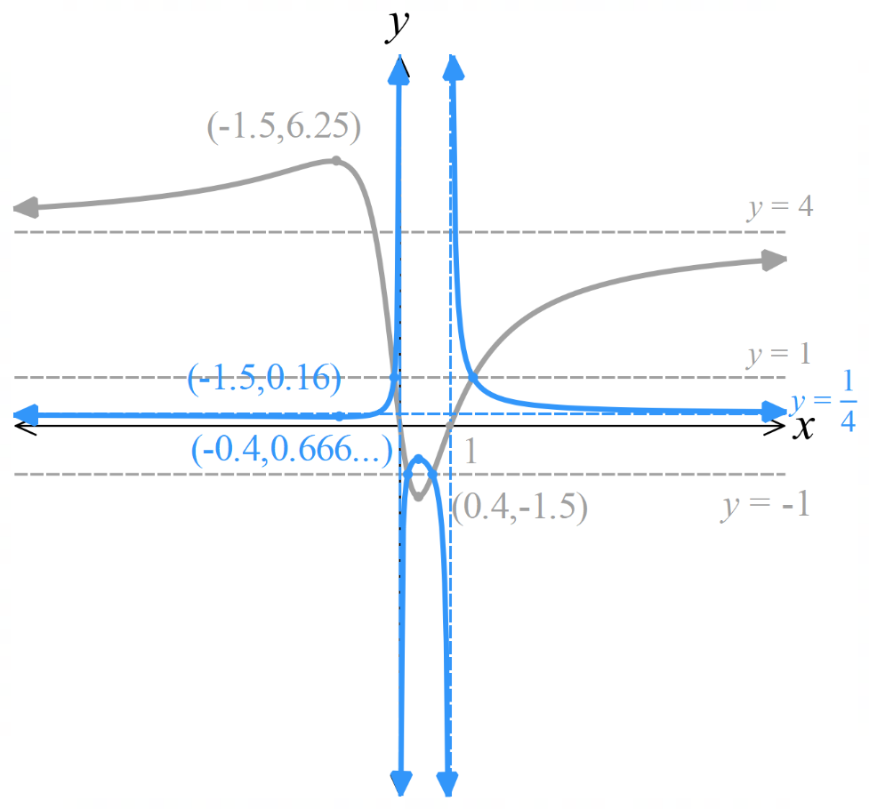
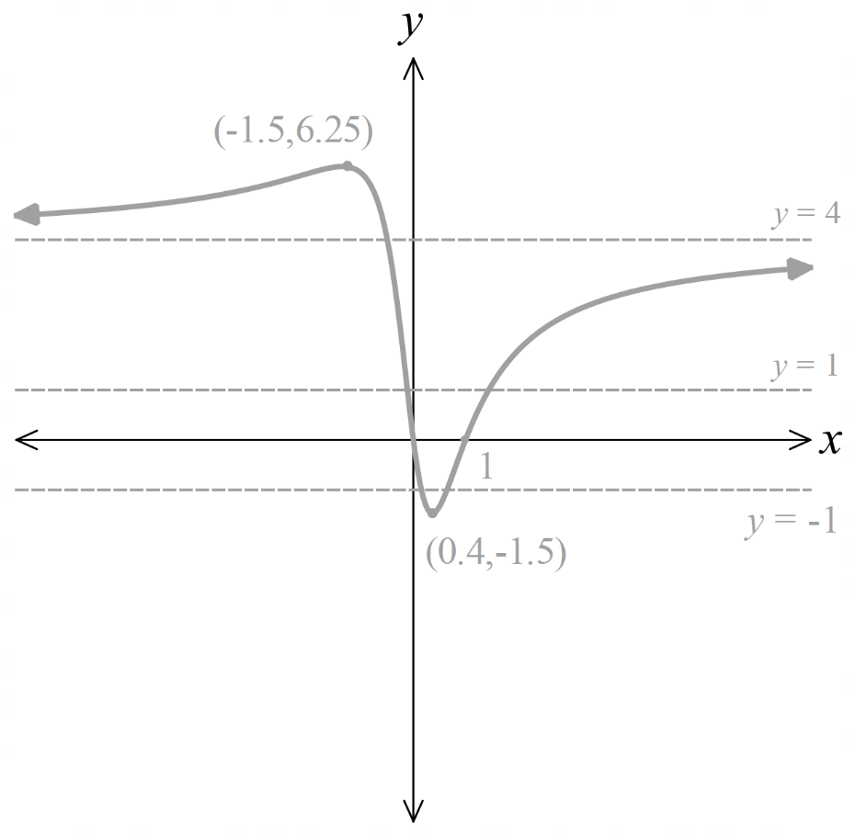

  - $y=\left|f\left(x\right)\right|$
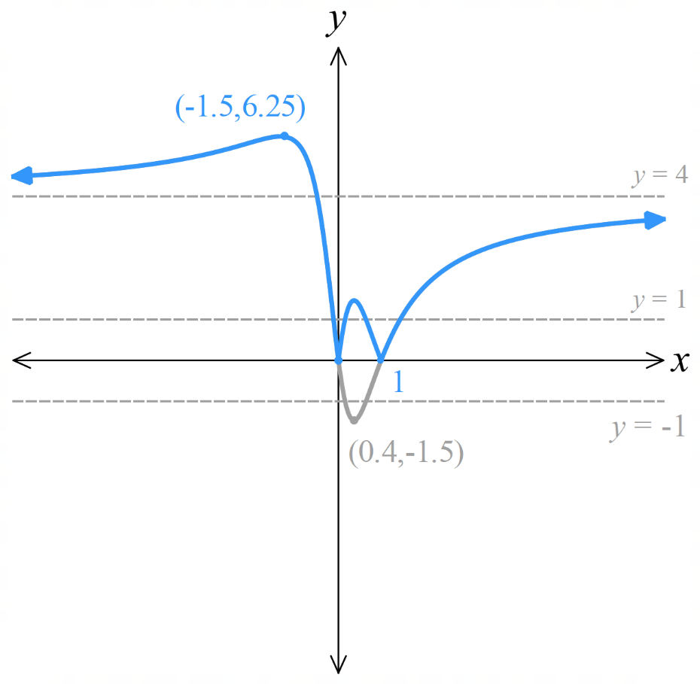

  - $y=f\left(\left|x\right|\right)$
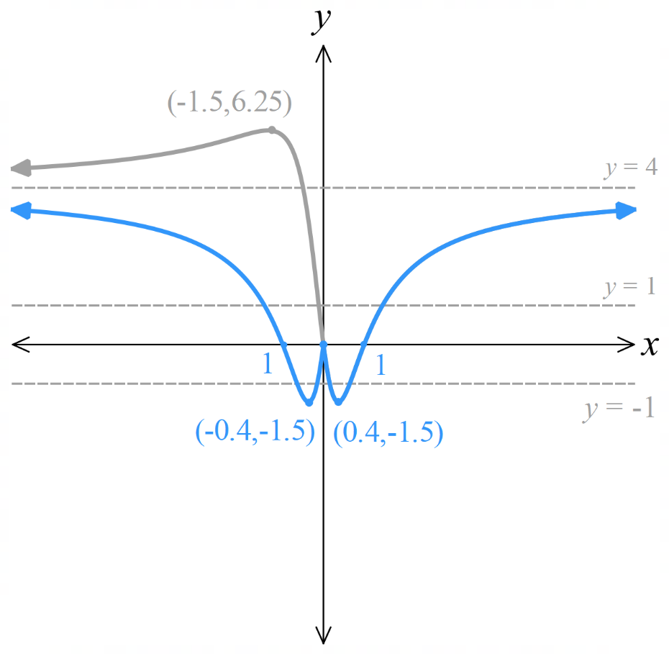

- $y=f\left(x\right)$ is given. One the same axis, sketch:
  - $y=$ $\frac{1}{f\left(x\right)}$
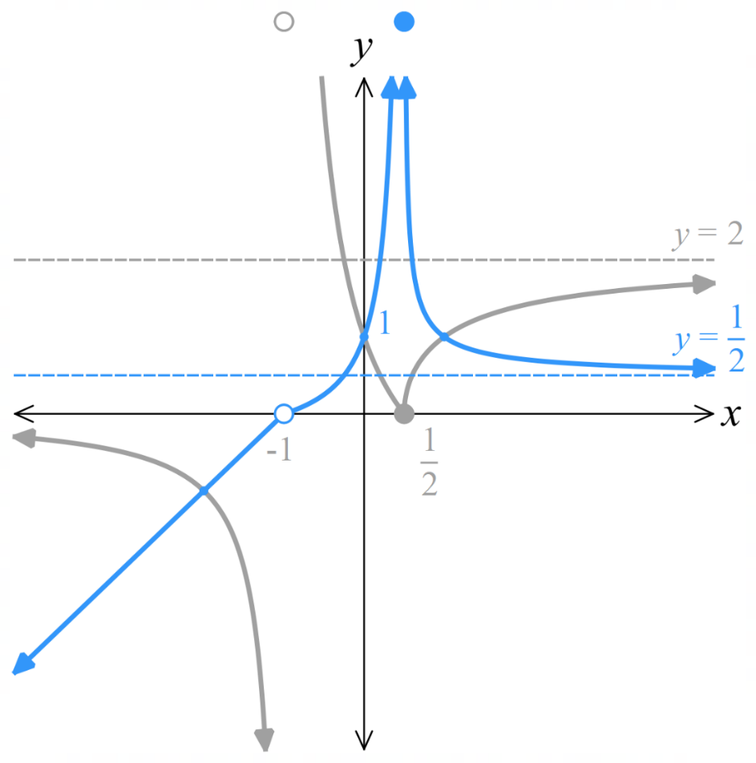
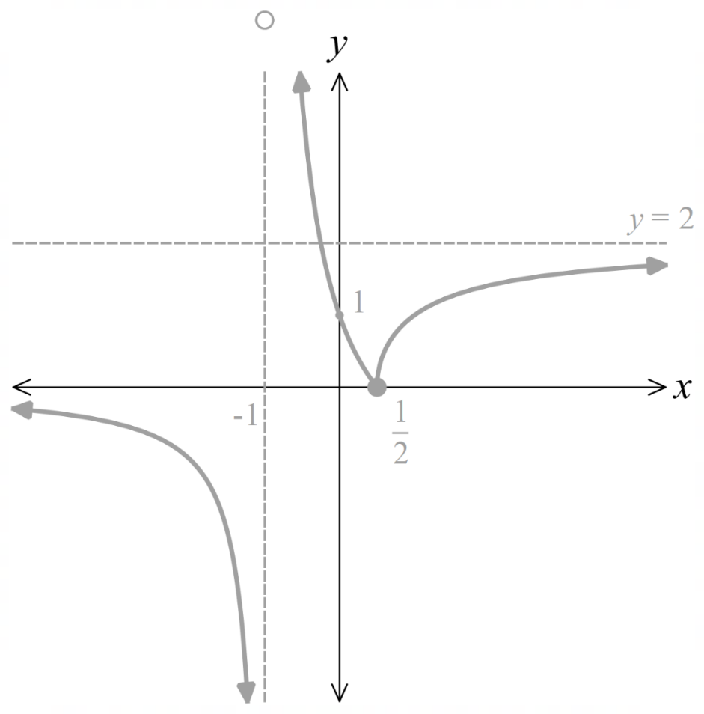

  - $y=\left|f\left(x\right)\right|$
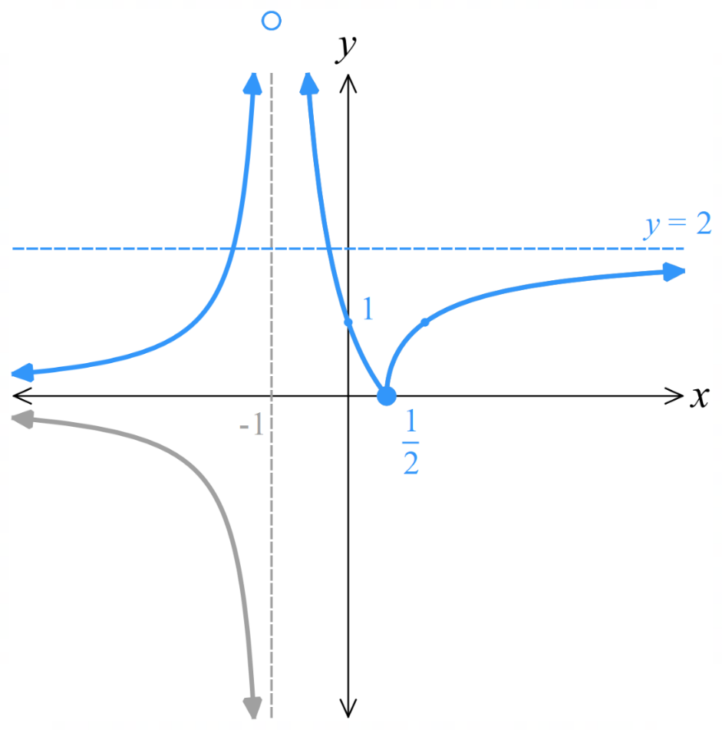
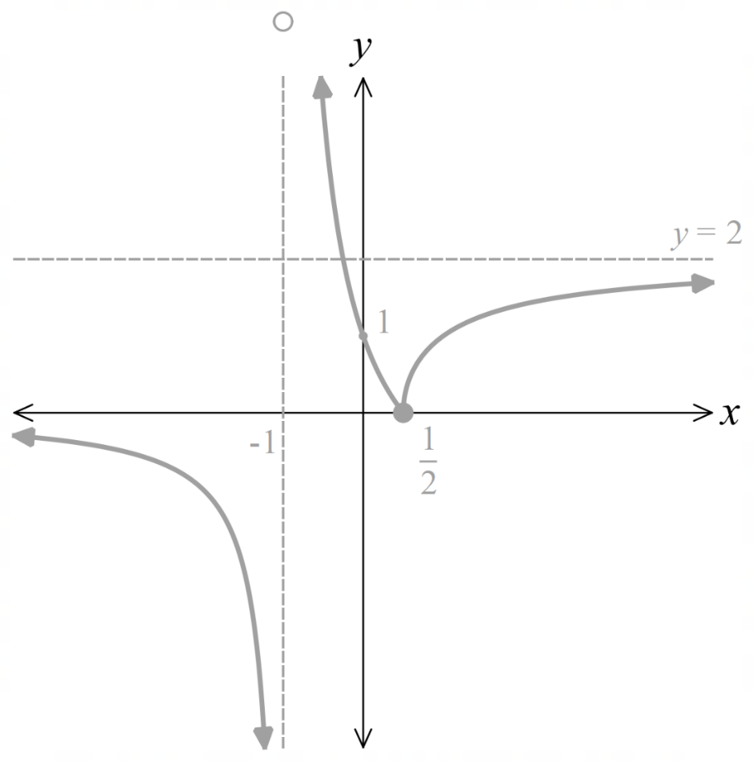

  - $y=f\left(\left|x\right|\right)$
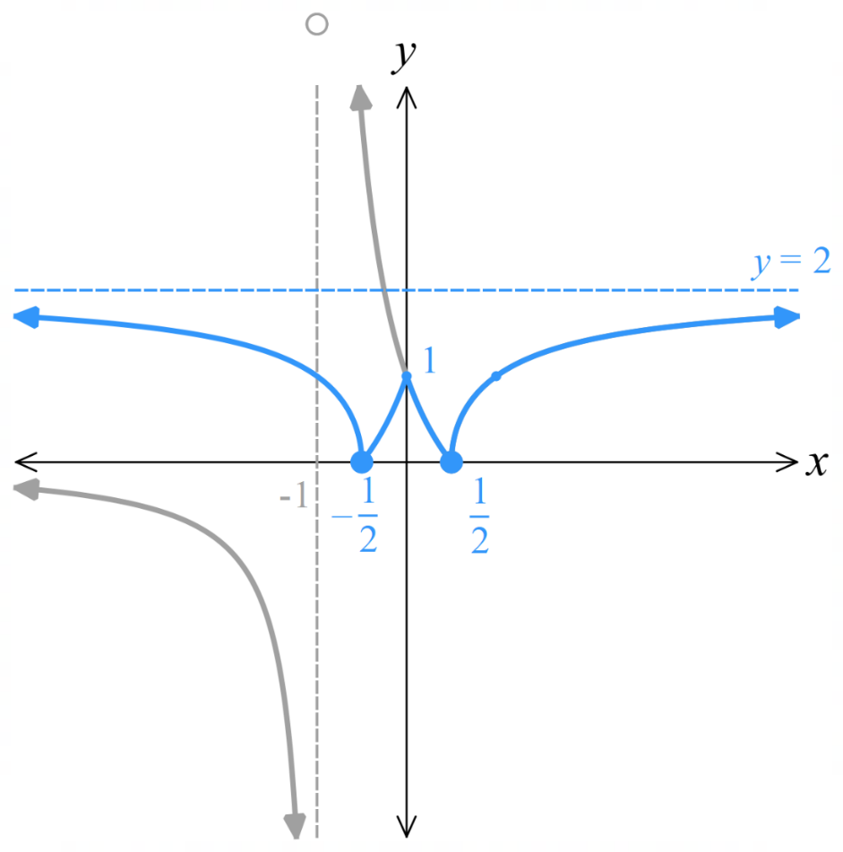

Sum and Difference of Graphs

- Sum of Graphs
To add two graphs $s\left(x\right)=f\left(x\right)+g\left(x\right)$:
- If the graphs are given, add the $y$-coordinates, wherever possible.
- If the equations of $f\left(x\right)$ and $g\left(x\right)$ are given, you can add the two functions algebraically to sketch the new function.
We will focus on the method of adding the $y$-coordinates, also called ordinates.

- Sketching the Sum and Difference of Two Graphs
The graphs of $f\left(x\right)$ and $g\left(x\right)$ are given.  Sketch $s\left(x\right)=f\left(x\right)+g\left(x\right)$.  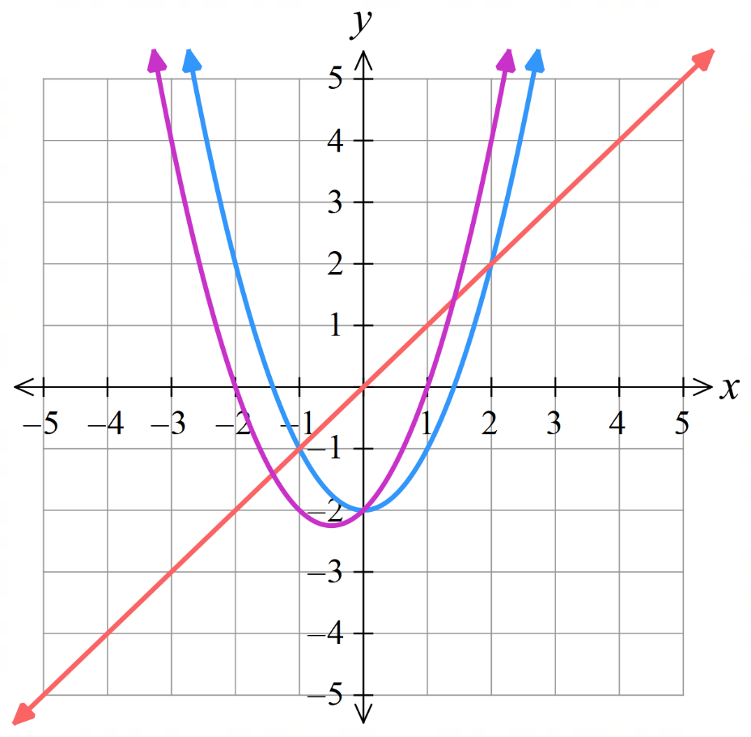  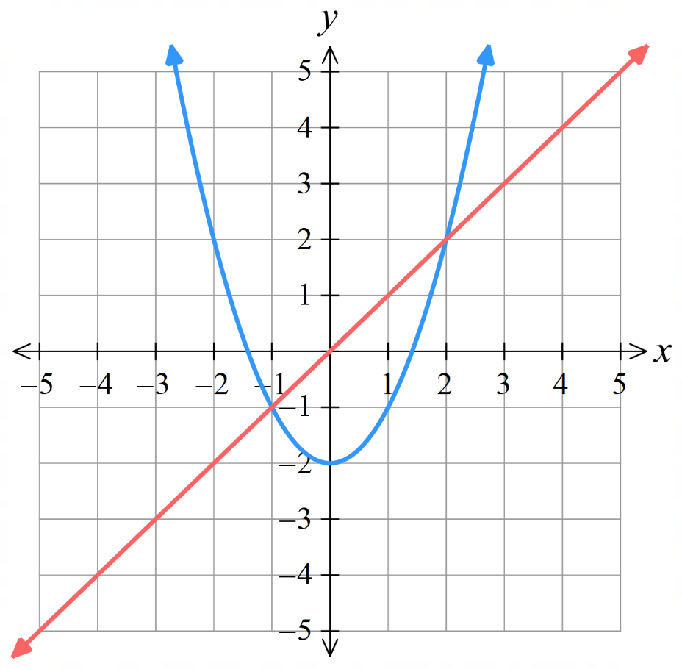 | 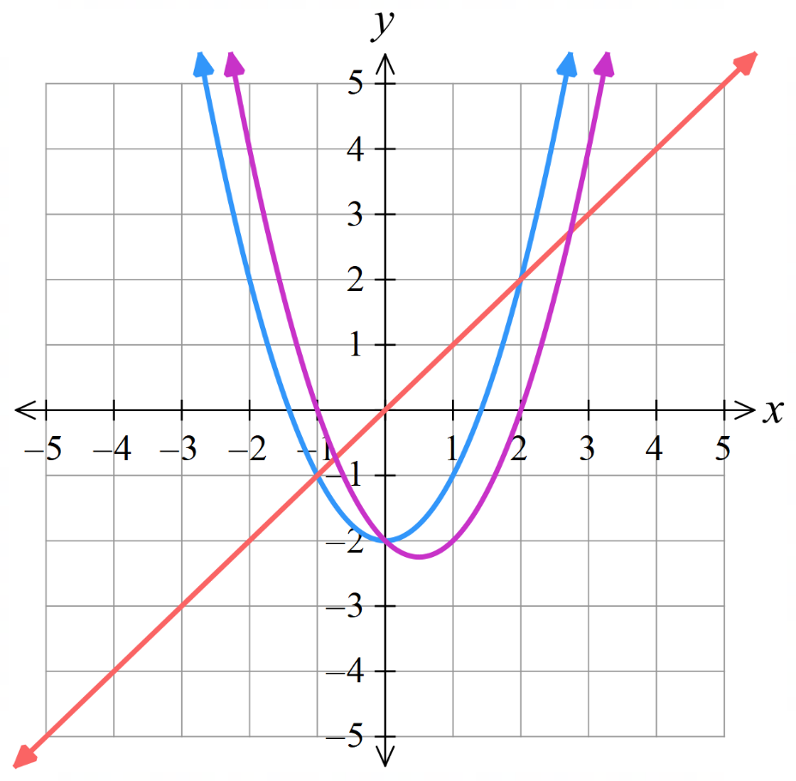  The graphs of $f\left(x\right)$ and $g\left(x\right)$ are given.  Sketch $d\left(x\right)=f\left(x\right)-g\left(x\right)$.

- Guided Practice
The graphs of $f\left(x\right)$ and $g\left(x\right)$ are given. Sketch $s\left(x\right)=f\left(x\right)+g\left(x\right)$.
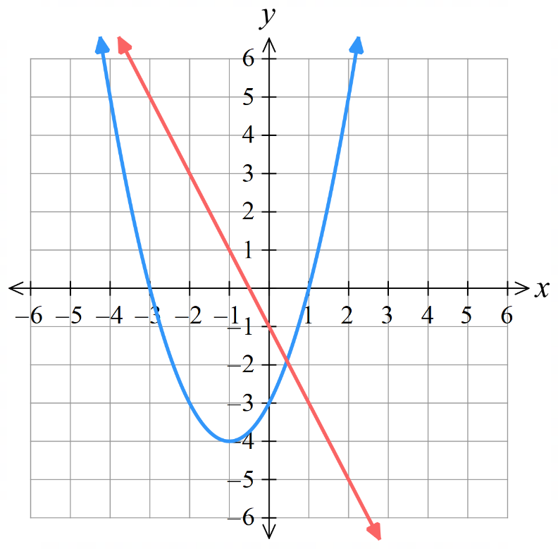 | 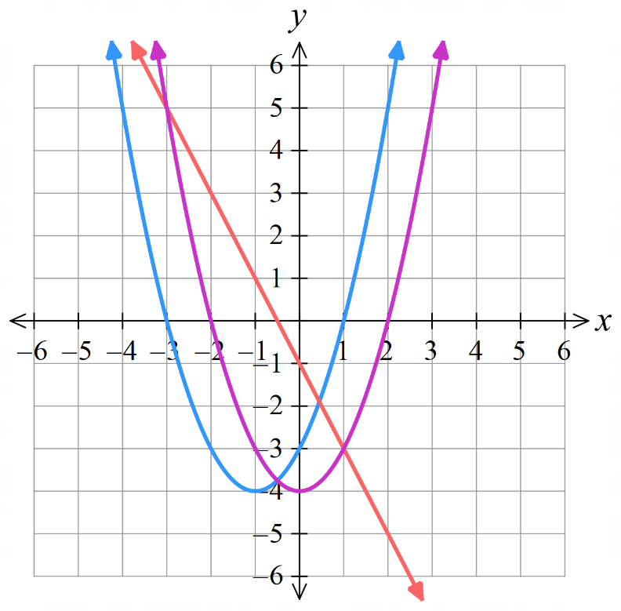  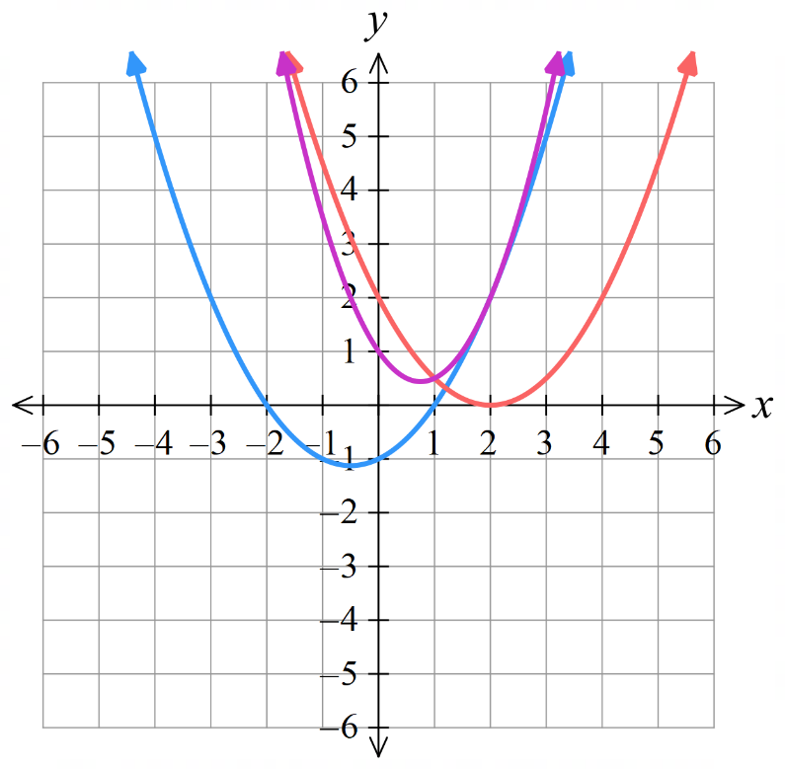  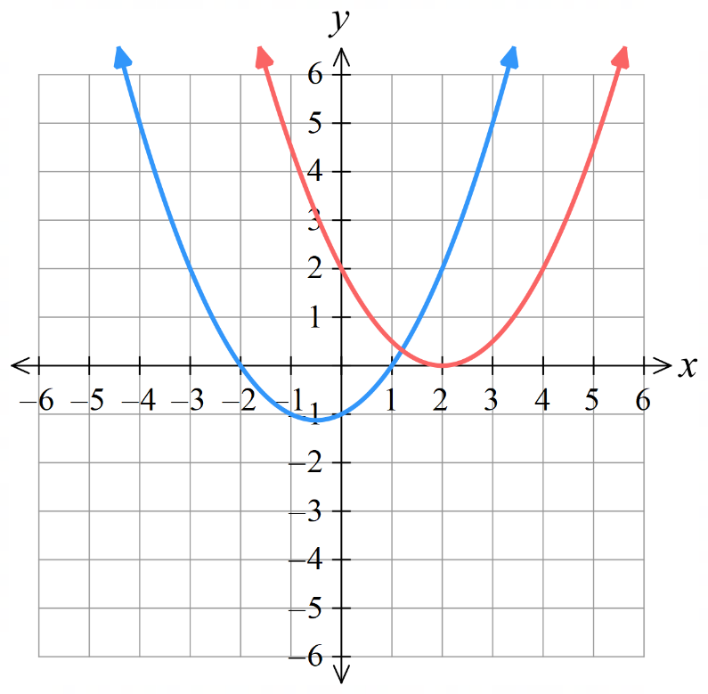
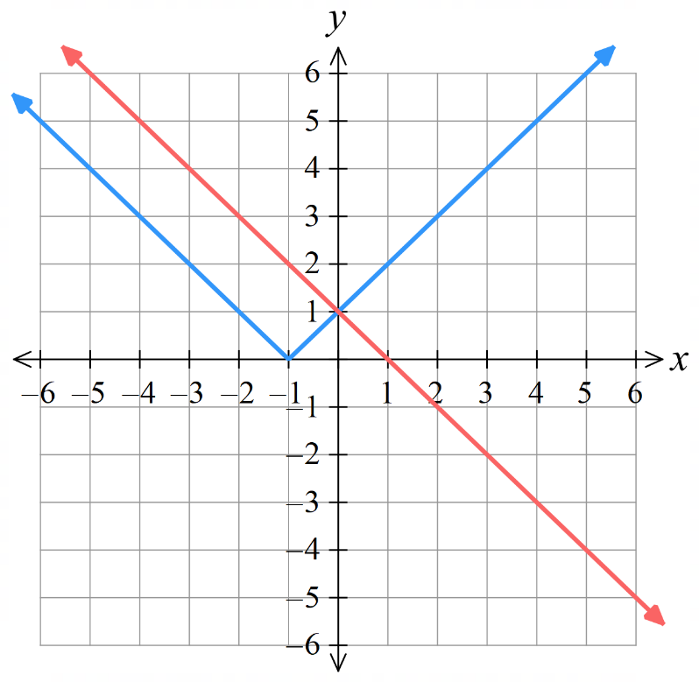  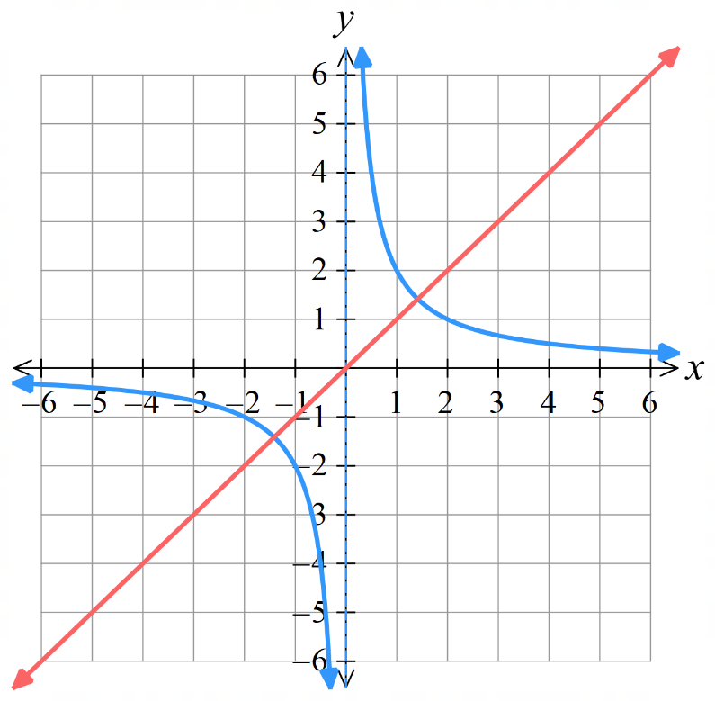 | 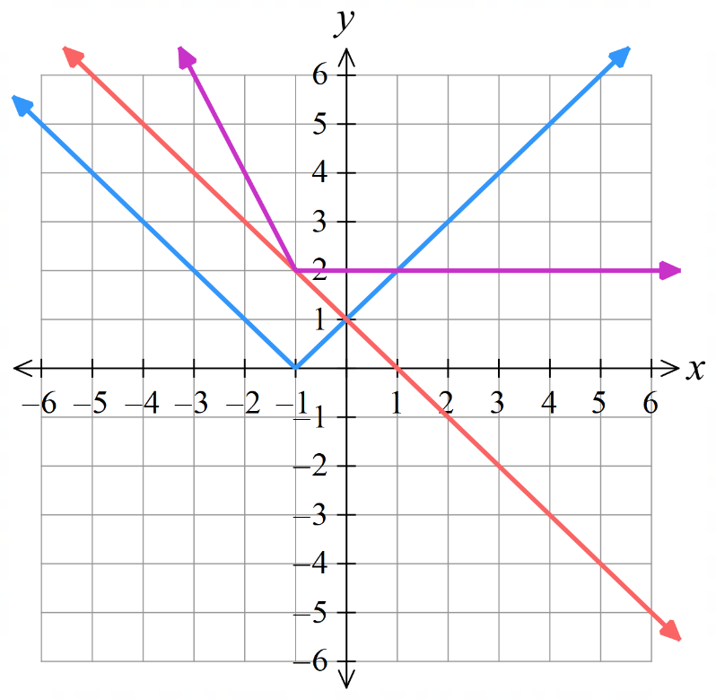  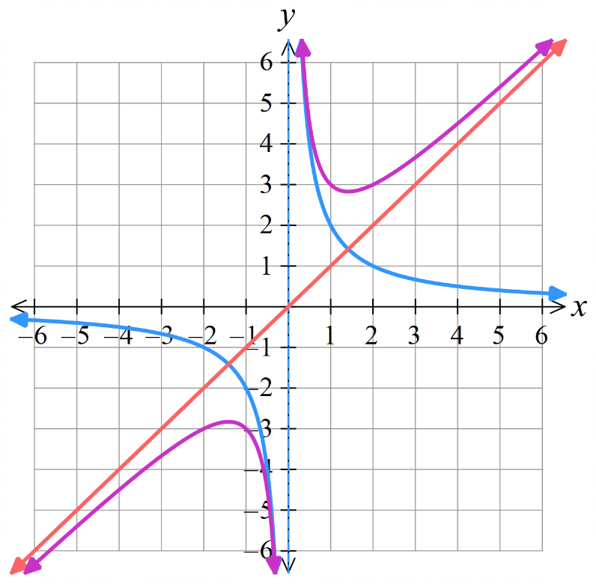

- Guided Practice
The graphs of $f\left(x\right)$ and $g\left(x\right)$ are given. Sketch $d\left(x\right)=f\left(x\right)-g\left(x\right)$.
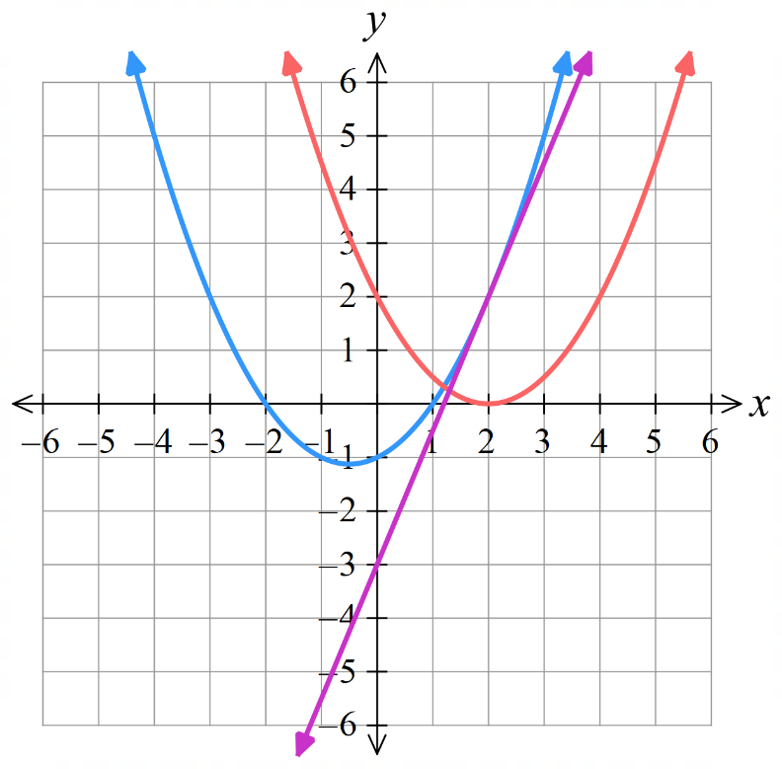
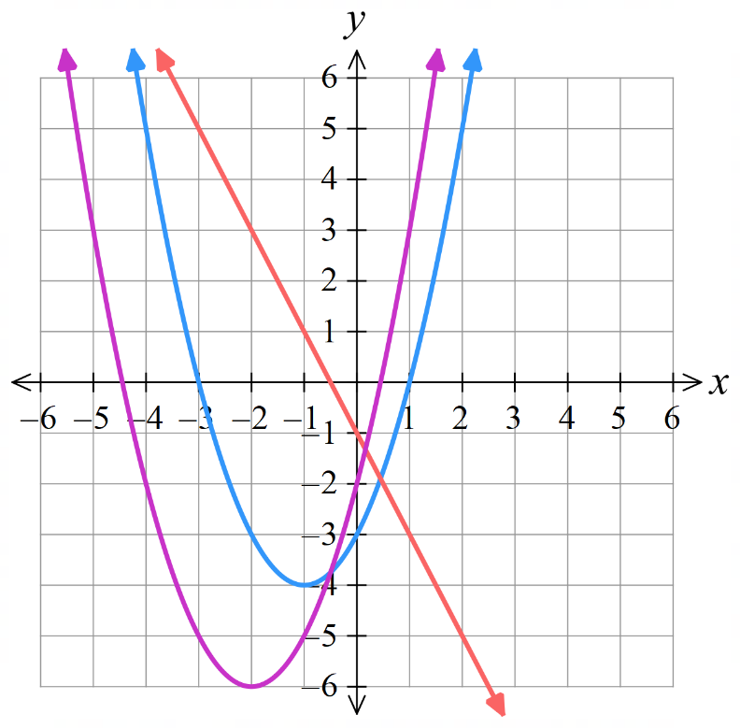

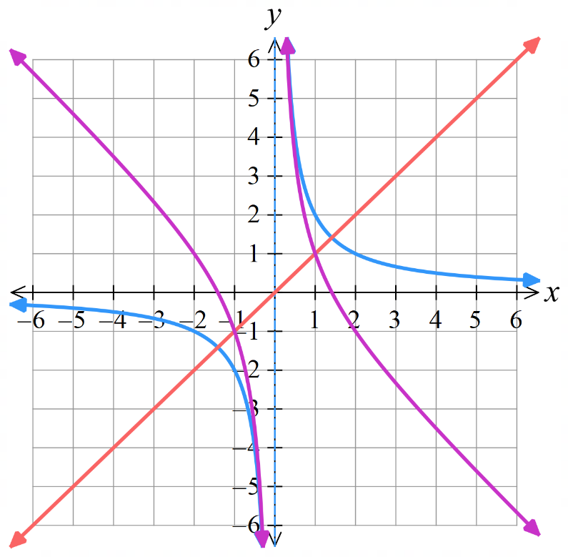
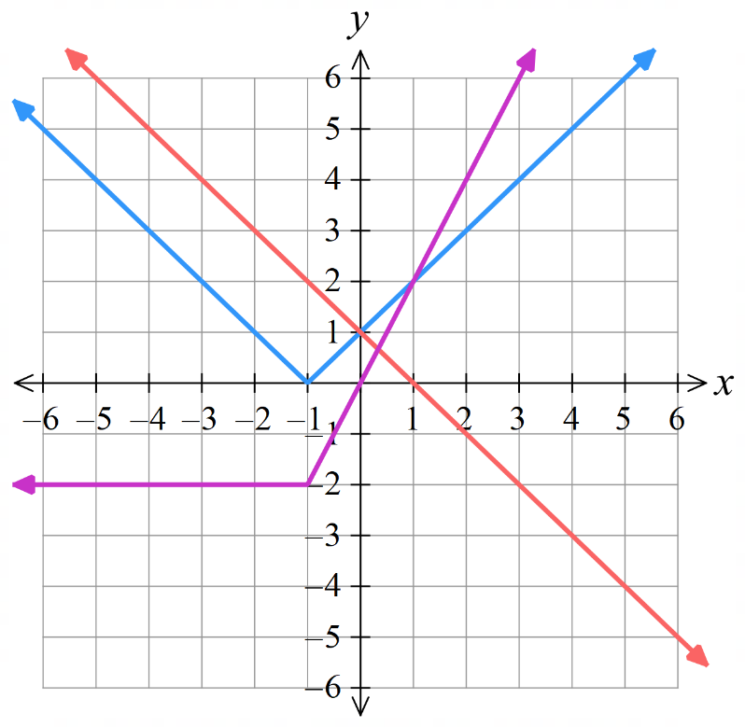

Foundation
- By drawing adding ordinates, draw the curve of $y=f\left(x\right)+g\left(x\right)$.
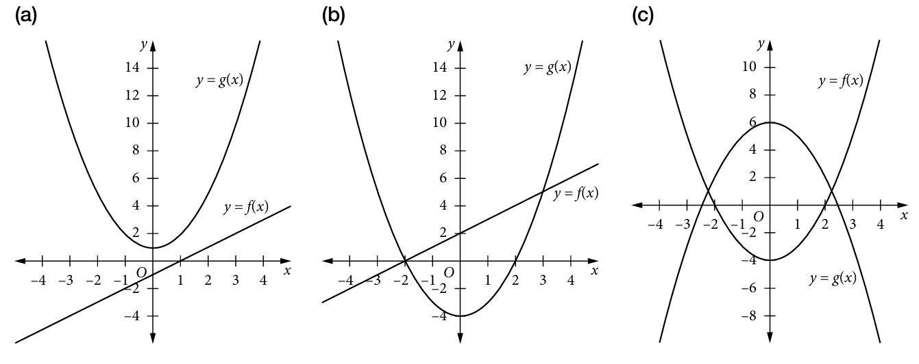  parabola, concave up cutting the x-axis at (−1, 0) and (0, 0) | parabola,  concave up cutting x-axis at (−2, 0) and (1, 0) and y-axis at (0, −3)
straight line with equation y = 2 | 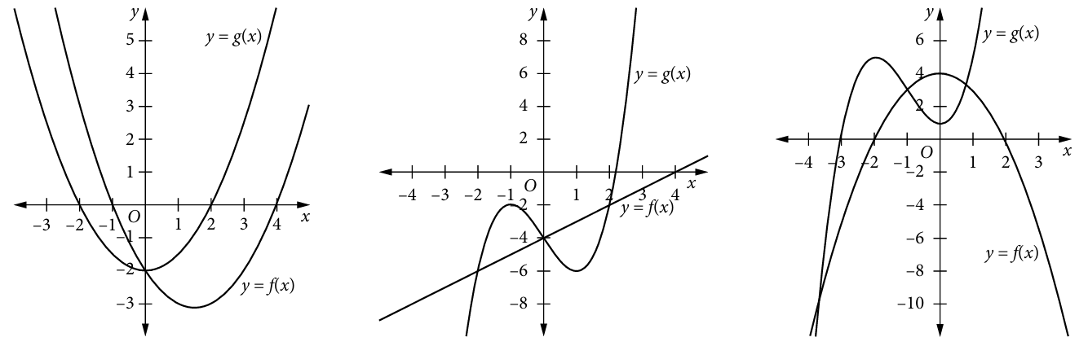  parabola, concave up cutting the y-axis at (0, −4)
cubic, cutting the x-axis at about (2.5, 0) and the y-axis at (0, −8).  It has the same shape as y = g(x), but lower. | cubic, cutting x-axis at about (−2.6, 0) and y-axis at (0, 5).  It has a similar shape to y = g(x), but flattens out more between turning points.

Development
In this section, you will sketch $f\left(x\right)$ and $g\left(x\right)$ then find the sum or difference.
Show the $x$ & $y$ intercepts and the intersection points of the graphs before adding/subtracting.

- Sketch the graph of $f\left(x\right)$ and $g\left(x\right)$ on the same axes, then graph $f\left(x\right)+g\left(x\right)$.
- $f\left(x\right)=x, g\left(x\right)=\left|x\right|$  Sketch $y=x+\left|x\right|$  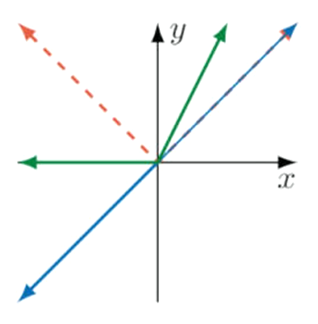 | - $f\left(x\right)=x$, $g\left(x\right)=x^{3}$  Sketch $y=x+x^{3}$  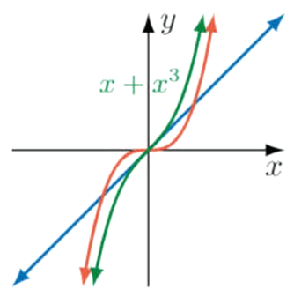

- Subtracting negatives often leads to mistakes.
Instead, it is easier to subtract graphs by sketching the negative and adding.
- $f\left(x\right)=\left|x\right|, g\left(x\right)=-x$  Sketch $y=\left|x\right|-x$  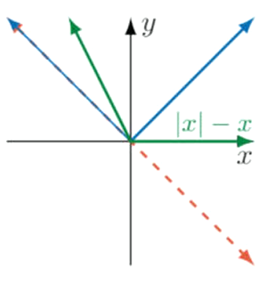 | - $f\left(x\right)=x, g\left(x\right)=-x^{3}$  Sketch $y=x-x^{3}$  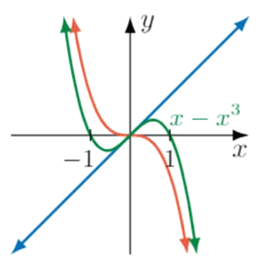

- Sketch these absolute value sums and differences. As absolute value graphs are made up of linear sections, your sums and differences should be made up of straight-line sections.
- $y=\left|x+1\right|+\left|x-2\right|$  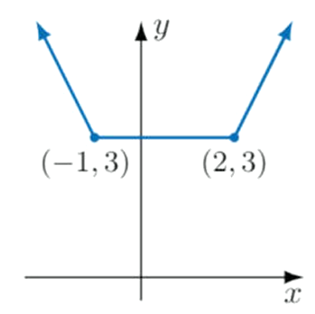 | - $y=\left|x-1\right|-\left|x+2\right|$  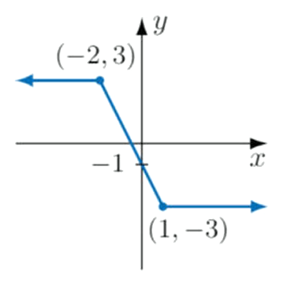
- $y=\left|2x+1\right|+\left|x-1\right|$  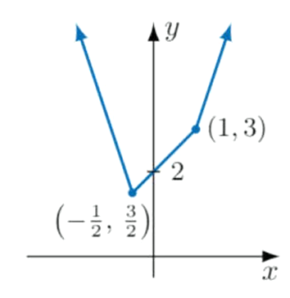 | - $y=\left|2x-1\right|-\left|x+1\right|$  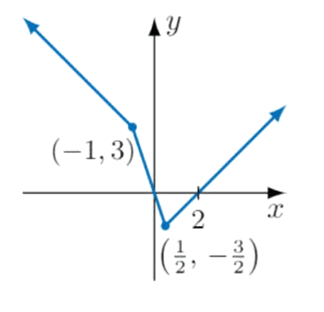

- Sketch:
- $y=x+$ $\frac{1}{x}$  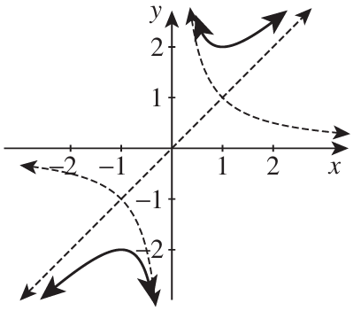 | - $y=x-$ $\frac{1}{x}$  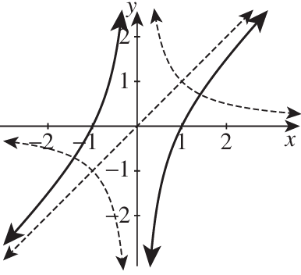
- $y=$ $\frac{1}{x}$ $+$ $\frac{1}{x+2}$  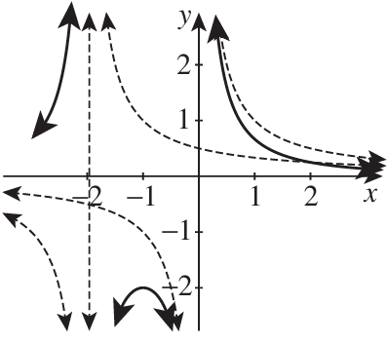  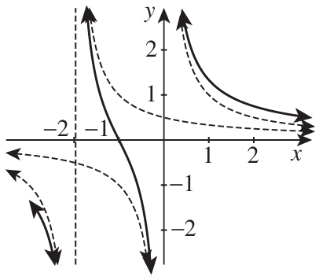 | - $y=$ $\frac{1}{x}$ $-$ $\frac{1}{x+2}$

- Using DESMOS, sketch $y=x$ and $y=2^{x}$ and $y=x+2^{x}$ on the same axes.
  - What do you notice about the graph of $y=x$ and $y=x+2^{x}$ as $x→-∞$?
This is called an oblique asymptote. Explain your observation.
$y=x$ is an asymptote. This is because as $x→-∞, 2^{x}→0$, so $x+2^{x}→x$
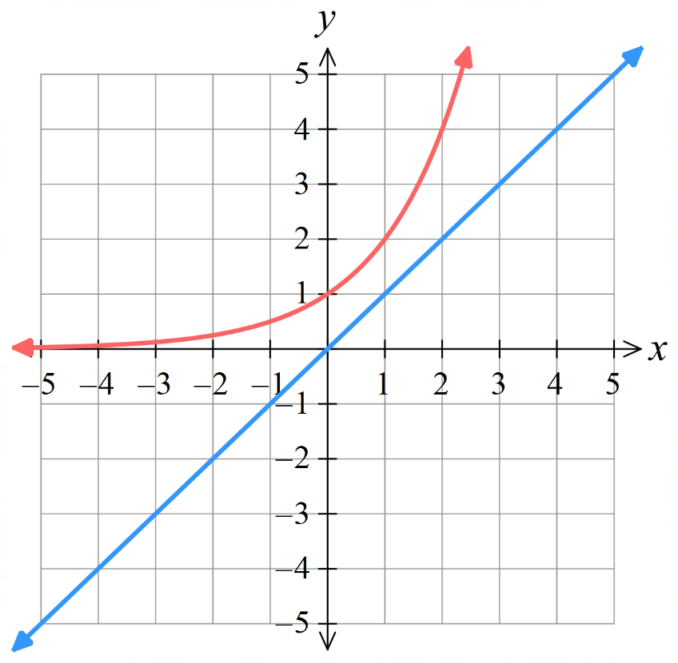
  - Attempt to recreate $y=x+2^{x}$ by adding ordinates.

- Sketch these graphs.
- $y=x-2^{x}$  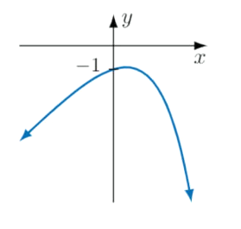 | - $y=x+2^{-x}$  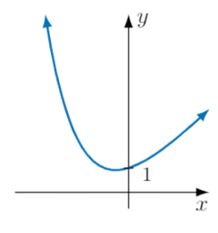

- Sketch $y=2^{x}+2^{-x}$.
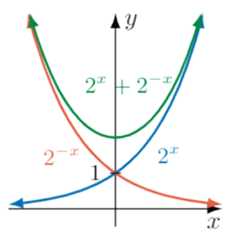

- Sketch $y=x-\sqrt{x}$.
